Quantification Analytics Tool

**Client name:** Chemonics Inc

**Scope of work:**

**Period of engagement:** Ongoing



**Document details:**

|  |  |  |  |
| --- | --- | --- | --- |
| **Author** | Ragini Joshi | **Initiation date** |  |
| **First reviewer** | Afaque Mohammed | **First reviewed date** |  |
| **First reviser** | Ragini Joshi | **First revision date** |  |
| **Second reviewer** | Sameer Gharpurey | **Second reviewed date** |  |
| **Second reviser** | Ragini Joshi | **Second revision date** |  |
| **Third reviewer (Client)** | FASP Team | **Third reviewed date** |  |
| **Third reviser** | FASP Team | **Third revision date** |  |
| **Author** | Ragini Joshi | **Initiation date** |  |

**Table of Contents**

Contents

Contents 1

Acronyms & Definitions 0

1. Overview 1

A. General Introduction 1

B. Background 1

2. Introduction to QAT 2

1. Introduction 2

A. Importance of Supply Planning 2

B. What QAT Supply Planning Can Do for You? 2

2. Objectives 3

3. Who Should Use QAT? 3

4. Important QAT Concepts and Terms 4

3. Getting Started 9

A. QAT Requirements 9

B. How to Install QAT 9

C. Logging in to QAT 11

D. User ID & Password 11

E. Logging out 12

F. Working Offline 12

4. Navigating QAT 12

A. Basic Navigation 12

B. Top Ribbon 13

C. Left-hand Menu 13

D. Buttons 14

E. Keys for Updating Records 14

5. User Roles and Permissions 14

A. Setting Up a New User 20

6. Troubleshooting & How to Report an Error/Bug 24

7. Translations 27

8. Application Dashboard 30

9. Three Levels of Hierarchy in QAT 31

10. Application Masters 31

A. Country 32

B. Currency 34

C. Dimensions 35

D. Language 37

E. Realm 38

F. Unit 41

11. Realm Level Masters 43

A. Realm Country 44

B. Data Source 45

C. Data Source Type 47

D. Funding Source 49

E. Manufacturer 52

F. Organization 53

G. Product 55

H. Technical Area 70

12. Setup Program 72

A. Introduction 72

B. Lead Times 73

C. Set up Program 74

13. Program Management 79

A. Program 79

B. Budget 82

14. PipeLine Program Import 86

15. Working with Program Data 94

A. Load Program 95

B. Import Program 96

C. Export Program 97

D. Delete Local Program 98

E. Commit version 98

F. Supply Plan Version and Review 100

16. Handling Procurement Agents 101

17. Background Data 107

A. Products 108

B. Selecting Products 108

C. Tickets for Product Creation 108

D. Consumption 108

E. Inventory 108

F. Region 109

G. Reorder Frequency 109

H. Freight Cost 109

I. AMC (Average Monthly Consumption): 109

J. MoS (Month of Stocks) 110

18. Supply Plan Data 110

A. Consumption Data 110

B. Shipment Data 115

C. Inventory Data 118

D. ERP Shipment Linking 120

E. ERP Shipment Delinking 121

F. Quantimed Import 122

19. Supply Planning 124

A. Supply Planning 125

a. Opening & Ending Balance 126

b. Consumption 126

c. Shipment 128

d. Manual Entry Shipments 129

e. Adjustments 131

B. Scenario Planning 132

C. Supply Plan Report 133

20. Reports 135

A. Importing Data Through an QAT Excel Template - 135

B. Important Formulae 138

C. QAT Problem List 140

D. Program Catalog 158

E. Stock Status 159

F. Consumption Reports 164

G. Shipment Reports 168

Appendix 179

Section 1 - Introduction 179

Section 2 – User & Program Management 180

Section 3 - Background Data for Realm 183

# 

# Acronyms & Definitions

|  |  |
| --- | --- |
| AMC | average monthly consumption |
| AMI | average monthly issues |
| ARTMIS | Automated Requisition Tracking Management Information System |
| ARU | alternate reporting unit |
| ATP | available to promise |
| CSP | coordinated supply planning |
| EOQ | economic order quantity |
| ERP | enterprise resource planning |
| FASP | forecasting and supply planning |
| FP/RH | family planning and reproductive health |
| GAD | goods available date |
| GHSC-PSM | Global Health Supply Chain – Procurement and Supply Management program |
| GLN | Global Location Number |
| GTIN | Global Transaction Identification Code |
| MNCH | maternal, newborn and child health |
| MOH | ministry of health |
| MOQ | minimum order quantity |
| MOS | months of stock |
| PEPFAR | President's Emergency Plan For AIDS Relief |
| PMI | U.S. President's Malaria Initiative |
| PPMR-HIV | Procurement Planning & Monitoring Report- HIV/AIDS |
| PPMR-M | Procurement Planning & Monitoring Report-Malaria |
| QAT | Quantification Analytics Tool |
| RO | requisition order |
| SKU | stock keeping unit |
| STG | standard treatment guidelines |
| TLP | targeted local procurement |
| USAID | United States Agency for International Development |

# Overview

# General Introduction

The Global Health Supply Chain – Procurement and Supply Management (GHSC-PSM) program is an official project of the United States Agency for International Development (USAID), implemented by Chemonics International and its consortium members. The purpose of GHSC-PSM is to ensure uninterrupted supplies of health commodities in support of US Government-funded public health initiatives around the world.

# Background

The forecasting and supply planning (FASP) tool modernization initiative is supported with funding from the U.S. President’s Emergency Plan for AIDS Relief (PEPFAR), the U.S. President’s Malaria Initiative (PMI), USAID’s family planning and reproductive health (FP/RH) program, and USAID’s maternal and child health (MCH) program, which share the cost of the project.

Previous USAID-funded projects, including the Supply Chain Management Systems (SCMS) and DELIVER developed and implemented the existing suite of FASP tools used in the global health domain. These tools have performed their specific functions well and achieved their main objectives. The tools, however, were designed separately, are inconsistent in terms of the user interfaces, and require manual manipulation for data exchange.

The primary objectives of this initiative are to build the next generation FASP tools on a scalable and modular platform that is operating-system agnostic; a tool that is web-based with significant offline capabilities; designed to allow for seamless data exchange and sharing across key stakeholders and public health systems, as well as have a user-centric interface for overall usability and automates supply chain functions for end-to-end data visibility and evidence-based decision making that extends across global and national supply chains and encourages coordination with all stakeholders.

# Introduction to QAT

## Introduction

## Importance of Supply Planning

Supply Planning is the component of supply chain management involved with determining how to best fulfill the requirements created from the demand plan. The objective is to balance supply and demand in a manner that achieves the service delivery and financial objectives of the health program.

## What QAT Supply Planning Can Do for You?

The Quantification Analytics Tool seeks to enable the users to accurately forecast and plan for the supply of healthcare commodities required in the country to maintain health services operational.

QAT enhances and modernizes the functionality offered by the incumbent PipeLine and Quantimed (module 2) tools by providing advanced scenario planning and updated planning logic; it also streamlines the forecasting and supply planning activities. Furthermore, the QAT enables offline functioning that helps users log their data even when there is no network coverage.

QAT can help you with monitoring and procurement planning functions, as explained below.

**QAT monitoring functions include-**

1. Monitoring stock balances, in terms of quantities and months of stocks on hand in the entire program.
2. Comparing stock balances to maximum and minimum stock parameters.
3. Automating the identification of problems such as additional procurements needed, stock outs, balances below minimum or above maximum.

**Procurement planning functions include-**

1. Calculation of shortfalls/surpluses and quantities needed to maintain the program’s optimum stock levels.
2. Automated calculation and tracking of pending actions, based on lead times such as shipments to plan, order, ship, and receive.
3. Calculation of estimated shipment and freight costs.
4. Tracking estimated budget expenditures.
5. Comparison of alternative procurement scenarios and analysis.

## Objectives

1. To plan, procure, monitor, and receive health commodities.
2. To guarantee lifesaving health supplies reach those in need.
3. To strengthen national supply planning methods.
4. To advance countries on their journey to self-reliance.

## Who Should Use QAT?

It is increasingly necessary that local program managers be empowered to do their own forecasting, monitoring, and procurement planning; they must also take charge of coordinating the activities of donors and local suppliers, as well as those of their own logistics management staff. While program managers and decision makers will be the primary users of QAT, the system can provide information to host country policy makers, country directors, procurers, and donors.

|  |  |
| --- | --- |
| **Who** | **Purpose** |
| **Planners / Program managers** | You are managing multiple funders (with different budgets), multiple procurement agents (with different catalogs, and lead times) and consumption and inventory data coming from different levels of your supply chain. QAT will help you decrease the risk of stock imbalances by providing increased visibility into procurement planning, and stock status monitoring in the near- and long-term. |
| **Host-country policy makers / country directors** | QAT will highlight any stock imbalances and the implications of different decisions, such as budgetary constraints and procurement policies |
| **Procurers and donors** | QAT highlights the current supply status and future procurement requirements |

Table 1.3- User Role and Purpose

## Important QAT Concepts and Terms

|  |  |
| --- | --- |
| **Terms** | **Definitions** |
| **Realm** | The QAT platform is subdivided into realms, each one governed by their own master data (inclusive of product catalog, funder names, procurement agent names, etc.) Future realms could be set up for other fields such as education supply chains, agriculture supply chains, etc. |
| **Programs** | A program arises similar in structure to a PipeLine “supply plans database”. Each program consists of only one country, one technical area, one region (national level, central level, etc.), and one organization (MOH, PEPFAR-only, PMI-only). |
| **Technical Area** | In QAT, technical area is synonymous to the commodity groups (i.e. ARV, Family Planning, Malaria, etc.) and are used to build a QAT program. |
| **Region** | QAT users can capture data at sub-national levels by structuring their programs with regions. The regions are defined at the program level. If a program administrator does not have subnational-level data or prefers to enter aggregated values, the user may keep the region “national” or “central.” To define sub-national levels, both forecast/consumption and inventory/adjustments must be entered at each level, which the application would then aggregate to a national total. |
| **Master Data** | Master data is a cleaned/standardized list of data that is shared and used by several applications (or programs in the case of the G;obal Health Realm) that make up a system. Many data points in QAT are standardized – for example, product lists, shipment statuses, data sources, etc. Users can request updates and additions to this master data though a ticketing mechanism. |
| **Syncing** | Many of QAT’s functionalities can be used offline; however, some data must be synced when online in order to have a “live” copy of the data for all program users to access. QAT will sync when a user is online or if the user chooses to manually sync. |
| **User Roles** | These are dedicated assignments to users that allow for different levels of access to data and functional areas within QAT. |
| **Procurement Systems Interfacing** | The software is designed to interface with different procurement management systems, from the various procurement agents. Initially, QAT will have an interface with ARTMIS that will enable import of USAID product information along with shipment data directly into QAT, reducing workload on planners to update shipment delivery dates, quantities, statuses. In the future, PSM will work to engage other donors such as Global Fund and/or UNFPA to interface with their systems, thus enabling importation of shipment data from them. |
| **Average Monthly Consumption (AMC)** | A dynamic value (*could be different month to month*) that determines the average quantity a product is used over a selected period of time. For QAT, the default AMC will be an average of the past three months of consumption, the current month, and two months into the future. If there is missing monthly consumption data within the calculated time period, it will be treated as “null”, not as zero. QAT Program Administrators have the ability to change the AMC time period to a maximum of 12 months into the past and 12 months into the future. |
| **Minimum & Maximum Stock Levels** | 1. The **minimum stock level** (in months) is determined per planning unit and is set at the program level. QAT program administrators can adjust as desired. 2. **The maximum stock levels** (in months) are dynamically calculated based on the minimum stock level plus the reorder interval. |
| **Reorder Interval** | A user-input number of months between shipments. QAT program administrators can adjust (default = 1 month) as desired. |
| **Minimum Order Quantity** | Minimum number of units a product must be ordered in. |
| **Volumetrics** | In QAT, programs users will be able to define volumes, and thus be able to estimate the volumetrics of orders. |
| **Tickets** | When a program user notices an issue with QAT (i.e. bug, system error) or would like to update or add master data, user role/access, a program, they may submit a ticket. This ticket will be resolved by a realm administrator and changes made accordingly. |
| **Planning Unit** | The product to be planned for in QAT. It is a product with full description up to the primary packaging (e.g. bottle of 30 tablets, 10x10 blister pack, etc.) |
| **Forecasting Unit** | The base unit that will be used for a specified forecasting period. e.g. one tablet, one condom, one milliliter. Note: this will be introduced in QAT Module 2 - Forecasting. |
| **Procurement Unit** | The product at the item level. A higher-level description of the planning unit including supplier-specific attributes. This information will not be visible/selectable by QAT users but will be sent automatically from procurement management systems. |
| **Alternate Reporting Unit** | The product and the unit that the country's data (consumption or stock) is reported in. This could be the same as the planning unit or may be different. QAT users can define an alternate reporting unit and a conversion factor (multiplier) to the planning unit. E.g. The planning unit is one bottle of 30 tablets; inventory reported in a box of 20 bottles (alternate reporting unit) = 100; multiplier is 20. Therefore, inventory reported is converted to planning units = 20 x 100 = 2,000 bottles of 30 tablets. |
| **Supply Plan Statuses** | Within QAT, there are a total of nine supply planning statuses that have been identified through the shipment’s lifecycle. These nine statuses are:   1. Suggested: shipments “suggested” by QAT as an early warning to avoid going below minimum stock levels. These are not actual shipments and as such, do not affect stock projections. Once a suggested shipment is accepted and thus status changed to planned. 2. Planned: could be manually entered or suggested shipments accepted by the QAT user and are included in stock projections. Must have an assigned procurement agent and funding source (which could be TBD). 3. Submitted: shipments that have been placed in a procurement management system (i.e. ARTMIS, WAMBO) and have a designated order number (i.e. RO number). This was previously known as ordered in PipeLine 4. Approved: shipments that have been approved by the procurement agent/funder. 5. Shipped: orders that have been shipped by the supplier. 6. Arrived: shipments that have arrived at the port of entry and are in the customs clearance process. 7. Received: shipments that have been received at destination and ready to distribute. 8. Cancelled: shipment was placed in a procurement management system, but later cancelled due to various reasons. 9. On-hold: shipment in QAT that has been placed in the procurement management system but is waiting for decision-maker action. |
| **Lead Times** | Lead times for QAT shipments have been mapped to the supply planning statuses and are inputted per product by the QAT program administrator. If the data is not available for lead times per product/procurement agent/country/shipping mode/program, default lead times can be entered at the program level. There are six different lead time calculations:   1. Planned to Submitted: time from when a shipment is planned (need identified) until it is entered into the procurement agent’s system. 2. Submitted to Approved: time from when the shipment is entered into the procurement agent’s system until it is approved for procurement. 3. Approved to Shipped: time from when the shipment is officially approved for procurement until it is shipped by the supplier. 4. Shipped to Arrived: time from when the shipment has left the supplier’s location until it arrives at the port of entry. 5. Arrived to Received: time from when the shipment arrives at port of entry and is in the customs clearance process until it arrives at the final destination and is ready to distribute. |
| **Unmet Demand** | QAT avoids negative stock balance and will only allow a program’s stock on hand (SOH) to be equal to or greater than zero. However, in order to capture the difference between the forecast and what was projected to be consumed up to the stock out, QAT will place that quantity in a separate row as unmet demand. This will be useful to inform what the theoretical real consumption would have been, had there not been a stock out (while avoiding negative SOH and the need for manual positive adjustments). |

Table -Important QAT Concepts and Terms

# Getting Started

## QAT Requirements

QAT is primarily operated on laptops and desktops with standard operating systems such as MS Windows, Linux/Ubuntu, and iOS.

The recommended web browser is Google Chrome, but users may utilize Chromium, Microsoft Edge, Mozilla Firefox, or Safari.

1. **Download Google Chrome**
2. When connected to the internet, open the available browser.
3. Type “Download Google Chrome” into the search bar.
4. OR type <https://www.google.com/intl/en_in/chrome/> into the search bar
5. Click on the “Download Chrome” function and follow any instructions for the installation.

## How to Install QAT

1. **Installing QAT software** **online**
2. An application/realm admin will create the user account/profile.
3. The new user receives an email to “Reset Password” once account is created
4. The user clicks on the “Reset Password” link in the email to set their new password.
5. The link received through the email will be valid for 15 minutes.
6. This link can be used only once. If needed, the user can generate the link again to reset the password by clicking “Forgot Password” on the login page.
7. After the password is set successfully, the user receives notification on the application.
8. The user can use their new credentials to log in to QAT.
9. **Installing the QAT ‘Progressive Web Application’ (PWA)** (**Google Chrome recommended):**
10. Go to <https://www.quantificationanalytics.org>
11. The user needs to **install** the software into his/her local machine.

Click here

1. Click on the add button in the address bar.

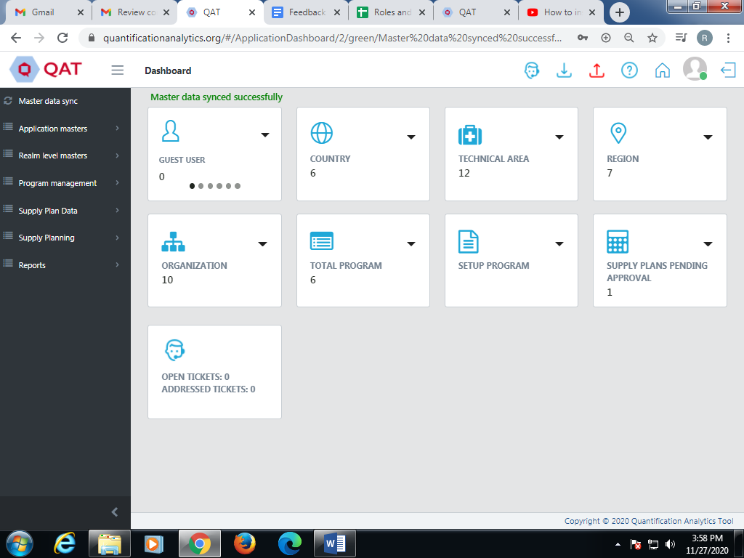

Figure 3.B-Install QAT

1. A small pop-up will be shown.
2. Click install.
3. QAT PWA will be installed to the user’s desktop.
4. The user can work in the installed software in online as well as offline mode.
5. However, the user has to login initially before installing the software in offline mode, and then continue working in offline mode.
6. After the installation user can open the QAT in his/her local machine.
7. Users can directly open from downloads or type **chrome://apps/** in the search bar.
8. The QAT software will be displayed on the screen (Only if it is installed in local machine as mentioned above).

**NOTE**:

1. Once a user moves from PWA to Browser; Click on the ctrl + f5 button to refresh.
2. Also, if the user needs to refer to Server specs, please check Appendix Section 3– QAT Server Scripts.

## Logging in to QAT

1. **Login**
2. To log in, type the URL <https://www.quantificationanalytics.org/> in the search bar and press enter, or open the PWA from your desktop.
3. A login screen will be displayed.
4. Type the username and password in the given sections.
5. After entering all the details click on the “Login” button.

## User ID & Password

1. **Forgot Password**

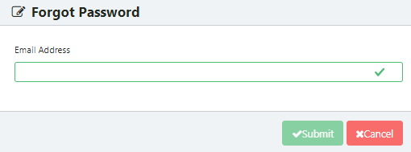

Figure 3.D-Forgot Password

1. A user who has forgotten their password, can click on the “Forgot Password?” link on the bottom right to reset it.
2. A new window will be opened on screen.
3. Type the email address in and click on the “Submit” button.
4. The user will get a link via email to reset their password.
5. **Change Password**
6. Go to the top right corner of the screen.
7. Go to the profile icon.
8. Click on “Change Password”.
9. Enter your old password followed by the desired new password.
10. Confirm the new password by typing it again.
11. Click on the “Submit” button.

## Logging out

To log out:

1. Go to the top right corner of the screen.
2. Click on the icon next to the profile icon i.e. logout button. (Refer “Buttons” section).

## Working Offline

QAT can be operated in both online and offline mode. The user can work in offline mode by installing the software or without accessing the network in the local area. But the user must log in online at least once after installing. This is required to ensure that the software on the local machine remains up to date.

The profile icon at the top right corner shows a green-colored circle when working in online mode. When the user switches to offline mode the color changes to red, as shown on the screenshot below.

# Navigating QAT

## Basic Navigation

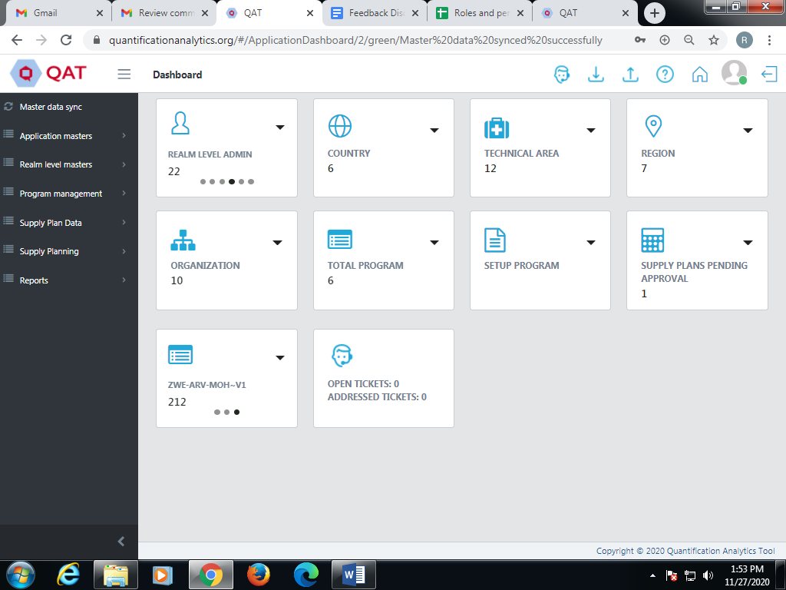

Figure 4.A- Basic Navigation

Once the user is logged into QAT, a dashboard will display on the screen. The user will be able to access the dashboard according to the **role assigned** to them. As shown above the role assigned to the user is of “Realm Level Admin. It consists of top ribbon, left hand menu and functions which are accessible to the user.

## Top Ribbon

Figure 4.B- Top Ribbon

* **Home** – returns user to the dashboard/home page
* The **profile** icon is green when working online and red while working offline. When the user clicks on the icon, they are able to:
  + View the username and associated role(s) assigned to them
  + Change their preferred language
  + Change their password
* **Log Out** – Logs user out of QAT

## Left-hand Menu

The left-hand menu consists of multiple functions. These functions are visible to users according to their roles. The left-hand menu shows certain functions which can be expanded to show sub-levels. As the user selects different functions from the menu, the respective data will be displayed on the screen.

|  |  |
| --- | --- |
| **Buttons** | **Action** |
|  | Hides the left-hand menu |
|  | Shown when sub-menu functions are hidden / collapsed. Click to expand and show submenus under a menu function |
|  | Shown when sub-menu functions are displayed. Click to collapse sub-menus. |
|  | Minimizes the left-hand menu |

Figure 4.C-Menu Bar Buttons

## Buttons

The following buttons are most commonly used in QAT:

|  |  |
| --- | --- |
| **Buttons** | **Action** |
|  | Submits records and make changes |
|  | Cancels the defined changes |
|  | Used to set up information again or differently |
|  | Adds a new record to the database |
|  | Updates records |
|  | Helps users to search the desired information. Searches all fields in the table displayed. |
|  | Allows a user to clear search fields |
|  | Indicates mandatory data entry fields |

Table 4.D-QAT Buttons

## Keys for Updating Records

|  |  |
| --- | --- |
| **Keys** | **Function** |
| **Backspace** | Deletes selection or character to the left of the cursor. |
| **Delete** | Deletes selection or character to the right of the cursor. |
| **Prt scr** | Takes a screenshot |
| **Alt+Tab** | Toggles between screens |
| **Tab** | Moves the cursor from one field to the next, and moves the  Cursor from one button to another without activating buttons. |

Table 4.E-Keys for Updating Records

# User Roles and Permissions

Users will have access to program data as per the roles and permissions assigned to them. Refer to the table from the “Role” section.

**User Permissions:**

Roles can be considered as a set of permissions. Roles are defined by application or realm administrators.

**User Roles:**

Roles can be considered as a set of permissions. Roles are defined by application or realm administrators.

QAT has various roles including Application Level Admin, Realm Level Admin, Program Level Admin, Supply Plan Reviewer, Program User and Guest User. QAT has three main roles in the following hierarchy:

**Application Level Admin → Realm Level Admin → Program Level Admin**

The application level admin is an administrator role. This has exclusive access to view and update the static and dynamic labels (via Translation function). However, this role cannot access the MIS reports section.

In addition, QAT has a provision to enable existing PipeLine application users to login to the QAT system using separate credentials (as guest users). These users will be enabled to directly upload the data into the QAT system.

A role can have zero or multiple permissions assigned to it. Permissions assigned define what actions a user with a given role is entitled to. For example, a program is managed by a program admin while a realm is managed by a realm admin. A Realm Level Admin can have access to one or multiple programs. The Program Level Admin can have limited access for particular program i.e. a Program Admin can only manage assigned program(s) not a realm. Roles can be assigned to users registered in QAT. The registration process can be done via the Application Masters menu, only accessed by application admins or realm admins. Roles can be modified as necessary.

The following table shows the business functions that are available to each role.

**NOTE:** Y = Yes and N = No, denote the permission to a particular business function for that role

|  |  |  |  |  |  |  |
| --- | --- | --- | --- | --- | --- | --- |
| **Business Function** | **Application Admin** | **Realm Admin** | **Program Admin** | **Supply Plan Reviewer** | **Program User** | **Guest User** |
| Application Dashboard | Y | N | N | N | N | N |
| Label Translations | Y | N | N | N | N | N |
| Manage Role | Y | N | N | N | N | N |
| Manage User | Y | Y | N | N | N | N |
| Manage Language | Y | N | N | N | N | N |
| Manage Country | Y | N | N | N | N | N |
| Manage Currency | Y | N | N | N | N | N |
| Manage Dimension | Y | N | N | N | N | N |
| Manage Unit | Y | N | N | N | N | N |
| Create Realm | Y | N | N | N | N | N |
| Database Translation | Y | N | N | N | N | N |
| Edit Realm | Y | Y | N | N | N | N |
| Manage Data Source Type | Y | Y | N | N | N | N |
| Manage Data Source | Y | Y | N | N | N | N |
| Manage Funding Source | Y | Y | N | N | N | N |
| Manage Procurement Agent | Y | Y | N | N | N | N |
| Manage Supplier | Y | Y | N | N | N | N |
| Manage Region | Y | Y | N | N | N | N |
| Manage Technical Area | Y | Y | N | N | N | N |
| Manage Organization | Y | Y | N | N | N | N |
| Manage Realm Country | Y | Y | N | N | N | N |
| Manage Tracer Category | Y | Y | N | N | N | N |
| Manage Product Category | Y | Y | N | N | N | N |
| Manage Forecasting Unit | Y | Y | N | N | N | N |
| Manage Planning Unit | Y | Y | N | N | N | N |
| Manage Planning Unit capacity | Y | Y | N | N | N | N |
| Manage Procurement Unit | Y | Y | N | N | N | N |
| Create a Program | Y | Y | N | N | N | N |
| Approve a Version | Y | Y | N | Y | N | N |
| View Program Dashboard | Y | Y | Y | N | Y | N |
| Edit Program | Y | Y | Y | N | N | N |
| Manage Budget | Y | Y | Y | N | N | N |
| Download Program | Y | Y | Y | N | Y | N |
| Import Export Program | Y | Y | Y | N | Y | N |
| Supply Plan | Y | Y | Y | N | Y | N |
| Commit version | Y | Y | Y | N | Y | N |
| List Data Source Type | Y | Y | Y | N | Y | Y |
| List Data Source | Y | Y | Y | N | Y | Y |
| List Funding Source | Y | Y | Y | N | Y | Y |
| Procurement Agent | Y | Y | Y | N | Y | Y |
| Supplier | Y | Y | Y | N | Y | Y |
| Region | Y | Y | Y | N | Y | Y |
| Technical Area | Y | Y | Y | N | Y | Y |
| Organization | Y | Y | Y | N | Y | Y |
| Tracer Category | Y | Y | Y | N | Y | Y |
| Product Category | Y | Y | Y | N | Y | Y |
| Pipeline Program Import | N | Y | Y | N | N | Y |
| Supply Plan Report | N | Y | Y | N | Y | Y |
| Product Catalog Report | N | Y | Y | N | Y | N |
| Consumption Report | N | Y | Y | N | Y | N |
| Consumption Global view Report | N | Y | Y | N | Y | N |
| Forecast Error over time Report | N | Y | Y | N | Y | N |
| Stock Status over time Report | N | Y | Y | N | Y | N |
| Stock Status Matrix Report | N | Y | Y | N | Y | N |
| Forecast Matrix Report | N | Y | Y | N | Y | N |
| Annual Shipment cost Report | N | Y | Y | N | Y | N |
| Stock Status Report | N | Y | Y | N | Y | N |
| Problem and Action Report | N | Y | Y | N | Y | N |
| Funder Report | N | Y | Y | N | Y | N |
| Procurement Agent Report | N | Y | Y | N | Y | N |

Table 5-QAT Roles and Permissions

## Setting Up a New User

1. **Adding a new user**

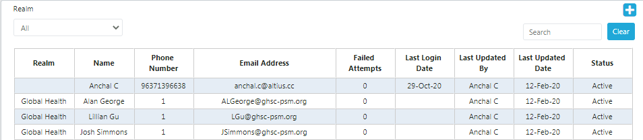

Figure 5.A- Add User

This feature is only available to **Application and Realm Administrator roles**. To create or edit user roles and permissions:

1. Click on Application Masters.
2. Select ‘User’ from that menu.
3. A screen will display with different users (see above screenshot).
4. On the top right corner click on the “Add” button (blue plus sign).
5. A new screen will be displayed as shown below:

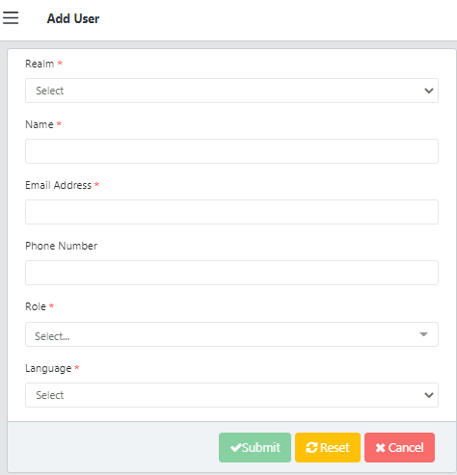

Figure 5.A- Add User

1. Enter the details and click “Submit”.
2. **User Access Control**

The previous step created the user and assigned it a role. The next step is to assign the relevant permissions through user access control setup.

1. From the user list table (see add user above), right click on the row of the user you want to edit.
2. Click on “Access Control”.

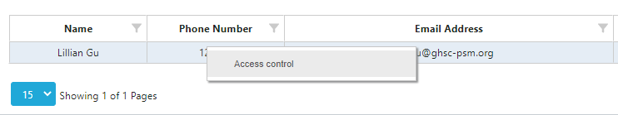

Figure 5.B.1- User Access Control

1. Select from the dropdowns on the table the different permissions assigned to that user.
2. A user can be assigned multiple permissions through adding rows – either through the “Add Row” button, or by right-clicking the row and selecting “insert row”

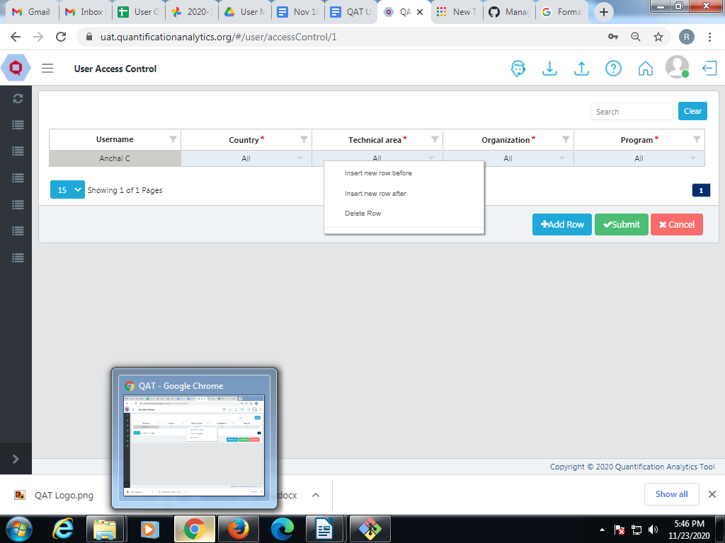

Figure 5.B.2- Add Access Control

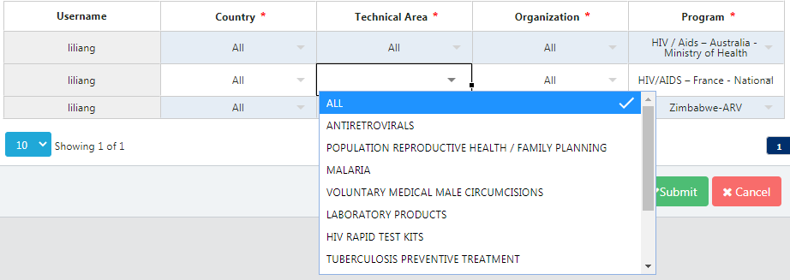

Figure 5.B.3- Change Access Control

1. To change the access given to the user, click on the dropdown button in that specific cell as shown above.
2. Enter the details and click “Submit”.
3. **Update User Information**

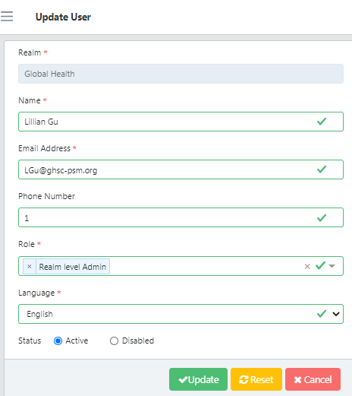

Figure 5.C- Update User

1. Click on the specific user from the User’s list.
2. The screen will show the “Update User” section.
3. Change the existing information, including disabling or activating the user.
4. Click on the “Update” button.
5. **Add Role**

This function is available to only **Application Administrator** role.

1. Click on Application Masters.
2. The screen will display different functions.
3. Select the function ‘Role’ and a screen will display different roles (see below screenshot).
4. On the top right corner click on the “Add” button.

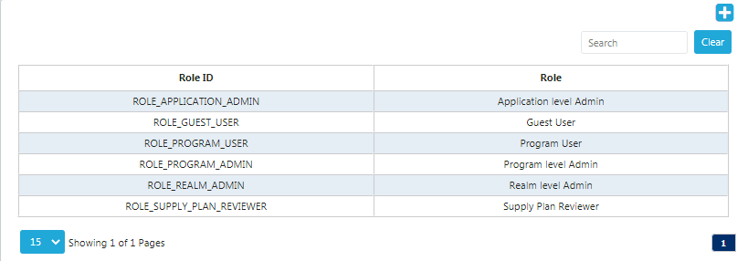

Figure 5.C.a- Add Role

1. A new screen of the add role will be displayed.
2. Enter the details and click on the “Submit” button.
3. **Update Role**

This function is available to only **Application Administrator** role.

1. The above screen shows how to update the existing roles.
2. Click on the Role ID and an update section will be shown.
3. Select the “Role” and “Business Function”.
4. Select the status as “Active”.
5. Click on the “Update” button to save the changes.

# Troubleshooting & How to Report an Error/Bug

When a program user notices an issue with QAT (i.e. bug, system error) or would like to update or add master data, or change user access, they may raise a “ticket.” The ticket will be raised in JIRA. JIRA link is as follow:  
[https://qathelpdesk.atlassian.net/jira/servicedesk/projects/QAT/queues/custom/9](https://www.google.com/url?q=https://qathelpdesk.atlassian.net/jira/servicedesk/projects/QAT/queues/custom/9&sa=D&source=hangouts&ust=1606538126105000&usg=AFQjCNH2uMgt0lcAuwhitIA9KzUTiDVk3A)

This ticket will be resolved by an Application Administrator and changes made accordingly. The procedure to raise a ticket is shown below:

1. **Report an Error/Bug**
2. Go to the top right corner of the screen.
3. Click on the “Help Desk” button as shown above.
4. The “Help Desk” screen will be displayed.

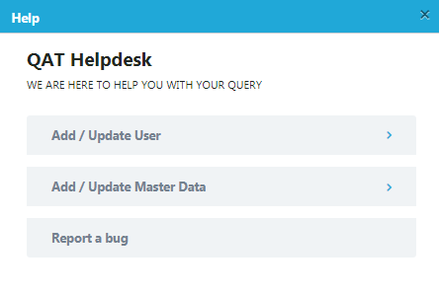

Figure 6.A- Help Desk

1. The screen will be displayed with the three functions: Add/Update User, Add/Update Master Data, and “Report a Bug.”
2. **Add/Update User**
3. Select the “Add/Update User” function.
4. Enter the details as shown below.
5. Mention the notes if required (i.e. if you are Updating a User you could explain why this User needs to change from their current QAT status)
6. Click on the “Submit” button to complete and raise the ticket.

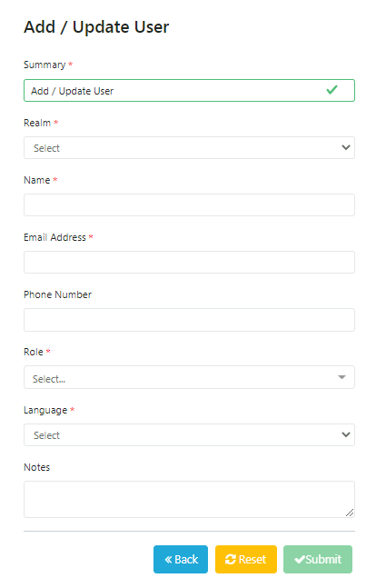

Figure 6.B- Add/Update User

1. **Add/Update Master Data**
2. Select “Add/Update Master Data”.
3. The screen will then ask if you would like to “Add Masters” or “Edit Masters”
4. Once chosen, you will then select the Master Data category in which you would like to add/update.
5. The screen will prompt you to enter all details required for that particular Master Category chosen
6. Click on the “Submit” button. The ticket has now been raised.
7. **Report a bug**

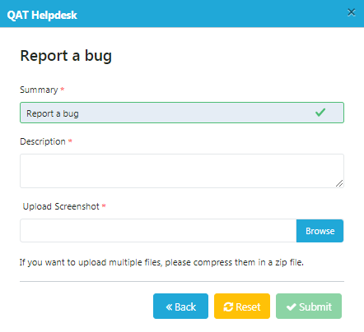

Figure 6- Reporting Bugs

1. Select the “Report a bug”.
2. Enter the description of the Bug/error. Be as descriptive and provide as much detail as possible.
3. Upload a screenshot of the bug by clicking the “Browse” button and pulling a saved screenshot file from your computer.

Click on the “Submit” button to raise the ticket.

# Translations

To ensure that the QAT application is used by every person around the world it has incorporated the feature of translations. QAT covers four different languages: English, French, Portuguese, and Spanish. The translations are further divided into Label Translations and Database Translations as mentioned below:

1. **Translating:**

There are two ways to change the language displayed for the user:

* + 1. There is a pull down menu on the top right corner of the login screen, where users can select their preferred language ahead of syncing and viewing their dashboard

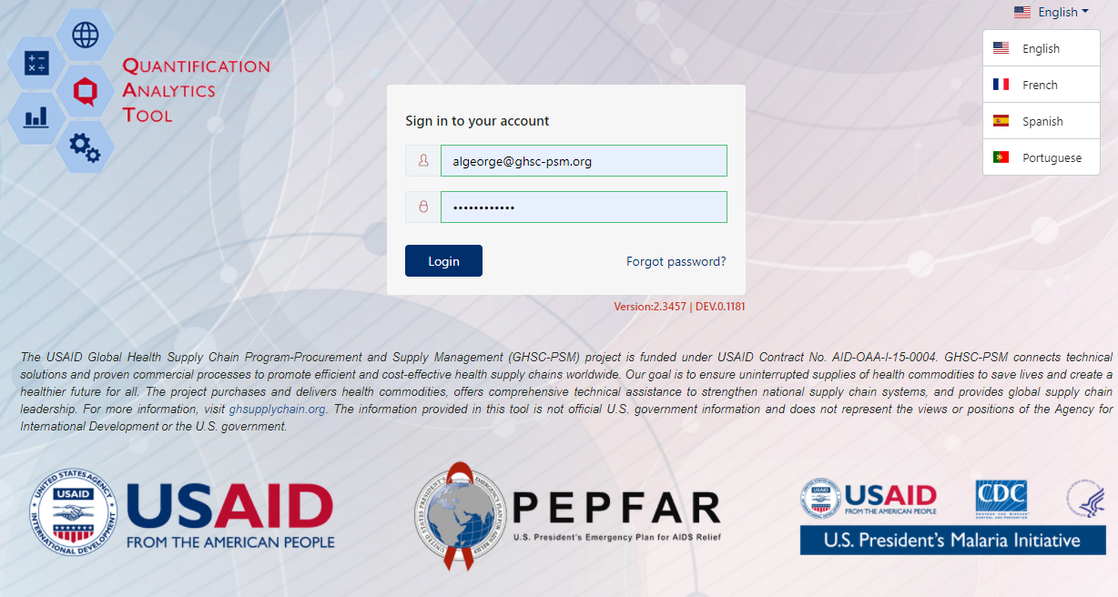

Figure 7.A.1- Translations

* + 1. Once inside the dashboard, go to the profile icon on the top right corner of the screen. Under “Change Preferred Language” select the required translation as shown below:

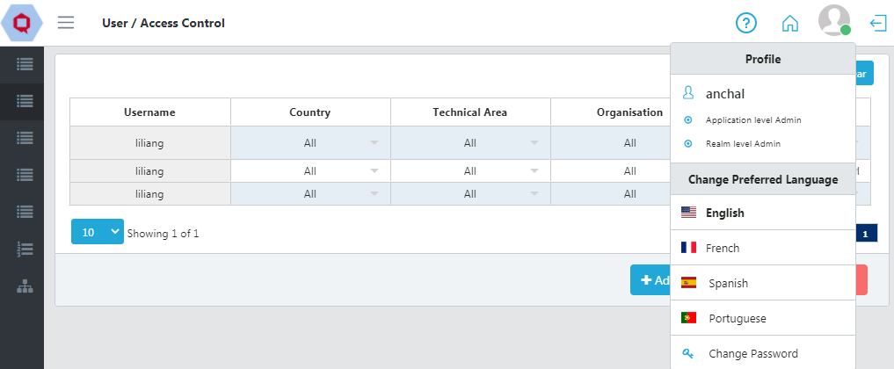

Figure 7.A.1- Translations

1. **Database Translations**

Database translation function is used to translate "Dynamic text" that is stored in the database.

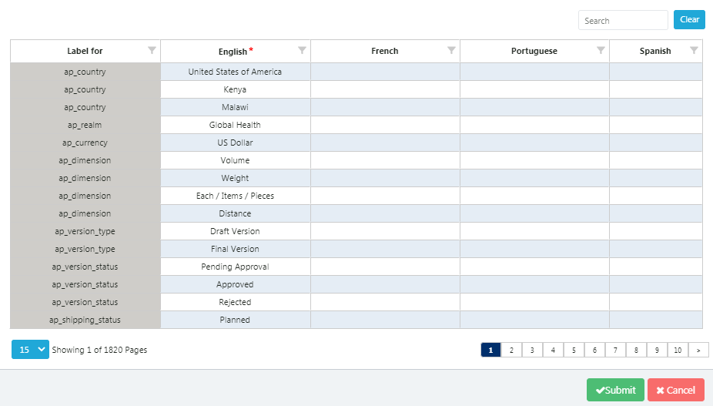

Figure 7.B- Database Translation

1. **Label Translations**

Label translation is used to translate "static text", for example on the "submit" and "cancel" buttons as well as messages such as "Login successful" and "Action Cancelled".

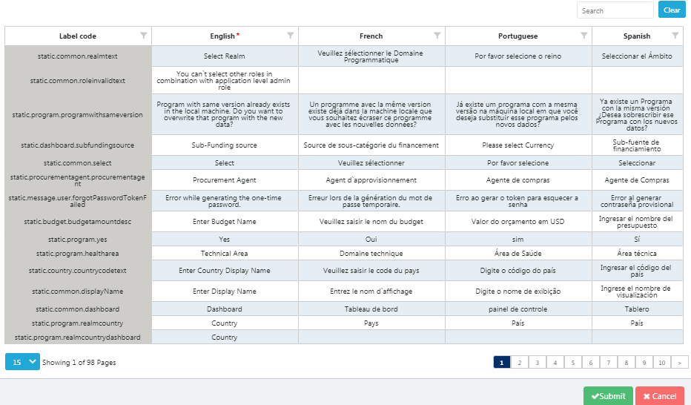

Figure 7-C- Label Translation

# Application Dashboard

The functions in the Application Dashboard will be visible according to the **user’s role**.

In this particular scenario, the role assigned is “Realm Level Admin”. Therefore, the screen shows four sections as number of users, Realms, Languages and Supply Plan. The screen shows Application Dashboard.

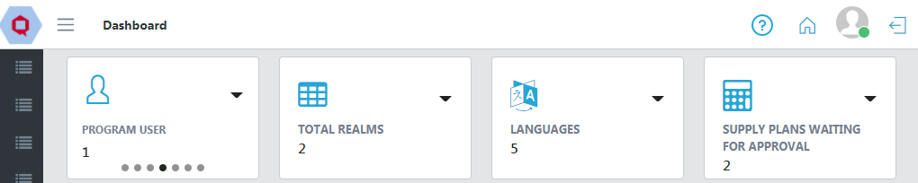

Figure 8- Application Dashboard

1. In the first Program User section there are sliding functions.
2. Click on the pull-down button. There will be two functions i.e. “List User” and “Add User”.
3. Both the “Add User” and “List User” functions will redirect users to the “User” from “Application Masters”.
4. Refer to the “Set Up User” function for the details.

1. **Total Realms**
2. The second section shows “Total Realms”.
3. Click on the pull-down button. There are two functions “Realm List” and “Add Realm” functions.
4. Both functions redirect to the section “Realms” function in the side bar menu.
5. **Realm List**

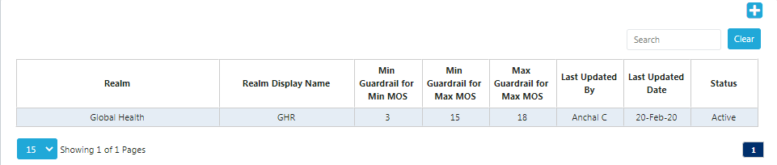

Figure 8.B- Realm List

1. Realm List shows Realm Display Name, Min Months of Stock Min Guardrail, Min MOS Max Guardrail and Max MOS Max Guardrail.
2. To add the Realm refer “Realm” function from Application Masters for the details.
3. **Language**
4. The third function is “Language”.
5. Click on the pull-down button.
6. Both “List Language” and “Add Language” functions redirect users to the “Language” function from the “Application Masters” menu in the sidebar.
7. Refer to The “Language” function from Application Masters for the details.
8. **Supply Plan Waiting for Approval**
9. The fourth function is “Supply Plan Waiting for Approval”.
10. Click on the pull-down button.
11. “View Supply Plan Waiting for Approval” will appear
12. This function redirects you to the “Supply Plan Version and Review” from “Reports” section.
13. Refer to Supply Plan Version and Review from “Working with Program Data” for the details.

# Three Levels of Hierarchy in QAT

The QAT system has **three levels of hierarchy** for conducting operations. The hierarchy levels are as follows:

|  |
| --- |
| **Application Masters > Realm Level Masters > Program Management** |

## Application Masters

## Realm Level Masters covers all the master data for the programs and their supply plans. For example, all programs in the Global Health realm will be governed by the same master data. The Realm Admin will be able to maintain this master data and create programs. Realm Admins will have access to view, create and edit the Technical areas, Planning Units, Organization List and Region List for that specific realm.

## Program Management is the third level of hierarchy in the QAT system. In this, the user can add and update particular programs. Program Admin and Program Users can add and update the program’s data (consumption, inventory, shipments).

## Programs are a combination of Country, Technical Area, and Organization and may have a Region. For example, Fasponia–ARV-MOH-National, is a program under the Global Health Realm for the management and planning of antiretrovirals for the ministry of health of Fasponia, and the consumption and inventory data is captured at a national level (region).

# Application Masters

## Application Masters is the top-most data hierarchy level in the QAT system. This master data applies to all the Realms and Programs within QAT. It consists of functions such as adding/editing/managing countries, currencies, or dimensions. Most of it is only accessible to Application Admins, though a few functions are available to Realm Admins such as adding and updating users and assigning roles to users.

**Application Admins** can select the specific application-wide master data they want to add or update:

# Country

QAT has a list of default countries such as Kenya, but new countries can be added by **an Application Admin**, as needed.

1. To see the countries, go to Application Masters and click on the side arrow.
2. Multiple functions will be shown while scrolling down in that section.
3. Click on “Country” and a List will be shown.

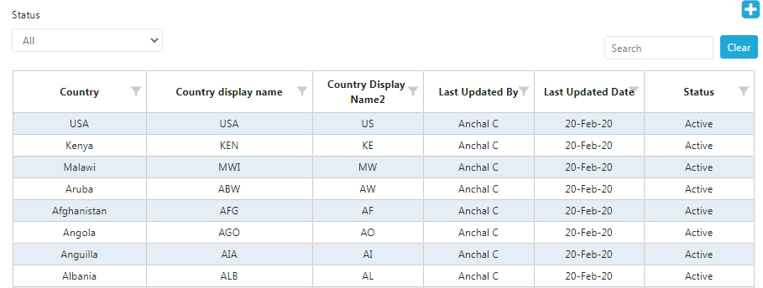

Figure 10.A- Country

1. Select the specific country by using the “Search” function at the top right corner of the list.
2. To select the status (Active” or “Disabled”) click on “Please select” as shown in the screen.
3. **Add Country**

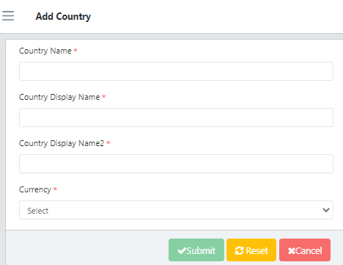

Figure 10.A.a- Add Country

1. Go to the top right corner in the Country List.
2. Click on the blue “add” button below the profile icon.
3. A new screen showing “Add Country” will be opened.
4. Enter the required details and click on the “Submit” button.
5. **Update Country**

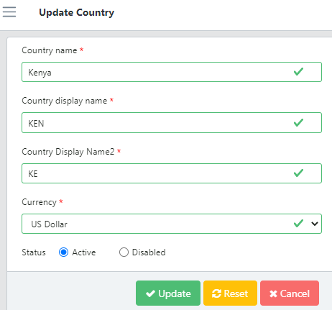

Figure 10.A.b- Update Country

1. To update the Country, go to the Country List.
2. Now click on any function that needs to be changed or updated.
3. Select the required Country and click on “Submit”.

# Currency

Application Masters has a currency function by which the **Application Admin** can view the current conversion rates.

1. Go to Application Masters and Click on the side arrow.
2. Click on “Currency” and a List will be shown.

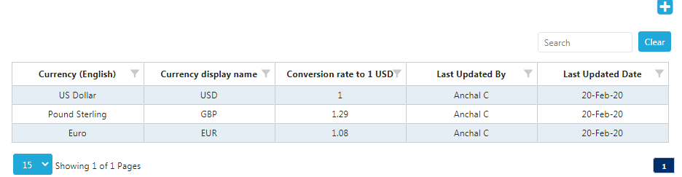

Figure 10.B- Currency

1. Select a specific country by using the “Search” function at the top right corner of the list.
2. **Add Currency**

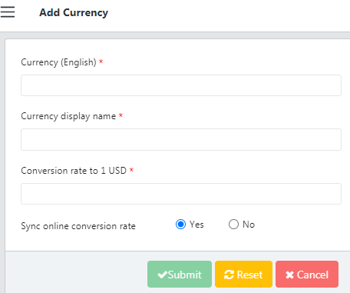

Figure 10.B.a- Add Currency

1. Go to the top right corner in the Currency List.
2. Click on the blue “add” button below the profile icon.
3. A new screen showing “Add Currency” will be opened.
4. Enter the required details and click on the “Submit” button.
5. The conversion rate to 1 USD can be entered manually or it can be obtained from the integration with the public online source by selecting “Yes” on the “Sync online conversion rate” function, which is the default.
6. **Update Currency**

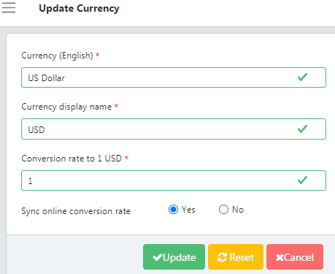

Figure 10.B.b- Update Currency

1. To update the Currency, go to the Currency List.
2. Click on any field that needs to be changed or updated.
3. Click the “Update” button.

# Dimensions

Dimensions denote various measurable values, such as length, volume, weight, or height. Only **Application Admins** can add/edit the master list of dimensions.

1. Go to “Application Masters” and Click on the side arrow.
2. Click on the “Dimension” and a list will be shown.
3. **Add Dimension**
4. Go to the top right corner of the Dimension List.
5. Click on the blue “add” button below the profile icon.

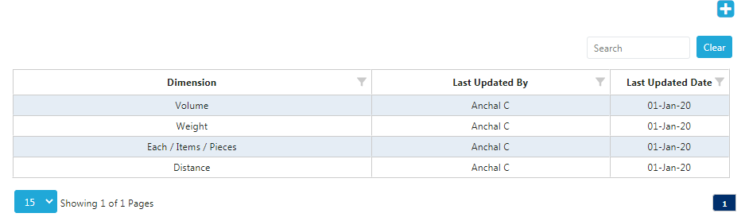

Figure 10.C- Dimension

1. A new screen “Add Dimension” will be opened as shown below:

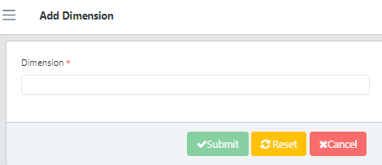

Figure 10.C.a- Add Dimension

1. Enter the required details and click on the “Submit” button.
2. **Update Dimension**
3. To update the Dimension, go to the Dimension List.
4. Now click on any function that needs to be changed or updated.
5. Click on the “Update” button.

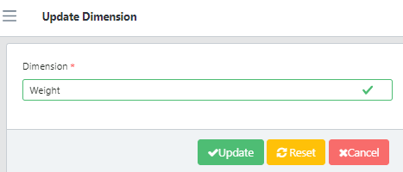

Figure 10.C.b- Update Dimension

# Language

## QAT offers four different languages: English, French, Spanish, and Portuguese. Only Application Admins can add/edit the master list of languages. To manage languages in QAT:

1. Go to Application Masters and click on the side arrow.
2. Click on “Language” and a List will be shown on screen.

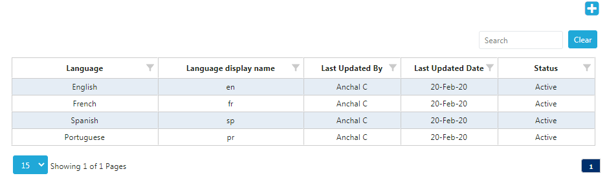

Figure 10.D- Language

1. **Add Language**
2. Go to the top right corner in the Language List.
3. Click on the blue “add” button below the profile icon.
4. A new screen showing “Add Language” will be opened.
5. Enter the required details (Language name, and display name) and click on the “Submit” button.

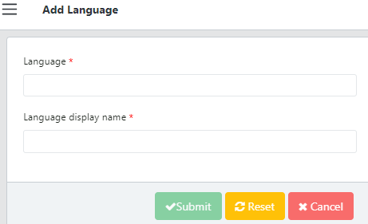

Figure 10.D.a- Add Language

1. **Update Language**
2. To update a language, go to the Language List.
3. Select the required fields that need changing and click on the “Submit” button.

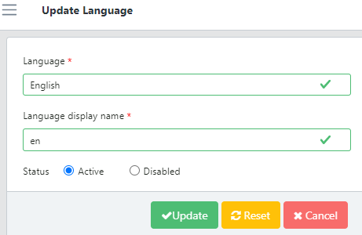

Figure 10.D.b- Update Language

# Realm

Realm defines a domain of activity such as Global Health. A **Realm** governs all the master data for every program and their supply plans. The **Realm Admins** will be able to create Programs. **Realm Admins will have access to Technical areas, Planning Units, Organization List and Region List.**

1. Go to “Application Masters”.
2. Click on “Realm” and a screen will be shown as seen below:

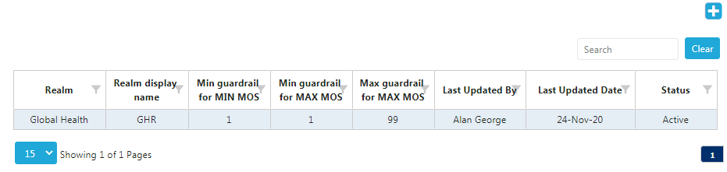

Figure 10.E- Realm

1. **Add Realm**

Adding realms is only available to **Application Admins**.

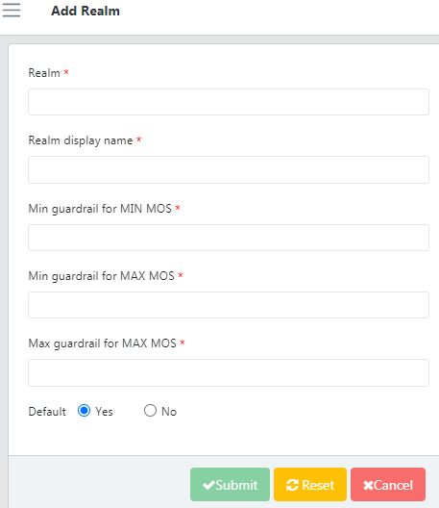

Figure 10.E.a- Add Realm

1. Go to the top right corner in the Realm List.
2. Click on the blue colored add button (+) below the profile icon. The “Add Realm” screen will be opened.
3. Enter the required details and click on the “Submit” button.
4. **Update Realm**

Both **Application Admins and Realm Admins** can edit existing realms.

1. To update, click on any realm on the Realm List.
2. Select any field that needs to be changed or updated.
3. Click on the “Update” button.

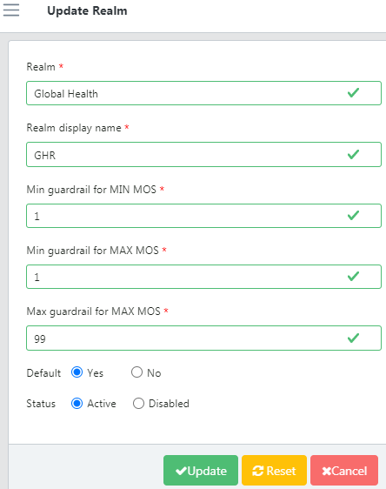

Figure 10.E.b- Update Realm

1. **Add Countries to a Realm**

In the Realm section, **Application and Realm Admins** can add countries to an existing realm:

1. Right click on the specific Realm.
2. Click on “Map countries to this realm” shown below:

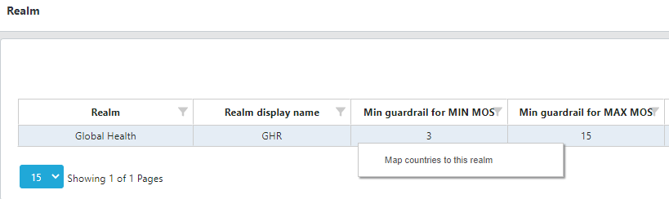

Figure 10.E.c- Map Realm Country

1. Click on the “Add Row” function to add the required information.

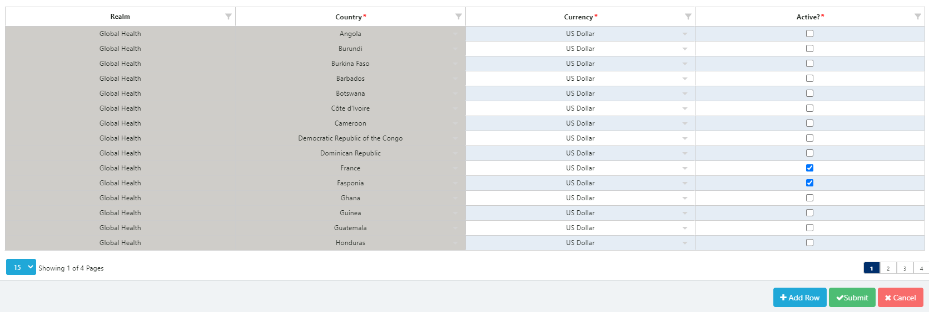

Figure 10.E.c- Add Realm Country

1. Now click on the “Submit” button.

# Unit

Unit is a fixed quantity (in this case a value like mL, gm or even Box) used as a standard of measurement. Only **Application Admins** can add/edit the master list of units available.

1. Go to “Application Masters” and Click on the side arrow.
2. Click on the “Unit” and a list will be shown.

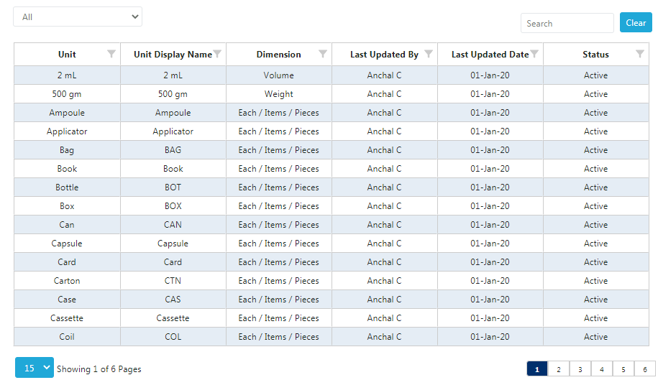

Figure 10.F- Unit

1. **Add Unit**
2. Go to the top right corner in the Unit List.
3. There is a blue add button below the profile icon.

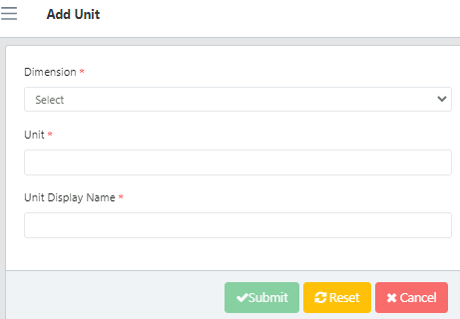

Figure 10.F.a- Add Unit

1. Click on that button and a new “Add Unit” screen will open.
2. Enter the required details and click on the “Submit” button.
3. In case the user wants to add it later click on the “Cancel” button.
4. **Update Unit**
5. To update the Unit, go to the Unit List.
6. Now click on any function that needs to be changed or updated.

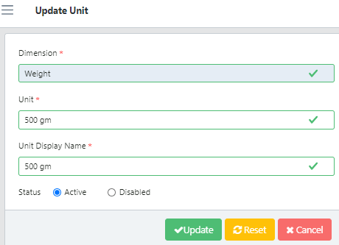

Figure 10.F.b- Update Unit

1. Select the required Dimension, Unit and Select the status.
2. Click on “Update” to submit changes or Cancel it if you don’t want to update.

# Realm Level Masters

The QAT application is subdivided into Realms, each with their own master data (inclusive of product catalog, funder names, procurement agent names, etc.) Realm is the second level of hierarchy in the QAT system.

A Realm covers all the programs and their supply plans. For example, “Global Health” is a Realm under which various programs are managed. Other realms could be set up for other fields such as education supply chains, agriculture supply chains, etc.

# Realm Country

**Application Admin** and **Realm Admin** can create/edit the realm country.

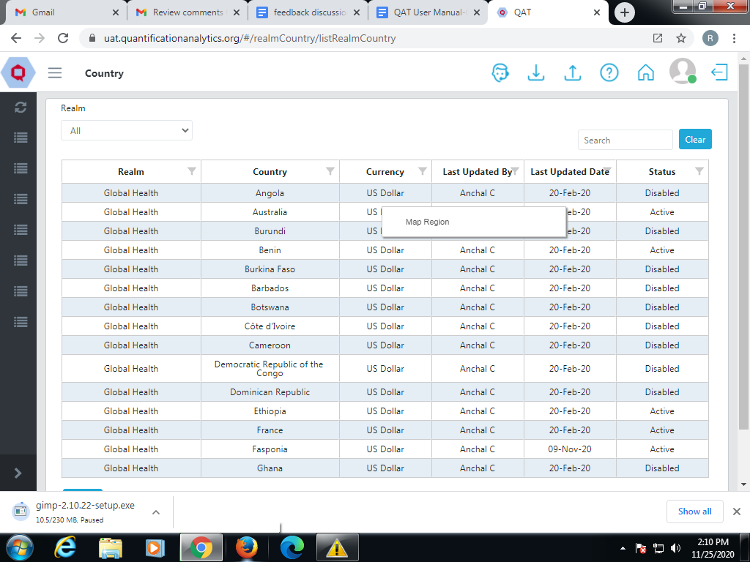

Figure 11.A- Realm Country

1. Go to “Realm Level Masters”.
2. Click on “Country” and the above screen will be shown.
3. Right click on a specific country that needs to be updated.
4. **Realm Country Region**

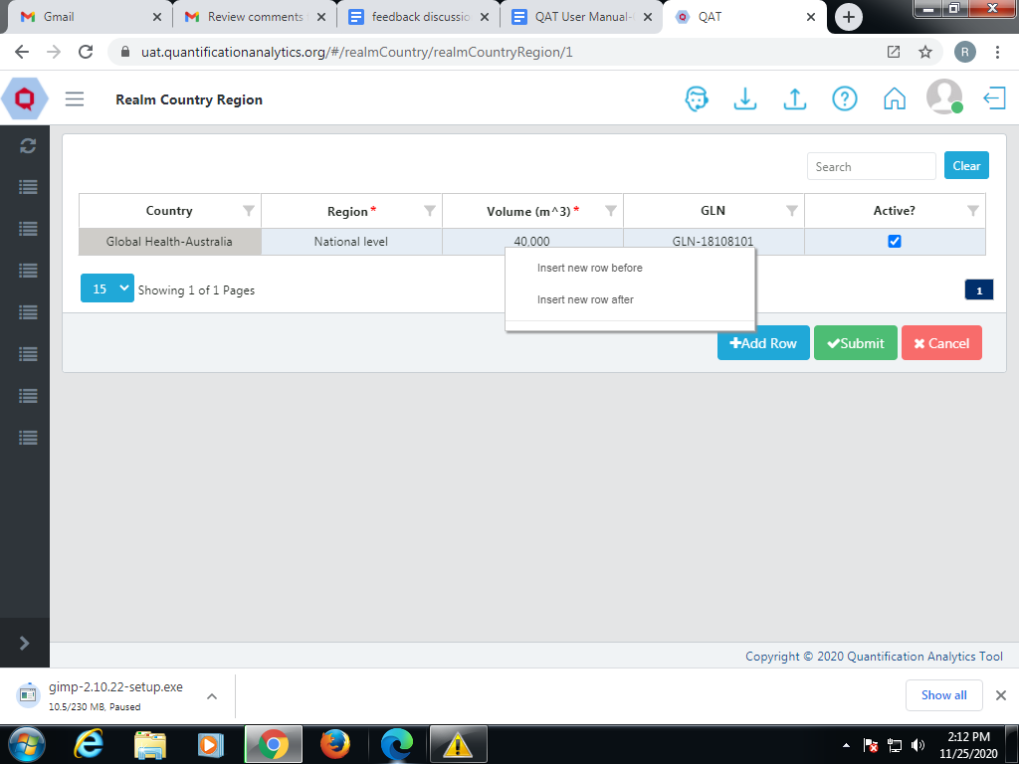

Figure 11.A.a- Realm Country

1. It will show the function “Map Region”.
2. Click on “Map Region”.
3. Right click on the cell of that country.
4. It offers two functions: “Insert new row before” and “Insert new row after”.
5. Click on the “Insert new row before” function.
6. A new row is added to the table.

OR

1. Click on the “Add Row” function to add the data.
2. Now click on the “Submit” button.

# Data Source

A data source is the location where data that is being used originates from. **Application and Realm Admins** can add/edit Data source.

The user can select different data sources from the list given below:

1. Go to “Realm Level Masters” and Click on the side arrow.
2. Click on “Data Source” and a list is shown.

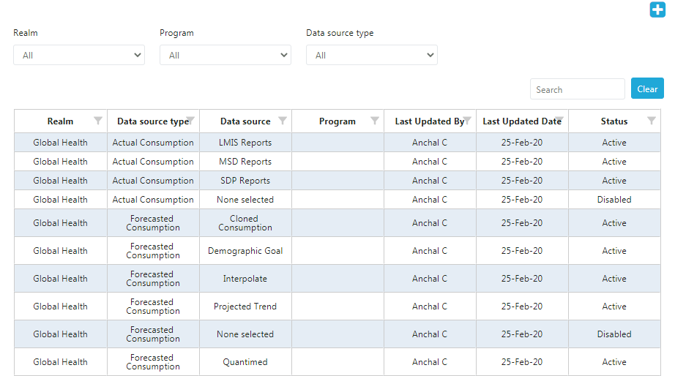

Figure 11.B- Data Source

1. Select the status (Active” or “Disabled”) as shown in the screen.
2. **Add a Data Source** 
   1. Go to the top right corner in the List.
   2. Click on the blue “Add” button below the profile icon.

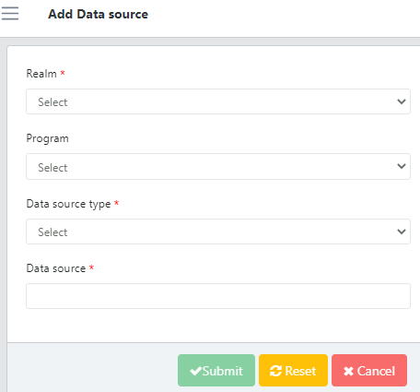

Figure 11.B.a- Add Data Source

* 1. A new screen showing “Add Data Source” appears.
  2. Enter the required details and click on the “Submit” button.
  3. Click on the “Cancel” button to not add the data source.

1. **Update Data Source**

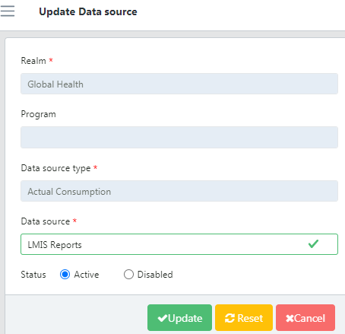

Figure 11.B.b- Update Data Source

1. To update the Data Source, go to the Data Source List.
2. Click on any function that needs to be changed or updated.
3. Type the required Data Source and the status; click on “Update”.

# Data Source Type

The QAT system has a Data Source Type for certain Realms. **Application and Realm Admins** can add/edit Data Source Type.

For example, ACTCON, which stands for actual consumption, is the Data Source Type for Global Health as shown below:

1. Go to “Realm Level Masters” and click on the side arrow.
2. Click on “Data Source Type” and a List will be shown.

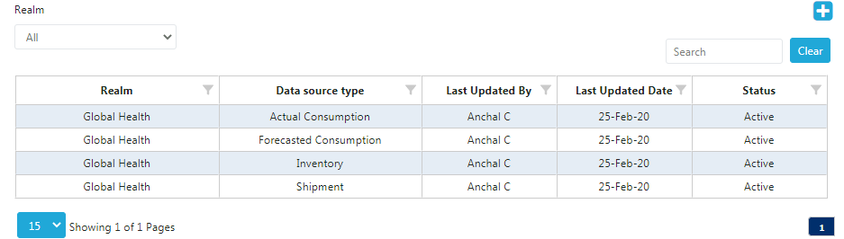

Figure 11.C- Data Source Type

1. Select the status (Active” or “Disabled”) as shown in the screen.
2. **Add Data Source Type**
3. Go to the top right corner in the Data Source Type List.
4. Click on the blue “add” button below the profile icon.

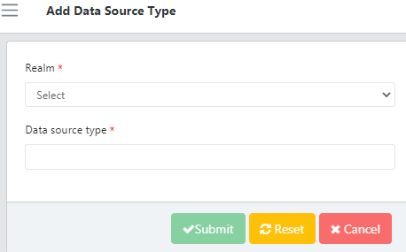

Figure 11.C.a- Add Data Source Type

1. A new screen showing “Add Data Source Type” will be opened.
2. Enter the required details and click on the “Submit” button.
3. **Update Data Source Type**
4. To update the Data Source Type, go to the Data Source Type List.

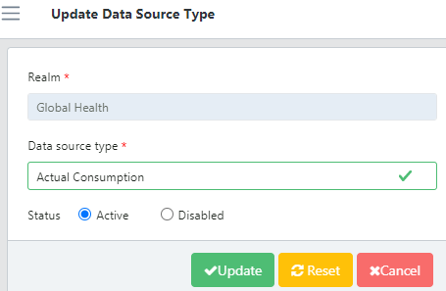

Figure 11.C.b- Update Data Source Type

1. Click on any function that needs to be changed or updated.
2. Select the required Data Source Type and click on the “Update” button.

# Funding Source

Funding Source is any financial institution or other entity providing funding or facilities for the organization. **Application and Realm Admins** can add/edit Funding Source.

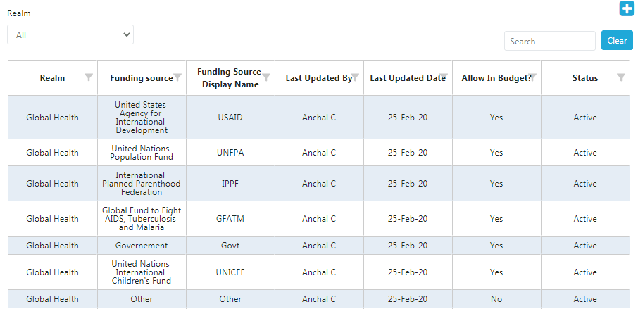

Figure 11.D- Funding Source

1. Go to “Realm Level Masters” and click on the side arrow.
2. Click on “Funding Source” and Funding Source List will be shown.
3. **Add Funding Source**

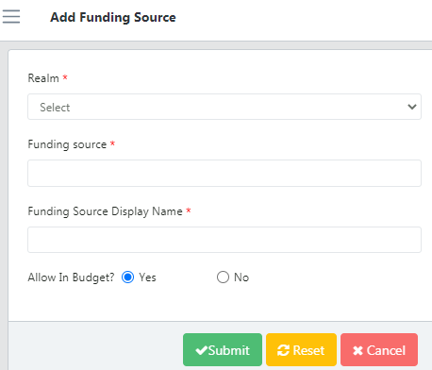

Figure 11.D.a- Add Funding Source

1. Go to the top right corner in the Funding Source List.
2. Click on the blue “add” button below the profile icon.
3. A new screen showing “Add Funding Source” opens.
4. Enter the required details and click on the “Submit” button.
5. **Update Funding Source**

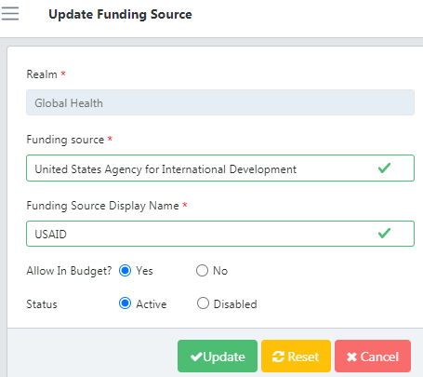

Figure 11.D.b- Update Funding Source

1. To update the Funding Source, go to the Funding Source List.
2. Now click on the function that needs to be changed or updated.
3. Enter the required Funding Source and click on the “Update” button.

# Manufacturer

**Only Application** can view/add/edit the manufacturer.

1. Go to “Realm Level Masters” and Click on the side arrow.
2. There are multiple functions in that section.
3. Click on the function named “Manufacturer” and a list will be shown.

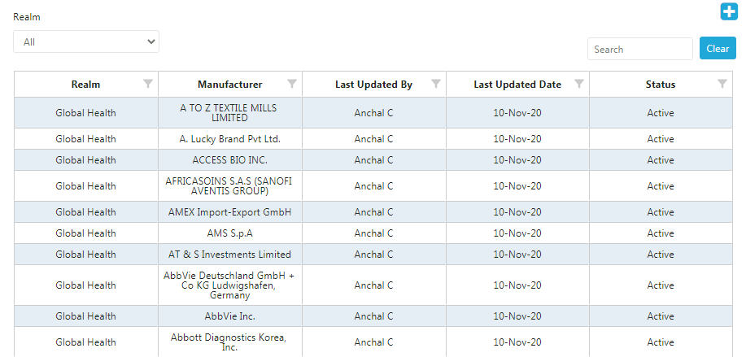

Figure 11.E- Manufacturer

1. **Add Manufacturer**

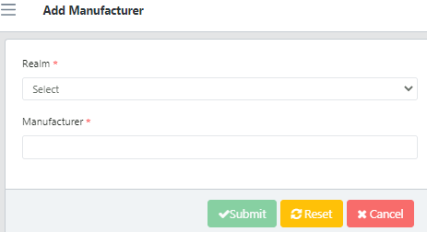

Figure 11.E.a- Add Manufacturer

1. Now go to the top right corner in the list of Manufacturers.
2. Click on the blue “add” button.
3. A new screen of “Add Manufacturer” will be opened.
4. Enter the required details.
5. Now click on the “Submit” button. In case the user wants to add it later click on the “Cancel” button.
6. **Update Manufacturer**
7. To update the Manufacturer, go to the Manufacturer list and click on any function that needs to be changed or updated.

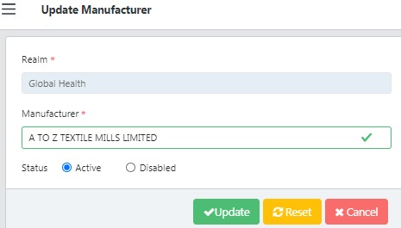

Figure 11.E.b- Update Manufacturer

1. Enter the required details.
2. Click on the “Update” button to save the changes.

# Organization

An organization is a group of people with a particular purpose, which can be a private or government body. **Application, Realm Admins, Program Admin, Program User and Guest User** can list/view organization.

1. Go to “Realm Level Masters” and click on the side arrow.
2. Click on the function “Organization” and a list will be shown.

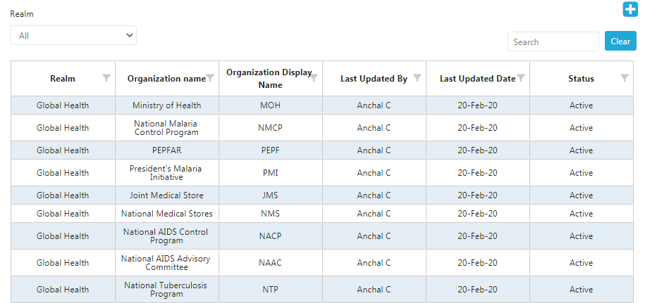

Figure 11.F- Organization

1. **Add Organization**
2. Now go to the top right corner in the list of Organization.
3. Click on the blue” add” button.

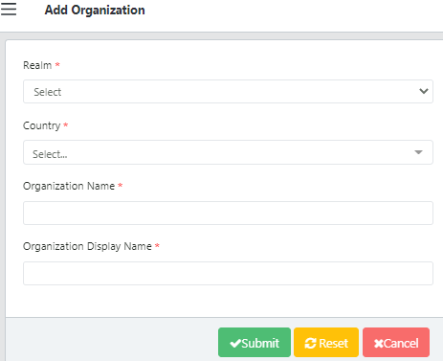

Figure 11.F.a- Add Organization

1. A new “Add Organization” screen will be opened.
2. Enter the required details.
3. Click on the “Submit” button.
4. **Update Organization**

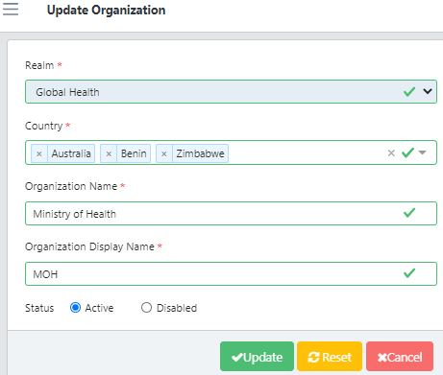

Figure 11.F.b- Update Organization

1. To update the Organization, go to the Organization list and click on any function that needs to be changed or updated.
2. Edit the required information.
3. Click on the “Update” button to save the changes.

# Product

Important Terms for Alternate Reporting Unit:

|  |  |
| --- | --- |
| GTIN | Global Transaction Identification Code |
| SKU Code | Stock Keeping Unit |

1. **Alternate Reporting Unit**

The Alternate Reporting Unit is a planning unit mapped within a Particular Country / Realm. **Application, Realm Admins, Program Admin** can list/view Alternate Reporting Unit.

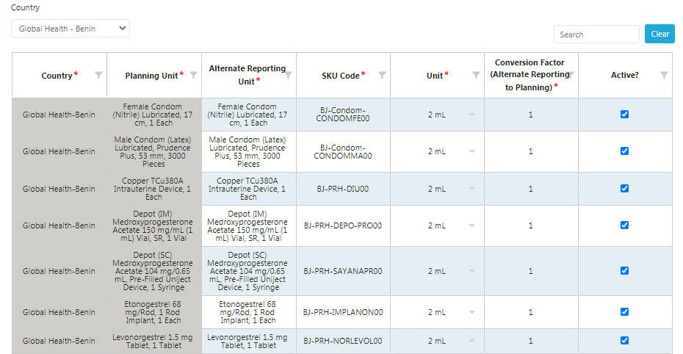

Figure 11.G- Map Alternate Reporting Unit

1. Go to “Realm Level Masters” and Click on “Product”.
2. Click on “Alternate Reporting Unit” in that section.
3. Select the Realm Country.
4. The above screen displays the data for that specific country.
5. **Add Alternate Reporting Unit**

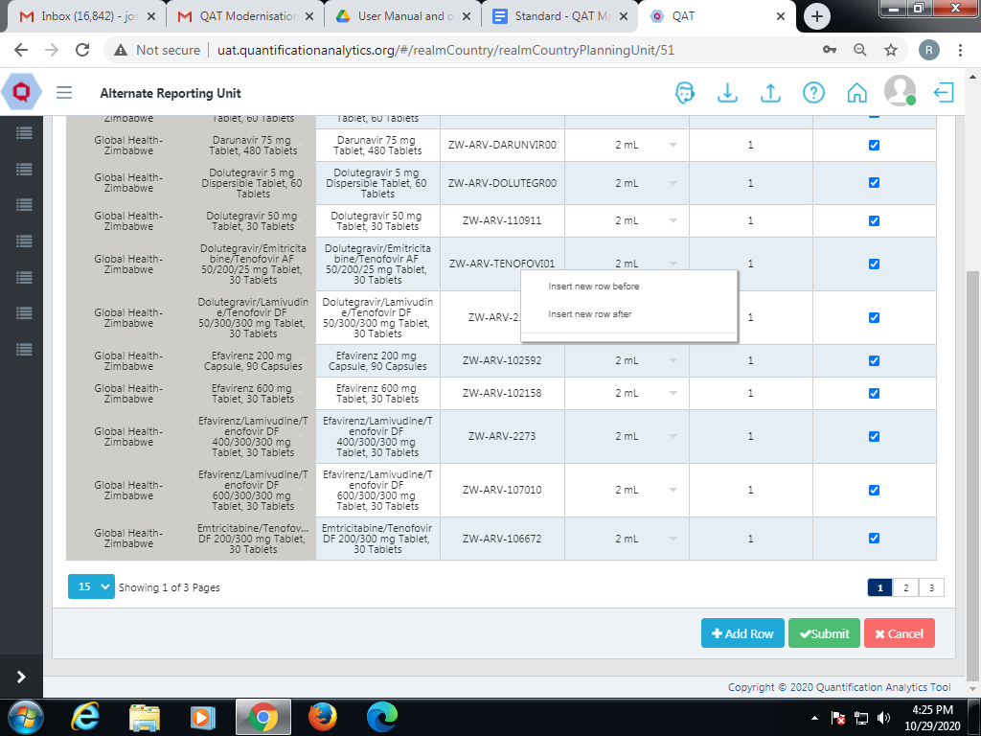

Figure 11. G.1a- Add Alternate Reporting Unit

1. Go to the top right corner in the Alternate Reporting Unit List.
2. There is a blue “add” button below the profile icon.
3. Click on that button and a new screen will be opened.
4. The user can right click on the specific cell.
5. Click on either the “Insert row before” or “Insert row after” function.
6. The user can also click on the “Add Row” function at the bottom to insert new rows.
7. Enter the details in the newly created row and click on “Submit”.
8. **Forecasting Unit**

It is a base unit that will be used for specified forecasting period. **Application Admin and Realm Admins** can add/edit Forecasting Unit.

1. Go to “Realm Level Masters” and Click on “Product”.
2. Click on the function “Forecasting Unit” and a list will be shown.

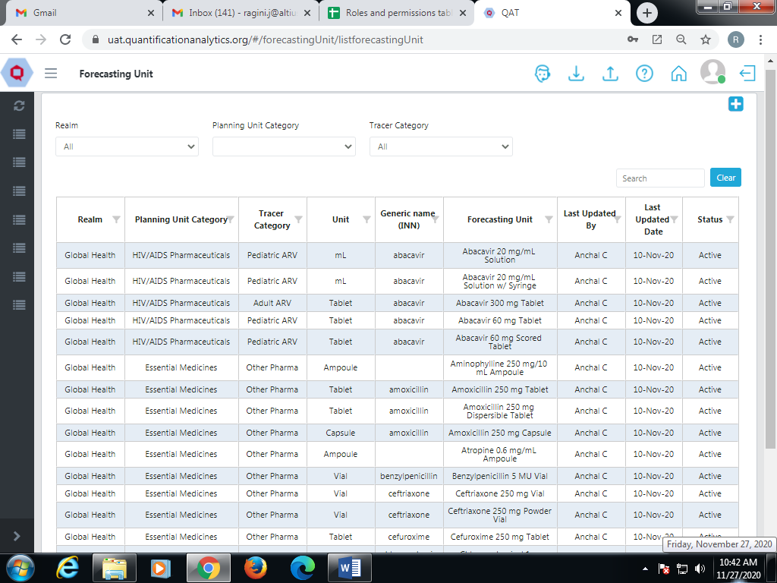

Figure 11.G- Forecasting Unit

* 1. **Add Forecasting Unit**

1. Go to the top right corner in the Forecasting Unit List.
2. There is a blue “add” button below the profile icon.
3. Click on that button and a new screen called “Add Forecasting Unit” will be opened.

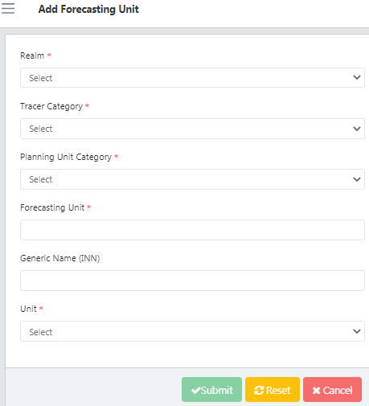

Figure 11. G.2a- Add Forecasting Unit

1. Enter the required details.
2. Click on the “Submit” button.
3. **Update Forecasting Unit**

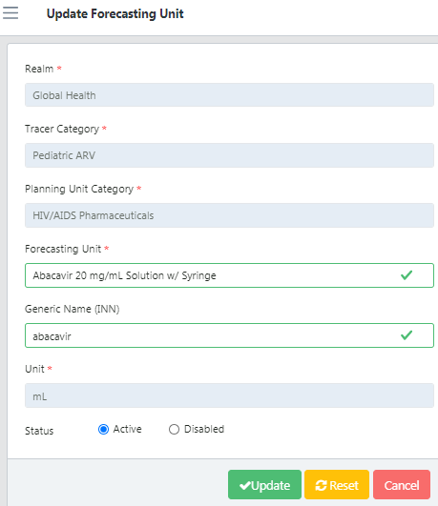

Figure 11. G.2b- Update Forecasting Unit

1. To update the Forecasting Unit, go to the Forecasting Unit List.
2. Click on any function that needs to be changed or updated.
3. Edit the required information.
4. Click on “Update” to save the changes.
5. **Planning Unit**

It is the product to be planned for in QAT. **Application Admins and Realm Admins** add/edit Planning Unit.

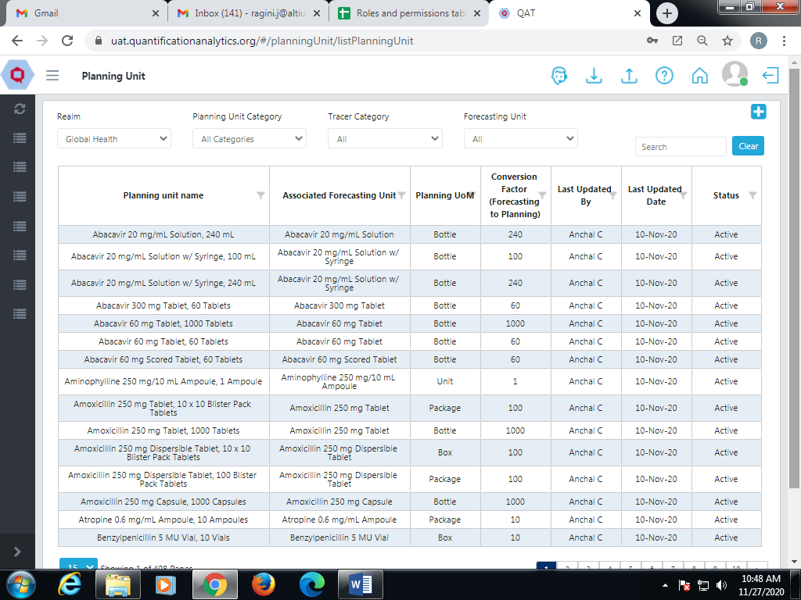

Figure 11.G- Planning Unit

1. Go to “Realm Level Masters” and Click on “Product”.
2. Click on the function “Planning Unit” and a list will be shown.
3. **Map Planning Volume**
4. Right click on the specific cell.
5. The function “Map Volumes” will be displayed.
6. Click on that function and a new screen will be opened.
7. Right click on the cell to insert or delete the row.
8. Enter the required details in the newly added row.
9. Click on the “Submit” button.

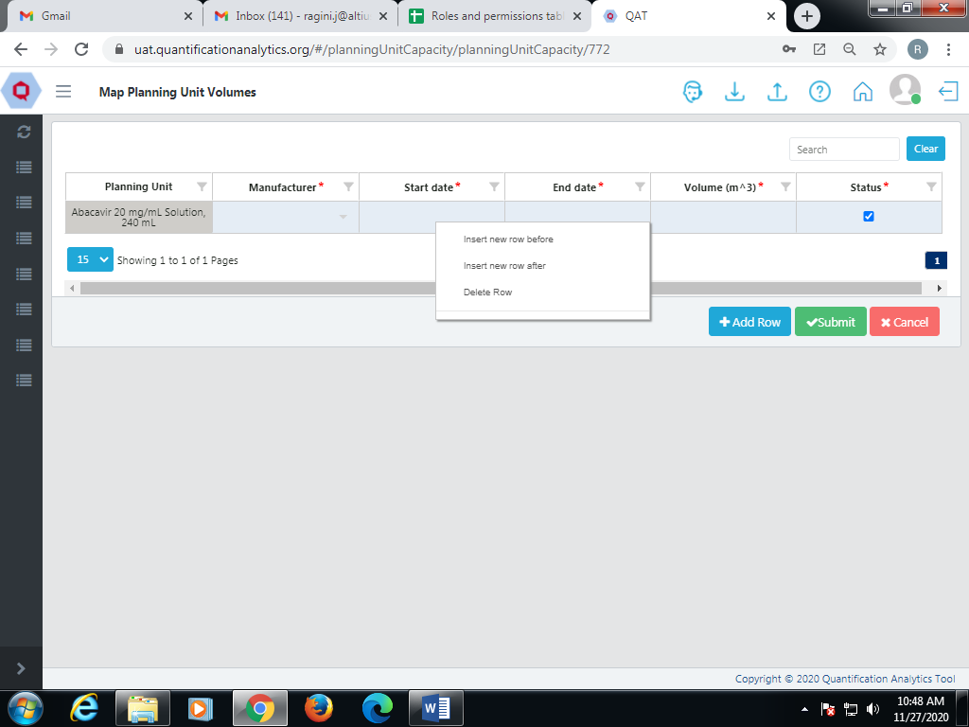

Figure 11. G.3a- Map Planning Volume

1. **Add Planning Unit**
2. Go to the top right corner in the Planning Unit List.
3. There is a blue “add” button below the profile icon.
4. Click on that button and a new screen called “Add Planning Unit” will be opened.

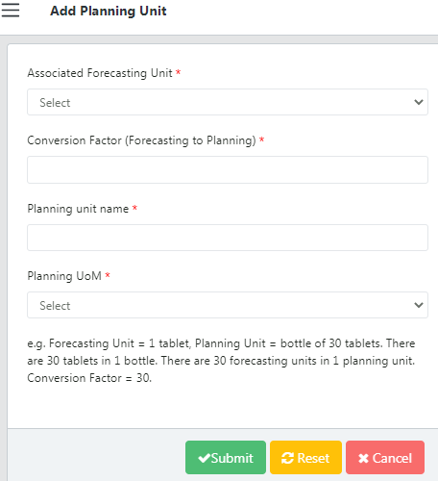

Figure 11. G.3b- Add Planning Unit

1. Enter the details and click on the “Submit” button.
2. **Update Planning Unit**
3. To update the Planning Unit, go to the Planning Unit List.
4. Click on any function that needs to be changed or updated.

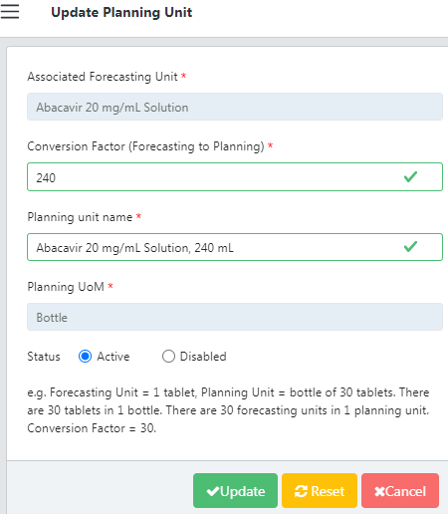

Figure 11.G.c- Update Planning Unit

1. Select the required Forecasting Unit, Planning Unit, and the Multiplier.
2. Click on the “Update” button to save the changes.
3. **Planning Unit Category**

A product refers to the types of stock available for different categories. It can be a medicine or medical device or medical implant used in the category where it's needed. **Application Admins and Realm Admins** add/edit Planning Unit Category.

1. Go to “Realm Level Masters” and Click on “Product”.
2. Select “Planning Unit Category”
3. The screen will show the Realm section as shown in the figure below:

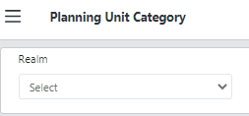

Figure 11.G- Planning Unit Category

1. **Adding a new Planning Unit Category**
2. The user can see the tree-view for each category.
3. The Planning Unit Tree View function allows the user to modify product data.
4. Click on the “Add” button to add a new category.
5. The user can drag a particular category and adjust in the tree view.

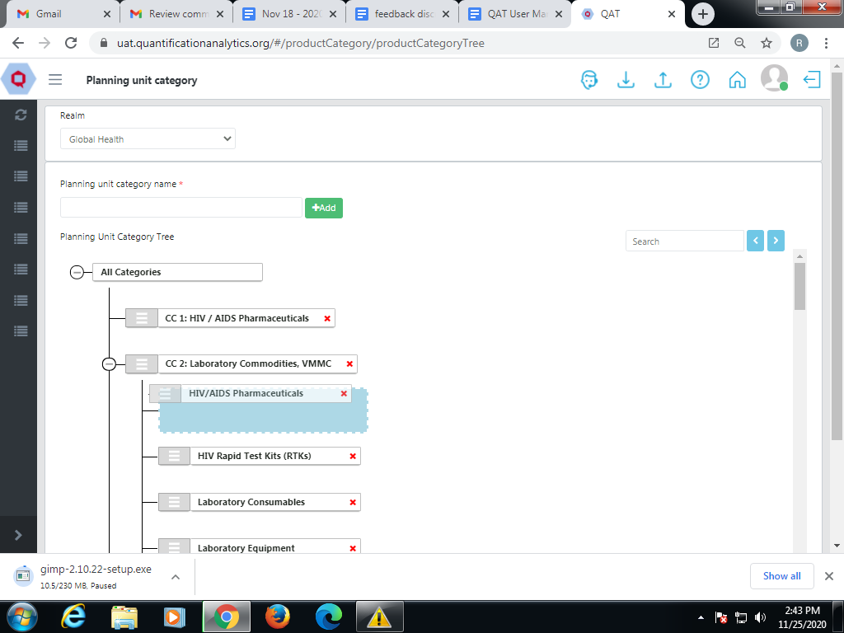

Figure 11. G.4a- Add Planning Unit Category

1. **Planning Unit Volume**

The user can view the information for a particular planning unit. The user cannot create/add/edit the table. **Application** **Admins** add/edit Planning Unit Volume.

**Note**: It is read only tab.

1. Go to “Realm Level Masters” and Click on “Product”.
2. Click on the function “Planning Unit Volume” and a list will be shown.

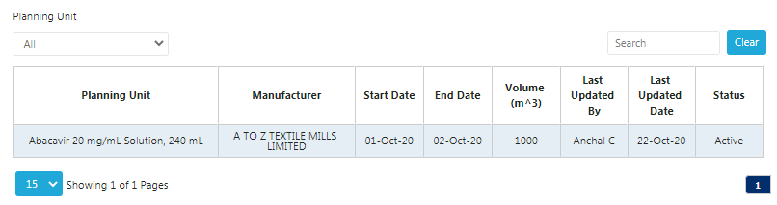

Figure 11.G.5- Planning Unit Volume

1. **Procurement Unit**

Procurement unit: Procurement unit is a Planning unit mapped to a particular procurement agent. **Application** **Admins and Realm Admins** add/edit Procurement Unit.

1. Go to “Realm Level Masters” and Click on “Product”.
2. Click on the function “Procurement Unit” and a list will be shown.
3. **Add Procurement Unit**

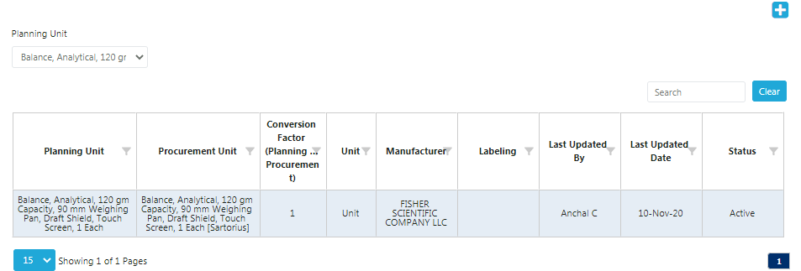

Figure 11. G.6a- Add Procurement Unit

1. Go to the top right corner in the Procurement Unit List.
2. Click on the blue add button below the profile icon.
3. A new “Add Procurement Unit” screen will be opened.

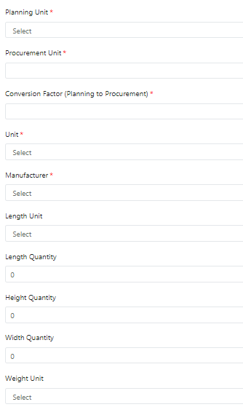

Figure 11. G.6a - Add Procurement Unit - 1

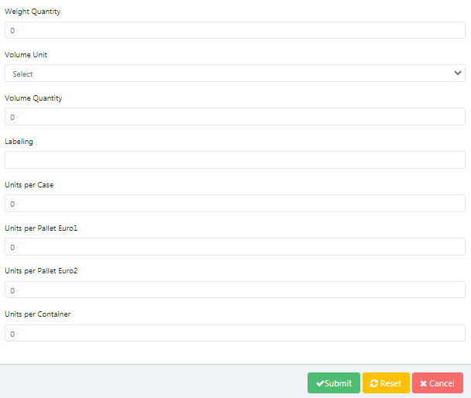

Figure 11. G.6a - Add Procurement Unit - 2

1. Enter the details and click on the “Submit” button.
2. **Update Procurement Unit**
3. To update go to the Procurement Unit List.
4. Click on any function that needs to be changed or updated.
5. Edit the required information.
6. Click on the “Update” button to save the changes.

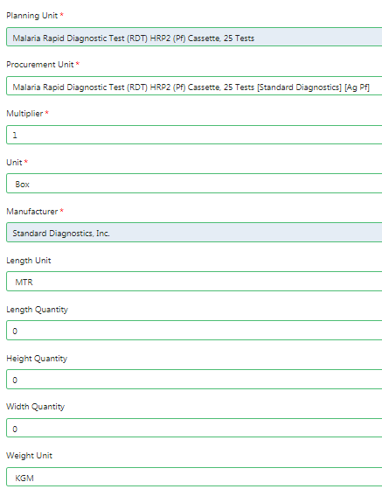

Figure 11. G.6b- Update Procurement Unit - 1

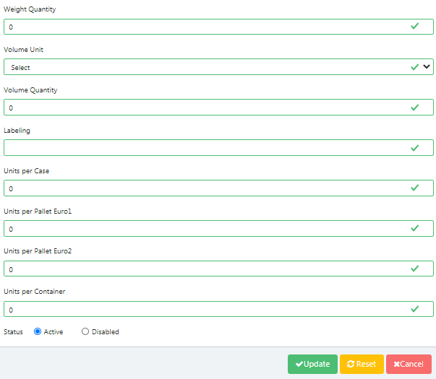

Figure 11. G.6b- Update Procurement Unit - 2

1. **Tracer Category**

In the QAT system, the Tracer Category is mapped to a particular Realm. For example, 1- Rod Implantable Hormonal Contraceptives Placebos are mapped to Global Health. **Application** **Admins and Realm Admins** add/edit Tracer Category.

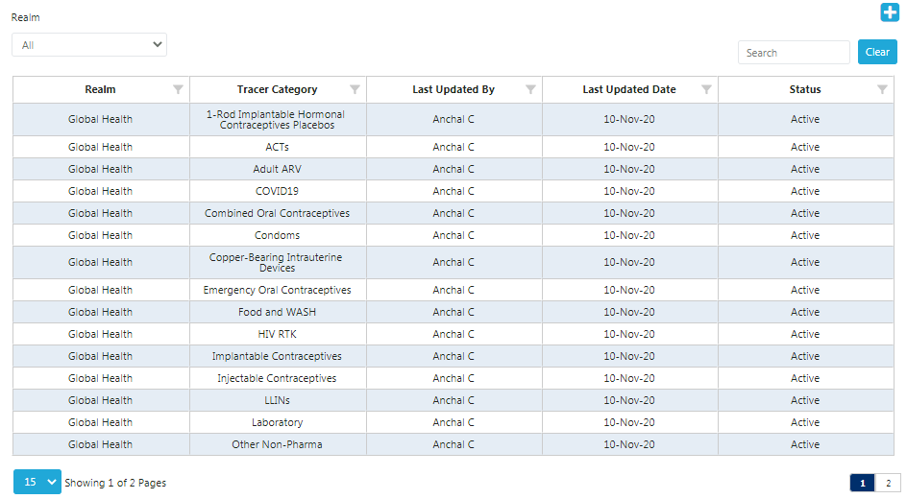

Figure 11. G. 7- Tracer Category

1. Go to “Realm Level Masters” and Click on “Product”.
2. Click on the function “Tracer Category” and a list will be shown.
3. **Add Tracer Category**
4. Go to the top right corner in the Tracer Category List.

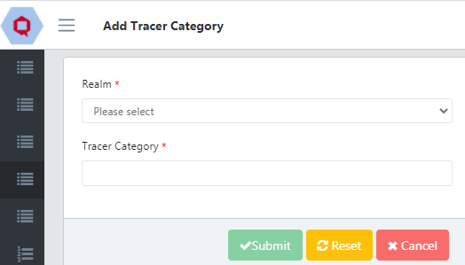

Figure 11. G. 7a- Add Tracer Category

1. There is a blue “add” button below the profile icon.
2. Click on that button and a new “Add Tracer Category” screen will be opened.
3. Select the Realm and add the Tracer Category.
4. Now click on the “Submit” button.
5. **Update Tracer Category**
6. To update the Tracer Category, go to the Tracer Category List.
7. Click on any function that needs to be changed or updated.
8. Select the required Realm, Tracer Category, and current status.
9. Now click on the “Update” button to save the changes.

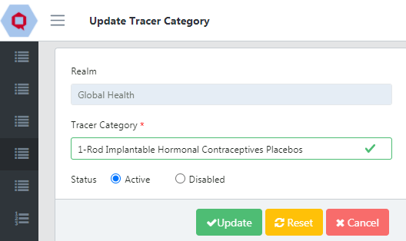

Figure 11. G. 7b- Update Tracer Category

# Technical Area

Technical Area specifies the medical condition or procedure according to the required program. **Application** **Admins and Realm Admins** add/edit Technical Area.

1. Go to “Realm Level Masters” and click on the side arrow.
2. Click on “Technical Area” and a List will be shown to you.

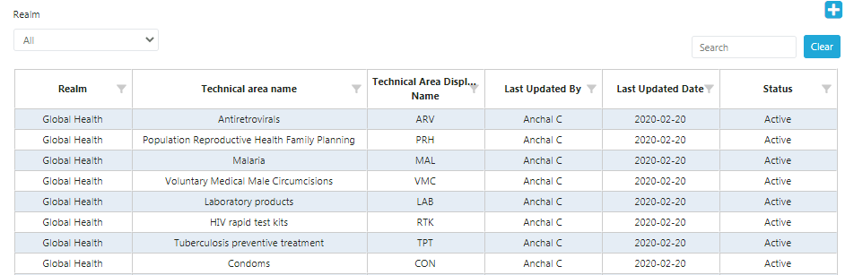

Figure 11.H- Technical Area

1. To select the status (Active” or “Disabled”) on the screen.
2. **Add Technical Area**

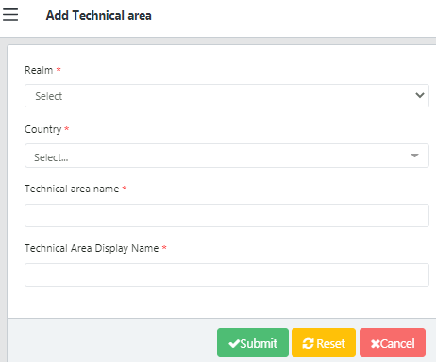

Figure 11.H.a- Add Technical Area

1. Go to the top right corner in the Technical Area List.
2. Click on the blue “add” button below the profile icon.
3. A new screen showing “Add Technical Area” will open.
4. Enter the required details and click on the “Submit” button.
5. In case the user wants to add it later click on the “Cancel” button.
6. **Update Technical Area**

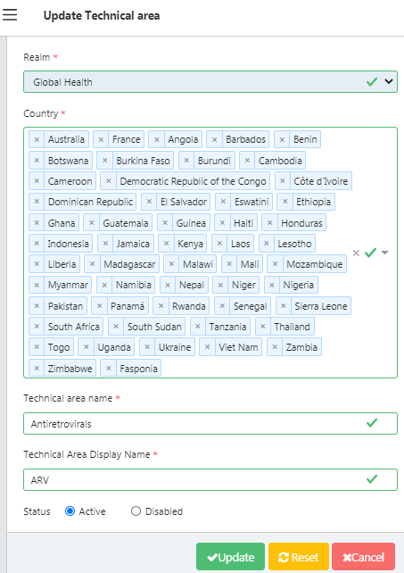

Figure 11.H.b- Update Technical Area

1. To update the Technical Area, go to the Technical Area List.
2. Now click on any function that needs to be changed or updated.
3. Select the required Country and click on the “Submit” button.

# Setup Program

## Introduction

Program is a combination of Country, Technical Area, and Organization and it may have one or more Regions. If Region is not specified, it will be set as “National” by default.

For example,

|  |  |  |  |
| --- | --- | --- | --- |
| **Country** | **Technical Area** | **Organization** | **Region** |
| Ethiopia | Malaria | Bill Gates Foundation | East-North |
| **OR** | | | |
| **Country** | **Technical Area** | **Organization** | **Region** |
| Zimbabwe | ARV | MOH |  |

In the above table, the first “Program” set is [Ethiopia – Malaria – Bill Gates Foundation – East-North]. While the second program is [Zimbabwe – ARV – MOH – National] (since the region is not specified).

Users may set up more than one program depending on their product management requirements.

**When setting up a Program, there at least one user must be assigned the Program Admin role so that this user(s) can set up the specific parameters within the program as detailed in the next section.**

To set up a particular program the user must log into QAT.

## Lead Times

Program default lead times are used to calculate procurement actions for needed

Quantities. A lead time is the latency between the initiation and completion of a process. For example, the lead time between the placement of an order and delivery of new products might be between 2 weeks and 6 months, depending on various particularities such as procurement time, availability, etc.

Default lead times are also used for shipments from suppliers without entered lead times and without entered shipment lead time dates.

* The **Plan to submit** field shows the estimated lead time (in months) expected from the time a shipment is planned when it is ordered.

Click in the Plan to submit field, delete the default value, and type the lead time.

* The **Order to Ship** field shows the estimated lead time (in months) expected from the time a shipment is ordered to when it is shipped. To change the default—

Click in the Order to Ship field, delete the default value, and type the order to

ship lead time.

* The **Ship to Receive** field shows the estimated lead time (in months) from the time a shipment is shipped to when it is received by the program. To change the default—

Click in the Ship to Receive field, delete the default value, and type the ship to

receive lead time.

## Set up Program

Setting up a Program means to set up the whole structure by adding specific Realm, Country, Technical Area, Organization, Region, Program Data, and Planning Unit.

Following are the details of terms used in adding/updating the program:

|  |  |
| --- | --- |
| Realm | the QAT application is subdivided into Realms, each with their own master data (inclusive of product catalog, funder names, procurement agent names, etc.) |
| Country | Represents country in which Program is managed |
| Technical Area | Indicates different technical clusters to group  specific service delivery activities. |
| Organization | Various organizations in a country may be involved in conducting service delivery activities, for example, the Ministry of Health (MOH) |
| Region | Defines a specific region(s) in the country. If not specified, by default Region is set to National |
| Program | Represents Country, Technical Area, Organization and Region |
| Program Manager | Registered user who manages the Program |
| Air Freight % | Default % applied to estimate Air Freight |
| Sea Freight % | Default % applied to estimate Sea Freight |
| Reorder Interval | Interval between orders to be placed to replenish the inventory to Maximum Months of Stock |
| Minimum Months of Stock | It shows the minimum level of stock which should be available at any given time in the normal course of business. |
| Plan draft lead times in months | Time required to "Plan the Draft " which specifies quantity of medicines, mode of shipping the medicines, etc. |
| Planned to submitted lead times in months | Time required to submit the draft supply plan to the respective Organization |
| Submitted to approved lead times in months | Time required to approve the draft submitted to that Organization |
| Approved to shipped lead times in months | Time required to Ship the medicines approved by the Organization |
| Shipped to arrived air lead times in months | Time required to ship medicines via air transport (Airplane) to that country |
| Shipped to arrived sea lead times in months | Time required to ship medicines via sea (ship) to that country |
| Arrived to received lead times in months | Time elapsed between "Medicines arrived in a given country / location" and " Medicines received by Warehouse" |
| Months in the past for AMC and Months in the Future for AMC | Default number of ( Past / Future ) months to use when calculating "Average monthly Consumption" |

Table 12.C- Function Details

**To set up a new Program follow the given steps:**

This is available to **Application and Realm Administrators only**. There are two ways to add a new program as shown below:

1. Go to “Program Management” from the sidebar menu.
2. Click on setup Program.

OR

1. Go to Program Management.
2. Now click on “Update Program Info”.
3. Go to the top right corner in the List
4. Click on the blue “add” button below the profile icon
5. That button will redirect the user to “Set Up Program”.
6. The “Setup Program” screen will display a series of functions.
7. Fill in the Realm section and click on “Next”
8. It will lead to the Country section.
9. Enter the name of the country and click on “Next”.
10. In the section of Technical Area put the condition such as Malaria, Family Planning, etc. Click on “Next”.
11. Similarly designate the Organization and Region. Go to the next function.
12. In the case of the Program Data and Planning Unit, enter all the details as mentioned above. To make changes in the previous sections you can click on the “Previous” button.
13. Now click on the “Submit” button to save the new Program.

**Realm**

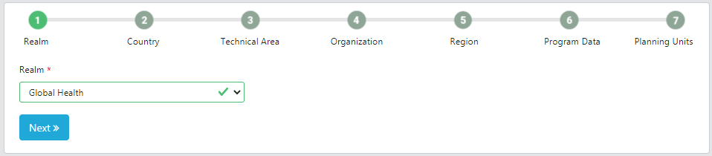

Figure 12.C.1- Set up Program - Realm

**Country**

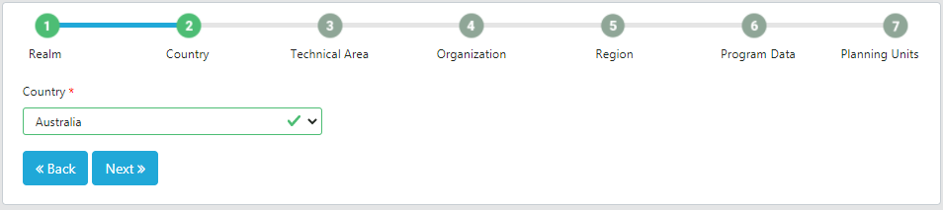

Figure 12.C.2- Set up Program - Realm

**Technical Area**

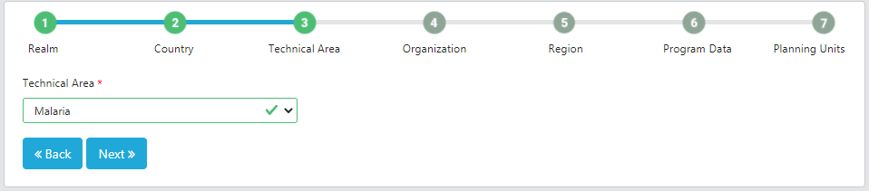

Figure 12.C.3- Set up Program – Realm

**Organization**

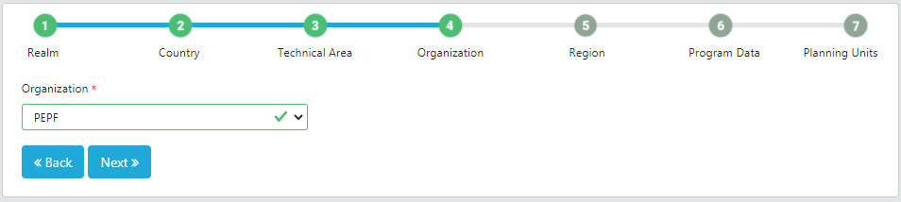

Figure 12.C.4- Set up Program - Organization

**Region**

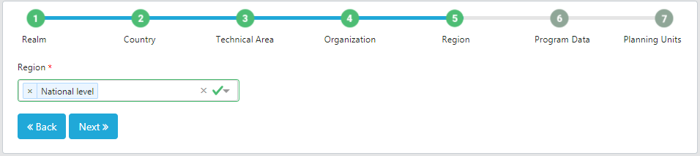

Figure 12.C.5- Set up Program - Region

**Program Data**

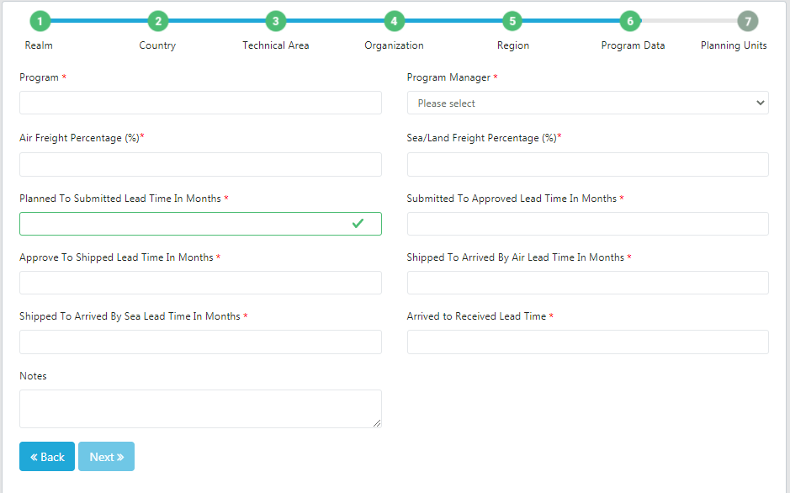

Figure 12.C.6- Set up Program – Program Data

**Planning Units**

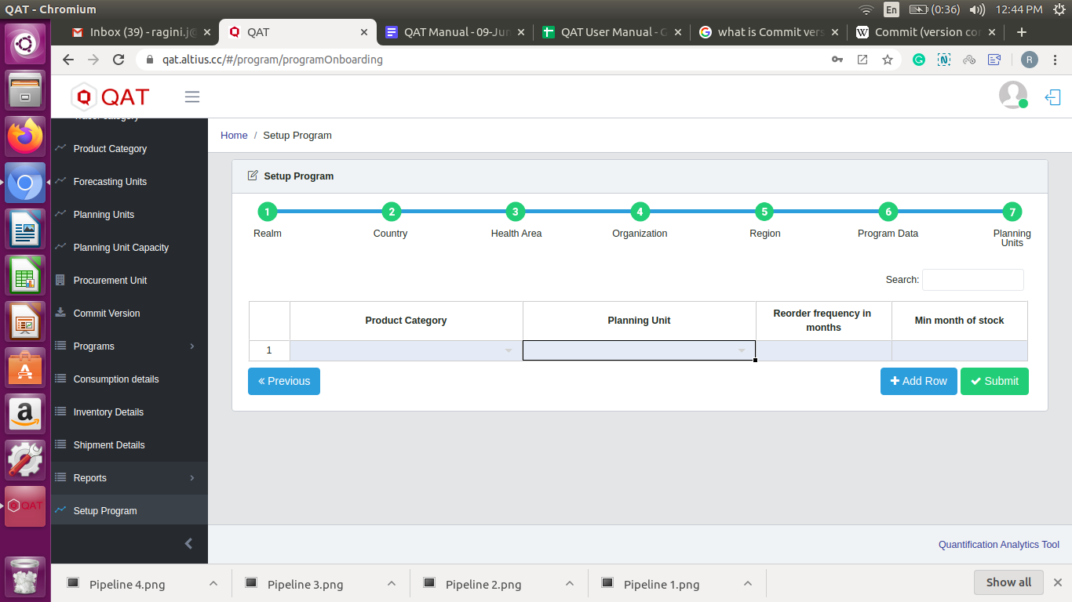

Figure 12.C.7- Set up Program – Planning Units

# Program Management

“Program Management” is the third level in the QAT system hierarchy. In this Master Data the user can add and update particular programs. The user can create one or more programs as required. Each program must choose only one Country, one Technical Area, set the number of Regions that will be used to manage data in the Program (e.g., National, Northern, Central, Southern, etc.), and one organization (MOH, PEPFAR-only, PMI-only). Users can plan the budget for that program, define the product type, planning units, and forecasting units. They can also map the planning unit capacities as per the requirements.

The Program once created can be “Loaded” or “Deleted” from a user’s local machine. Dataset files can also be “Imported” to the local machine or “Exported” from the local machine to share with other users if there are connectivity issues.

# Program

1. **Update Program Info**

This function is available for **Application** **Admins, Realm Admins** and **Program Admins.**

1. To update the Program, go to the Program Management.
2. Now click on “Update Program Info”.

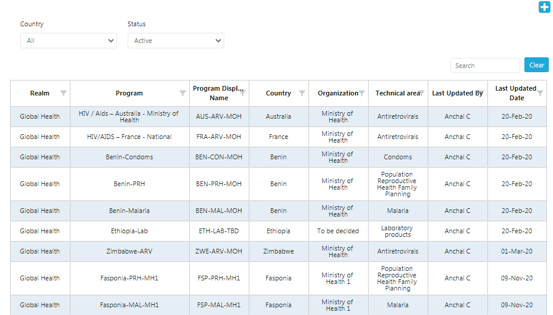

Figure 13.A.1- Update Program Info

1. Click on the program that needs to be updated.
2. Edit the required information.

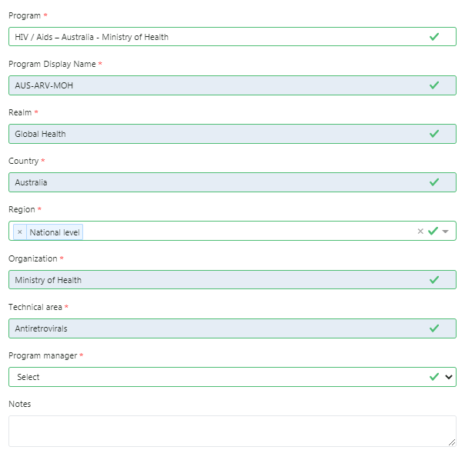

Figure 13.A.a- Update Program -1

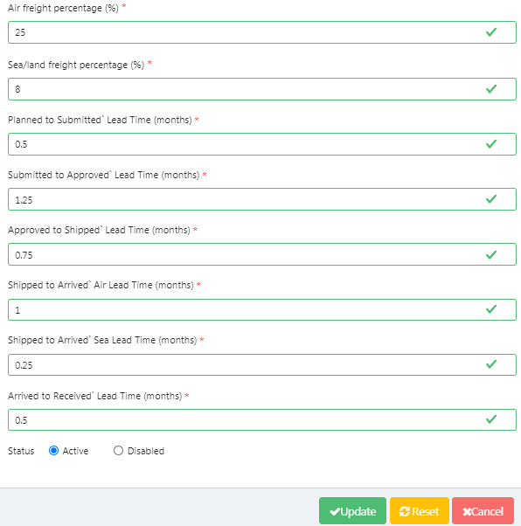

Figure 13.A.a- Update Program -2

1. **Update Planning Units**

This function is available for **Application** **Admins, Realm Admins** and **Program Admins.**

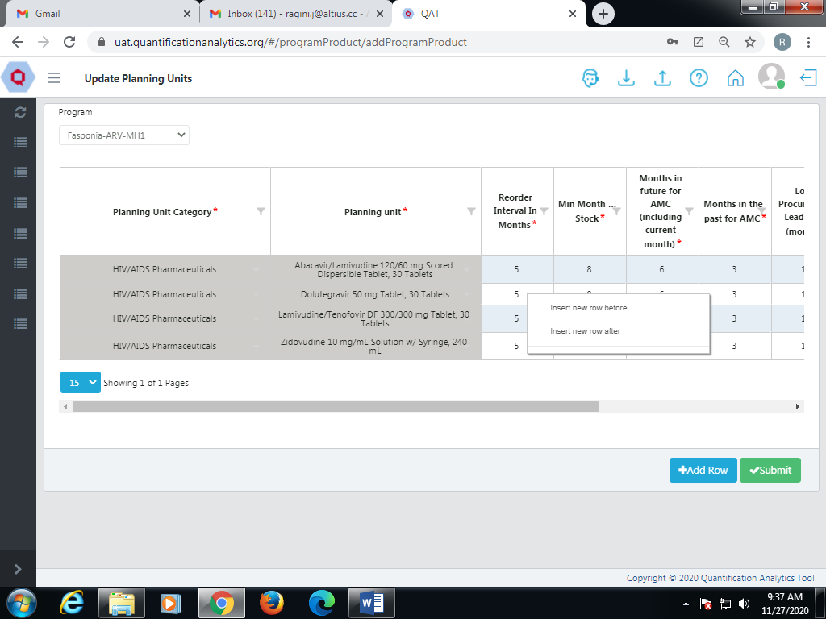

Figure 13.A.b- Update Planning Unit

1. To update the program planning unit, go to update the planning units.
2. Select the required program as shown above.
3. Click on that function and a new screen will be opened.
4. Right click on a cell to insert or delete the row.
5. Enter the details in the newly added row(s) and click on the “Submit” button.

# Budget

Budget represents an estimate of capital and expenditure for a set period of time. This function is available for **Application** **Admins, Realm Admins**, **Program Admins and Program Users.**

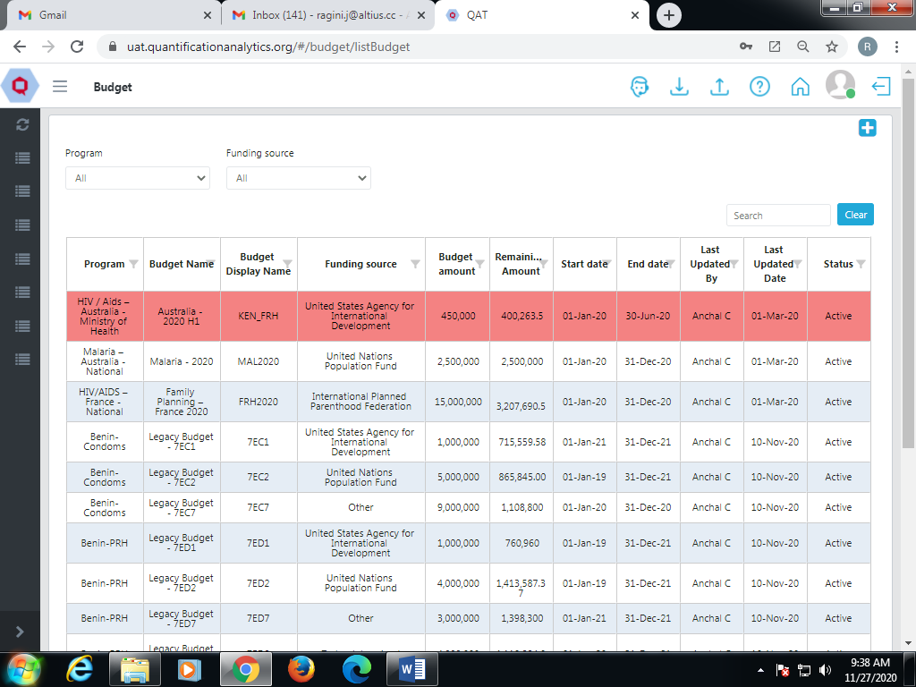

Figure 13.B- Budget

1. Go to “Program Management” and the Budget function will be shown.
2. Available budgets will be displayed on the screen with an amount, a start date and an end date.
3. **Add Budget**
4. Go to the top right corner in the List.
5. Click on the blue “add” button below the profile icon.
6. A new screen showing “Add Budget” will be opened.

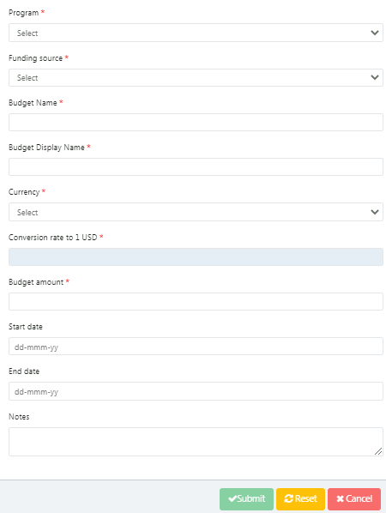

Figure 13.B.a- Add Budget

1. Enter the required details and click on “Submit” button
2. The user has the functions of resetting the Add Budget Screen or Cancelling the budget before submitting it.
3. **Update Budget**

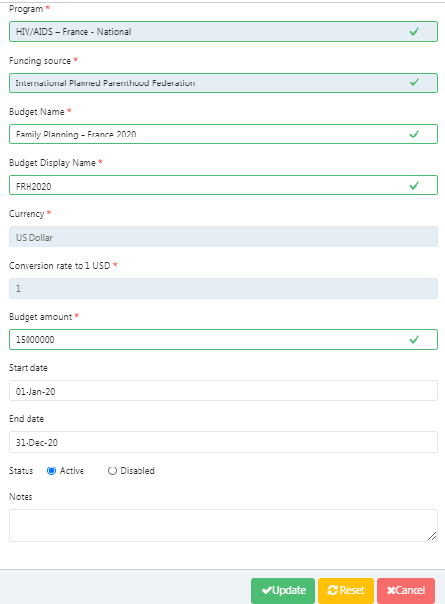

Figure 13.B.b- Update Budget

1. To update the Budget, go to the Budget List.
2. Now click on any function that needs to be changed or updated.
3. Select the required Budget and click on the “Update” button.
4. Update the selected budget as required
5. The user can then submit the budget update but has the functions of resetting the Budget Update Screen or Cancelling the update before submitting it.

# PipeLine Program Import

**Introduction**

The users using PipeLine will have a .accdb file which will be stored in the local machine. But the QAT system allows only json file format while importing the program. Therefore, QAT has a process that converts the .accdb file into json file format.

Users can convert the .accdb file into a json file using the following process.

1. Go to “Program Management” and click on “PipeLine Program Import”.
2. On the top right corner click on the “Add” button.
3. It will lead to a file input screen.
4. Click on the downward arrow button from the top right corner.
5. “Download PipeLine Converter” will be shown on the screen.
6. Select the required system for the local machine: Linus/Windows.
7. The converter will be downloaded in the zip format.
8. The user needs to open the file and run the tool, the following screen will be displayed:
9. The users can browse their .accdb file, select the destination and click on convert.

As soon as the file gets converted into. json format, the user gets a notification. This file can be stored on the user’s local machine. As shown below, the user can import the file to the QAT system. The json file can be selected from his/her local machine. The user will see one row that is generated in the program list. Once the user clicks on that row, he/she will be able to enter all the information as shown below:

1. **Note for PipeLine users**

While importing the data into the system -

1. The inventory can never be negative.
2. All the shipment related data must be properly updated.
3. **How to import files**
4. In QAT go to the sidebar menu.
5. Go to “Program Management”.
6. Click on the “PipeLine Program Import” function.
7. To import the program, click on the “Add” button.
8. A new screen will be opened.
9. Choose a file from the local machine and click on “Submit”.
10. After completing the process, the user will get a message that the program is successfully imported.
11. This program will be shown in the QAT program list where the user can “Download”, “Import”, and “Export” programs.

**NOTE:** - At the last step (Shipment screen) a pop-up will be displayed if any program contains negative inventory.

After importing PipeLine data, the user will navigate through a series of screens where there will be prompts to enter data. After editing data on one screen, the user should click on “Next”. It is possible to navigate to previous screens by clicking “Back”. The user should navigate through the following screens for program info, Planning Unit, Data Source, Funding Source, etc. and enter all the details as shown below:

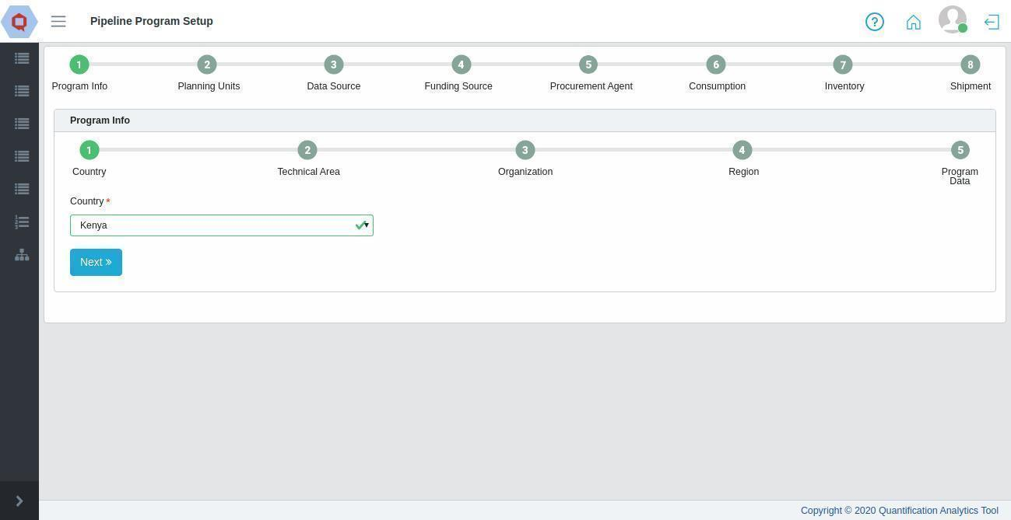

Figure 1- Country

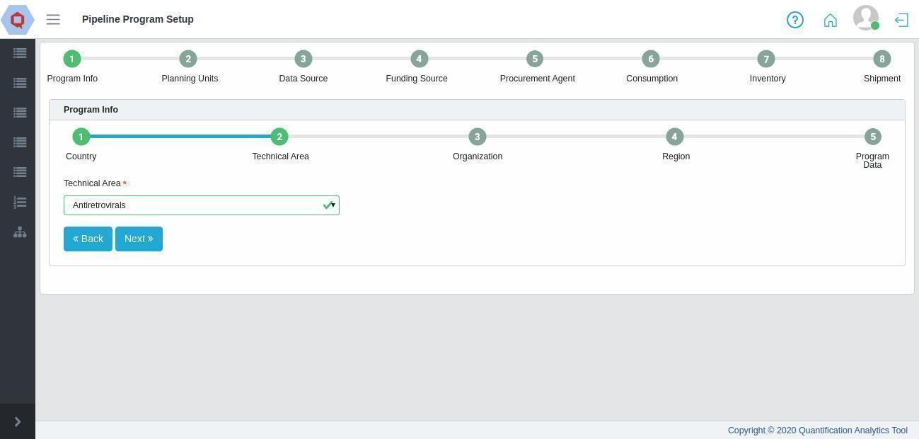 Figure 14- Technical Area

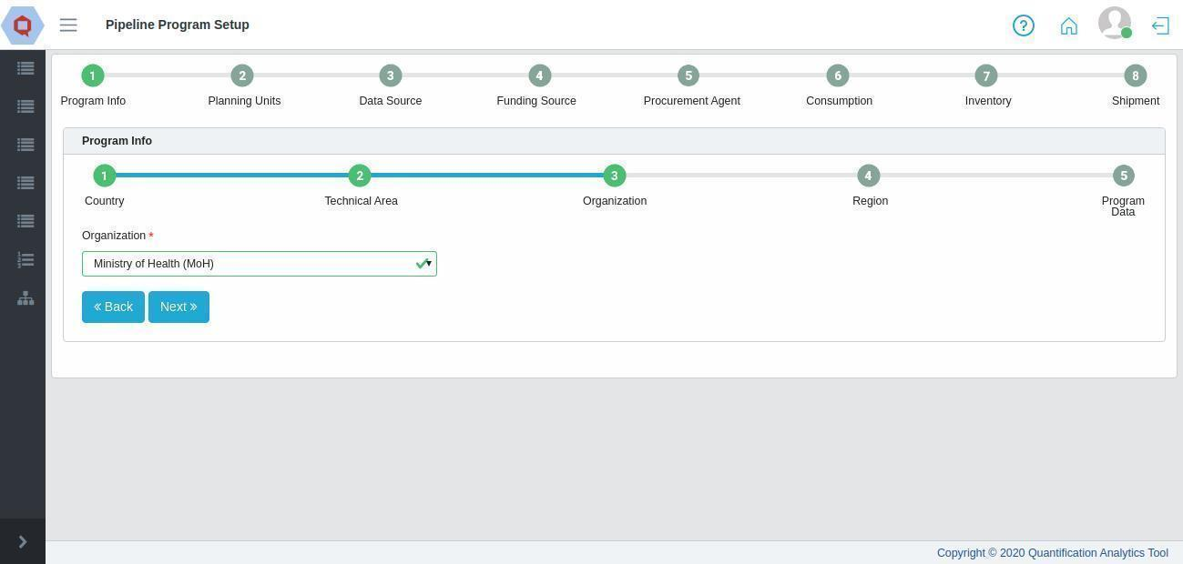 Figure 14- Organization

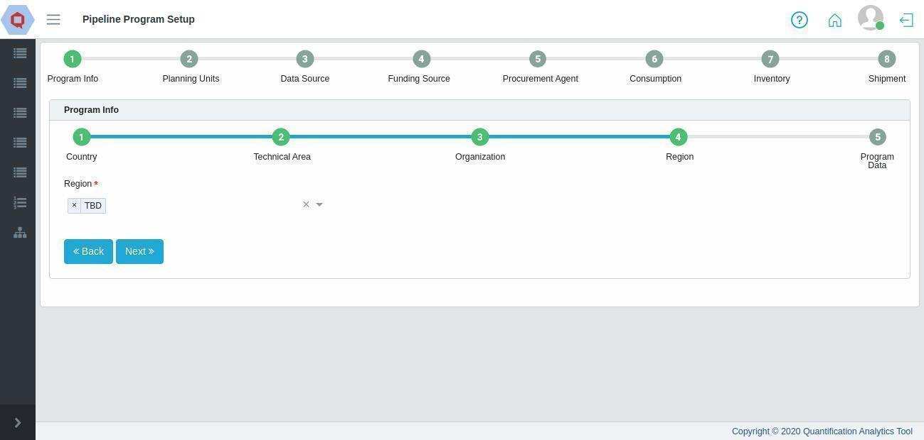 Figure 14- Region

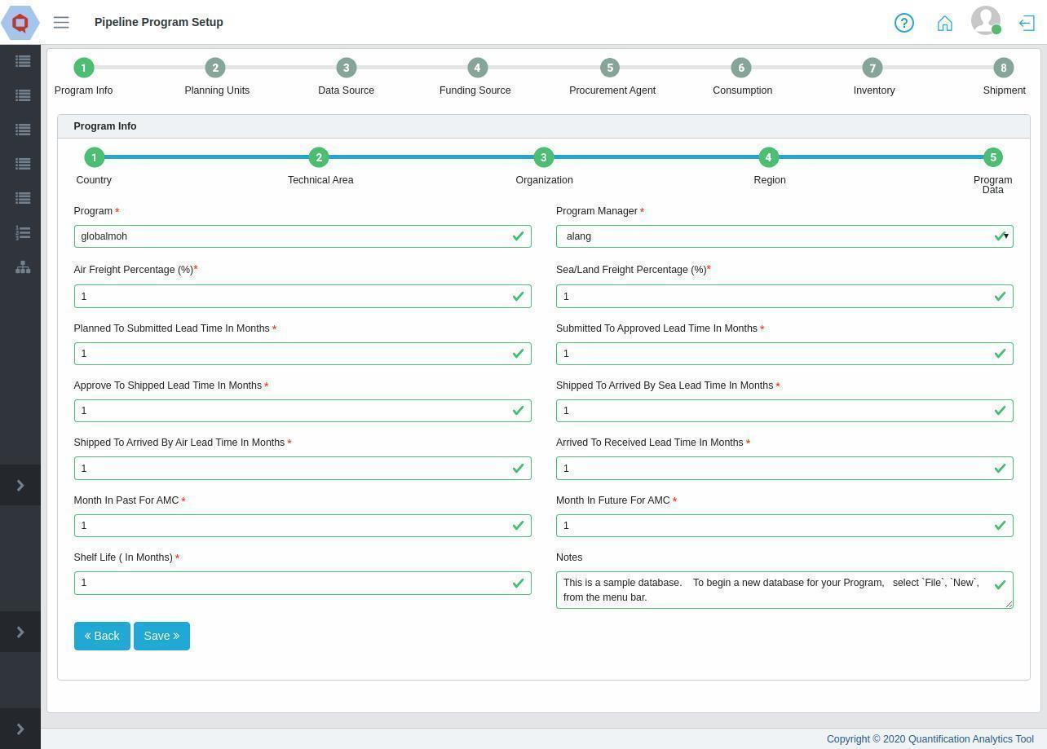 Figure 14- Program Data

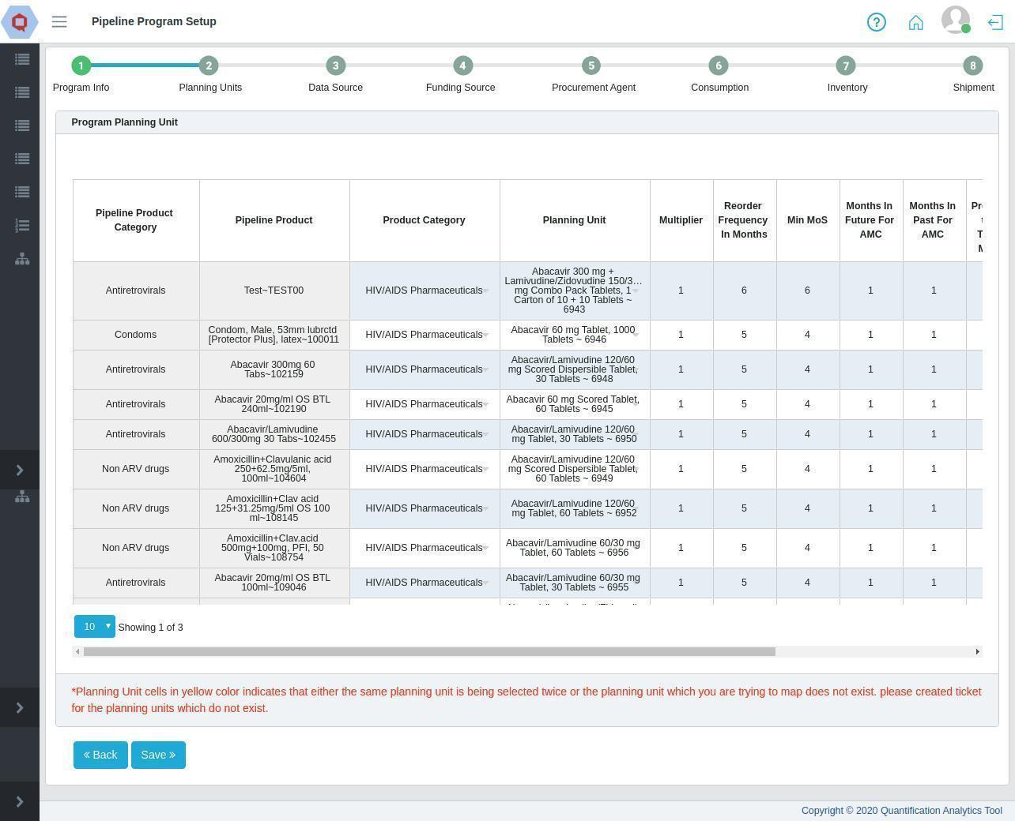 Figure 14- Planning Units

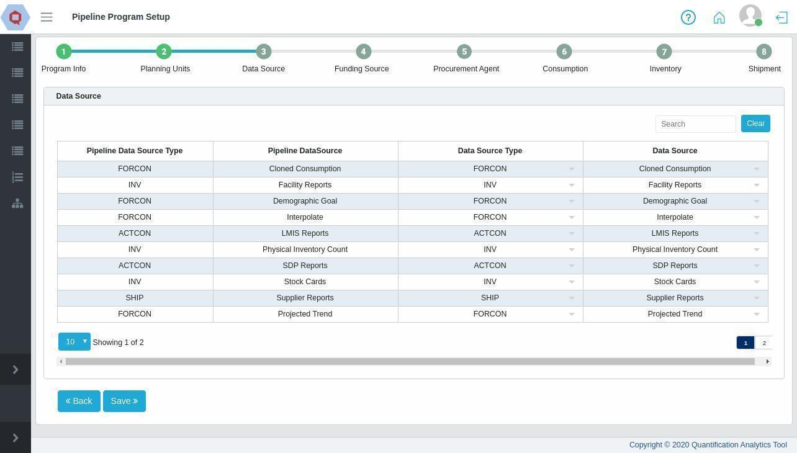 Figure 14- Data Source

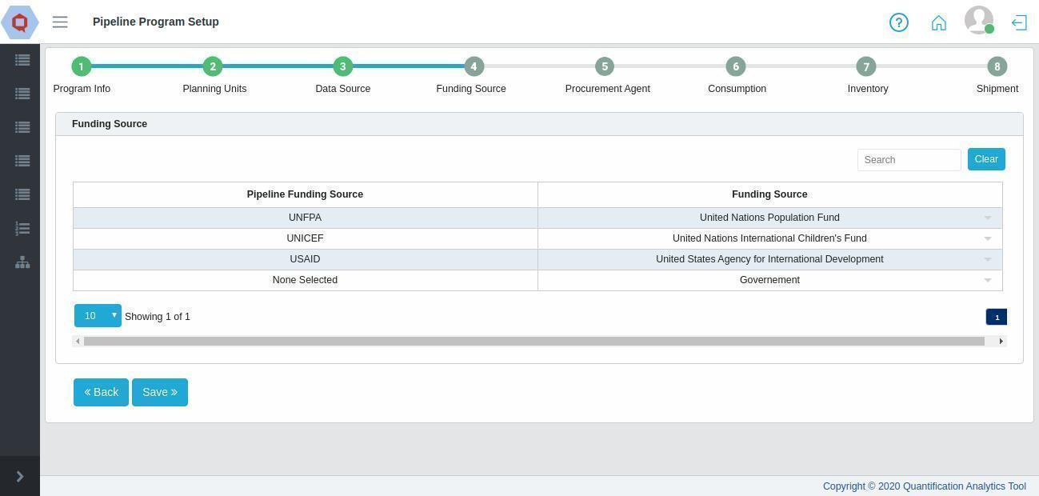 Figure 14- Funding Source

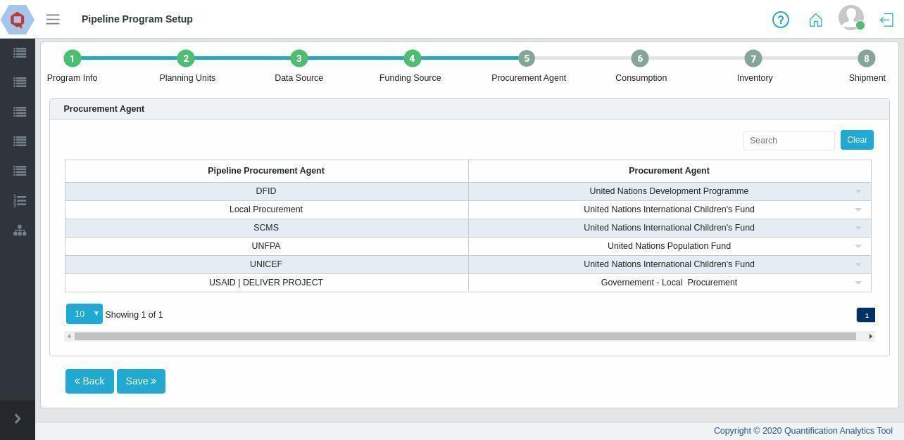 Figure 14- Procurement Agent

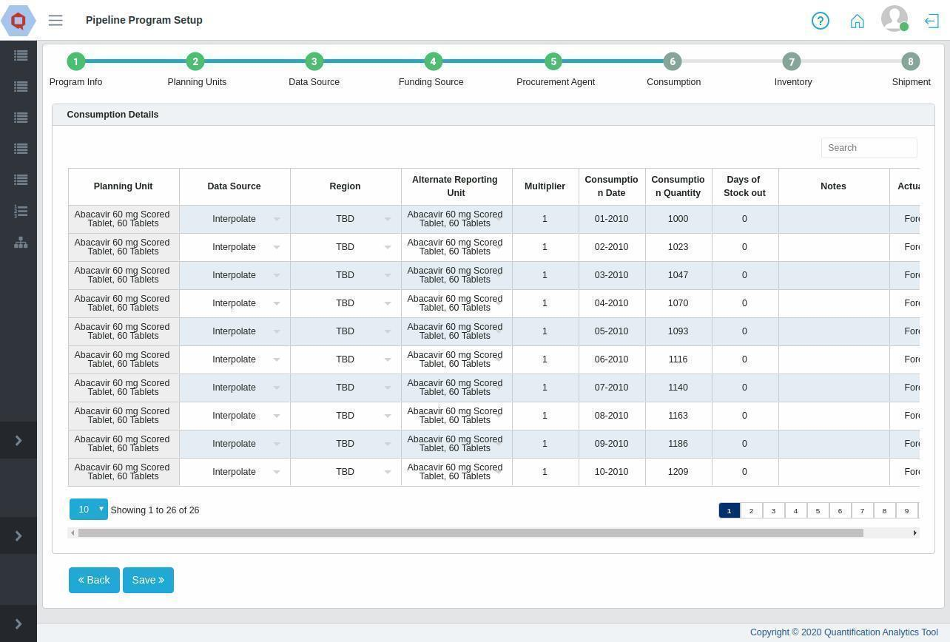 Figure 14- Consumption

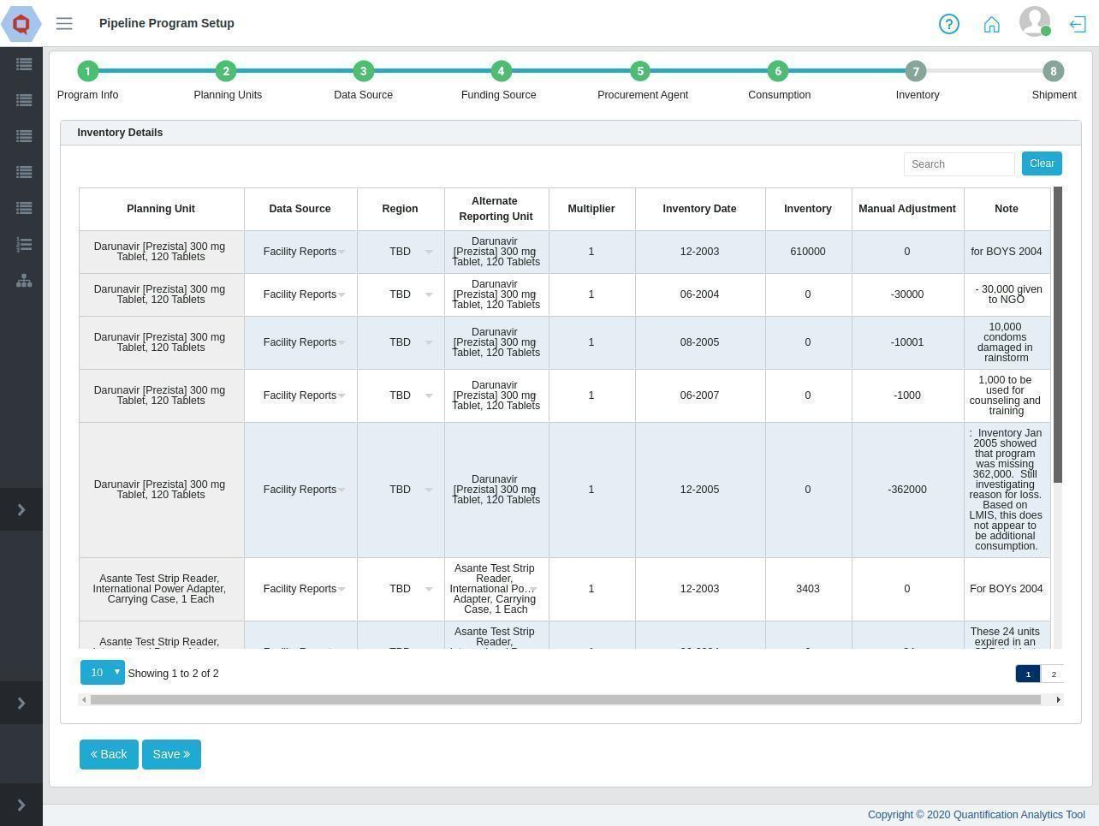 Figure 1- Inventory

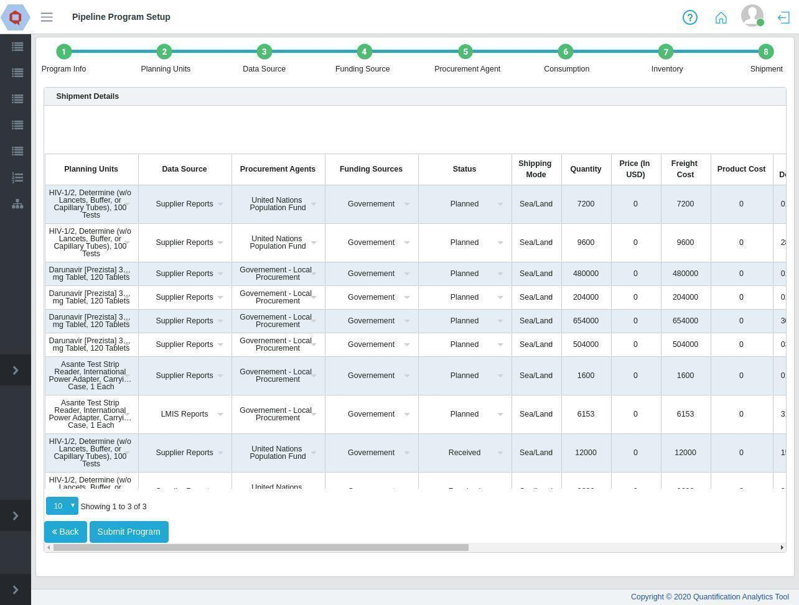 Figure 14- Shipment

After the file is successfully imported to QAT;

1. The users can go to “Program Management”.
2. Click on the “Programs” function.
3. The program list will show the imported program.
4. Now the user can “Load”, “Import” and “Export” that program.

# Working with Program Data

|  |  |  |
| --- | --- | --- |
|  | **Online** | **Offline** |
| Data from others | Load | Import |
| Data from users | Commit | Export |

Program data can be loaded, committed, imported, and exported in QAT. Users must **load** program data for supply planning, and need to commit. The **export** program is used when the data needs to be shared with other users via external devices such as a pen drive/flash drive. Similarly, the data can be imported into the local system using the **import** data function.

## Load Program

This function is available for **Application** **Admins, Realm Admins**, **Program Admins, Program Users and Supply Plan Reviewers.**

* The “Load Program” function is used when the user is working in offline mode.
* When the user loads a Program, it gets stored in his/her local index database in the API format.
* Programs must be loaded in order to complete the following functions, even if the user is online:
  + Enter/update data (consumption, inventory/adjustments, shipments). For example, if the user is working on “Consumption Details”, he/she must select a program from the given list. The list will show data only for those “Programs” which have been loaded in the local index database.
  + Supply/scenario plan
  + View problem list
* This “Program Data” is essential when the user works offline for Reports or Inventory Data such as Consumption or Inventory Details.

**How to load a Program:**

1. Go to “Program Management” > “Load Program”

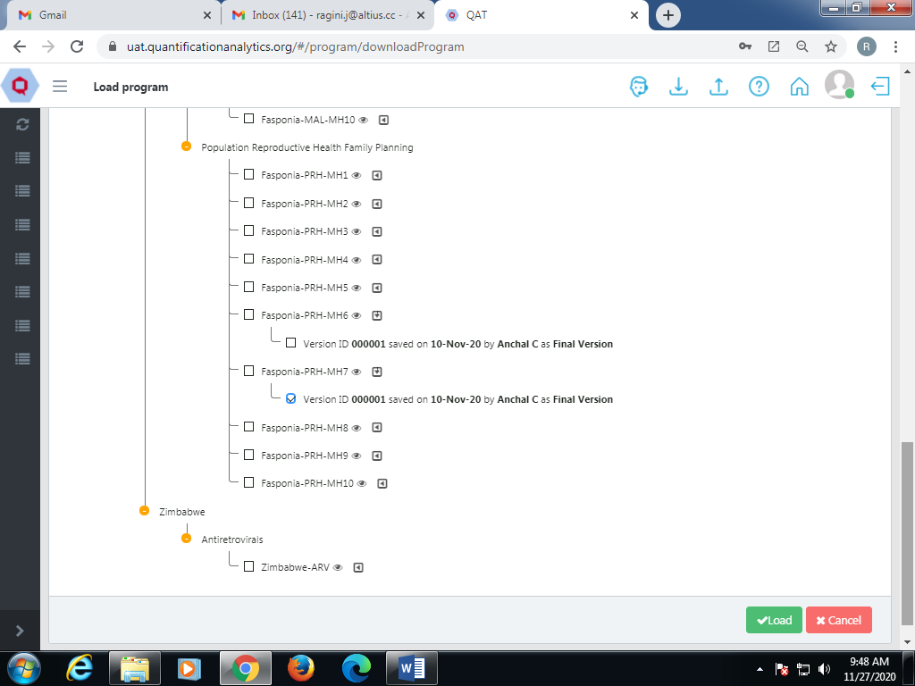

Figure 15.A- Load Program

1. The screen will display the Program Data as shown above.
2. If the user clicks on the yellow colored dot, the program will display a tree view as shown above.
3. Select the checkbox next to the program you want to download. By default, QAT will download the latest version of the supply plan for the selected program.
4. The program can have multiple versions.
5. Click on the second right button next to the program.
6. It will show the available versions for the program.
7. Users can select the required version.
8. Click on the “Load” button to download the program to your system.

## Import Program

This function is available for **Application** **Admins, Realm Admins, Program Admins** and **Program Users.**

* The “Import Program” function is used when the user is working on the program in offline mode.
* The user can include the required program in the QAT system through this function.
* The program data file must be saved in the zip format.
* By using the Import function, program data can be shared with others offline. For example, user B can (while offline) import a program that user A exported and saved to an external device (Pendrive, Hard disk, etc.)
* The user can choose the file from the local machine to import that program in QAT.
* While importing a program the user can load the copy of the file to a local system or software or Web application.

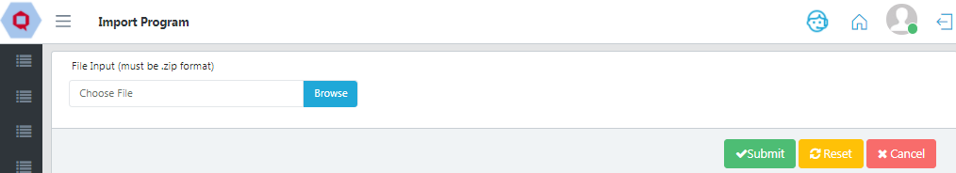

Figure 14.B- Import Program

**How to import a program:**

1. Go to “Program Management” > “Import Program”
2. Click “Browse”. Choose the required file that needs to be imported.
3. The selected file will be in the zip format
4. The zip file can have multiple programs while exporting.
5. The user can select the required program.
6. Click on the “Submit” button to import the program into the local machine.

## Export Program

This function is available for **Application** **Admins, Realm Admins, Program Admins** and **Program Users.**

* The “Export Program” function is used when the user wants to export the program to his/her local machine.
* The program data file will be exported in the zip format. The zip file contains encrypted data format for that program.
* By using the Export function, Program data can be shared with others offline. For example, user A can export a program and save that file on a USB drive to share with user B, who is offline.
* While exporting a program, the user can load the copy of the file to his/her system or software or Web application.

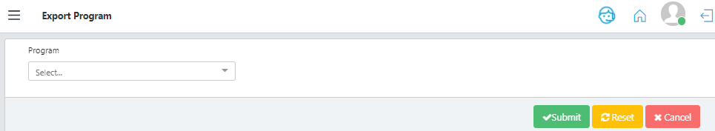

Figure 15.C- Export Program

**How to export a program:**

1. Go to “Program Management” > “Export Program”
2. Select the program to be exported using the dropdown. Programs must be first loaded before exporting is available. See Load Program.
3. Click on the “Submit” button to save the changes.
4. A browse window will pop up. Select the folder you want to save the exported file in. Then click “Save.”
5. The .zip file will now be saved in the selected folder.

## Delete Local Program

Deleting a program will not delete the program from the server. Deleting a program deletes your local copy. Deleting programs is helpful if you have lots of old versions on your computer and you want to clear storage space.

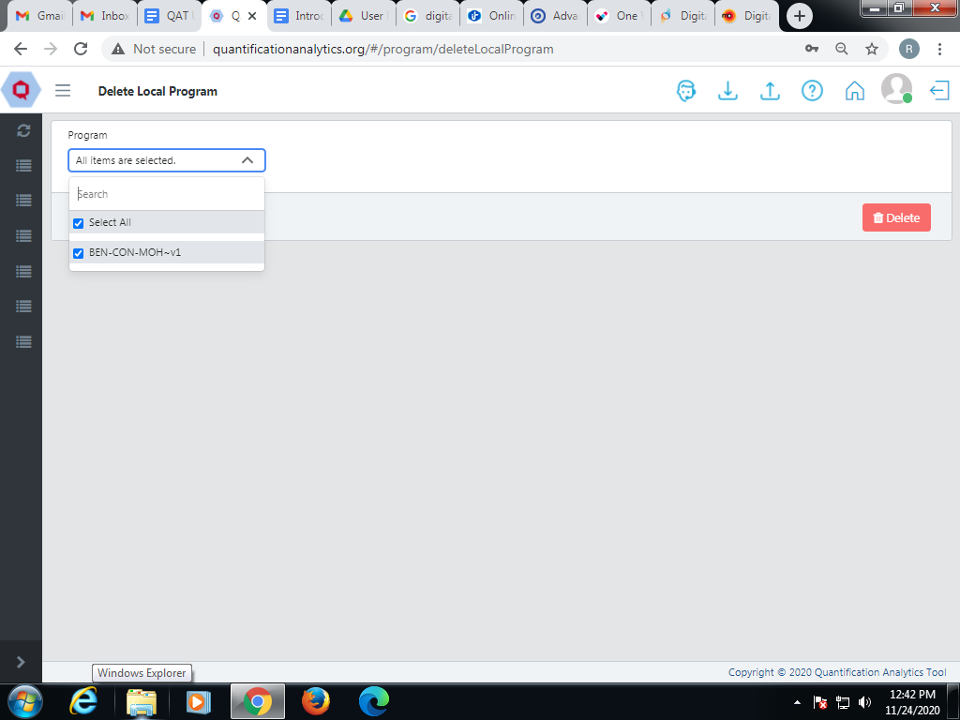

Figure 15.D- Delete Local Program

1. Go to “Program Management” > “Delete Local Program”.
2. Select the program(s) that needs to be deleted.
3. Click on the “Delete” button to save the changes.
4. You will see a confirmation message that the selected program(s) have been deleted.

## Commit version

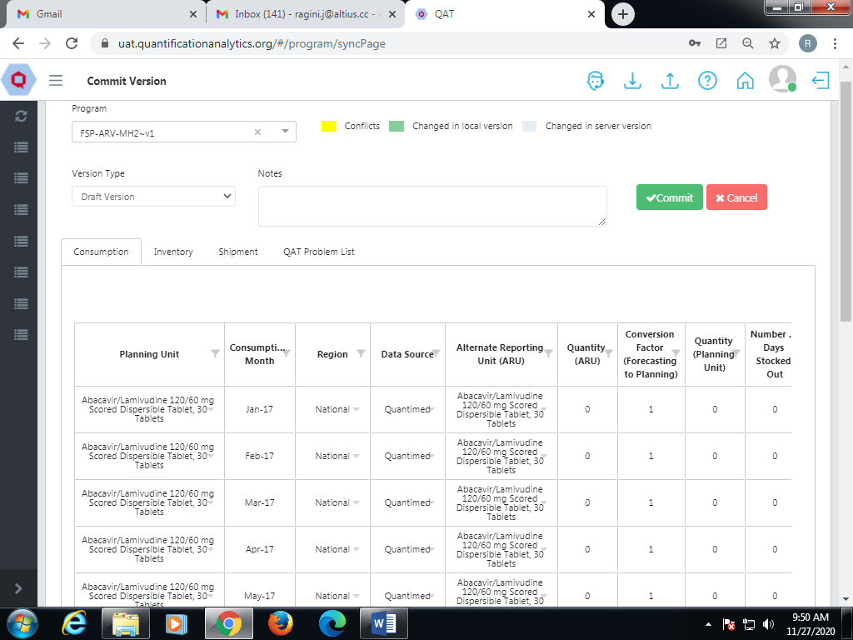

Figure 15.E- Commit Version

This function is available for **Application** **Admins, Realm Admins, Program Admins** and **Program Users.**

The purpose of the Commit Version is to allow users to sync the most up-to-date supply plan data to the server & submit final supply plans for the supply plans to be synced to the ERP System. It will compare supply plan details from the "Local / offline version" with the "Live /Online version." It is important to note that users are only able to commit a Supply Plan as a Final Version if all Problems within the QAT Problem List have been closed through data entry or “Addressed” with an explanatory note.

Legend Explanation:

* Green: represents a change that has been made in the local/offline version; by committing your program, it will save and sync that new data to the online server as a new version.
* Light blue: represents a change made by another user that has already been committed to the live/online version; by committing your program, it will overwrite the live/online version with your new version.
* Yellow: represents a conflict in data between the local/offline version and the live/online version for the same data cell. You must resolve these yellow conflicts, by right clicking “Resolve Conflict” and choosing whether to keep the local/offline version or the live/online versions.

## Supply Plan Version and Review

This function is available for **Application** **Admins, Realm Admins** and **Supply Plan Reviewers.**

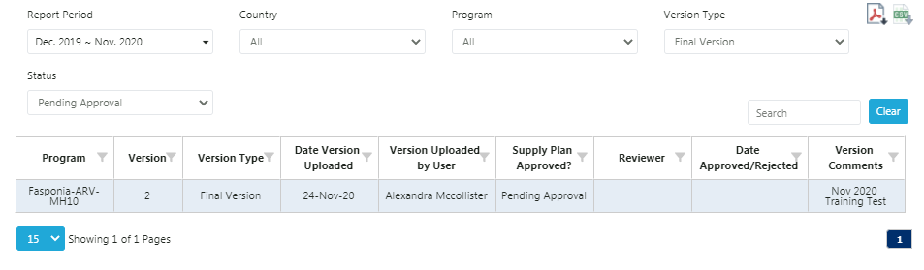

Figure 15.F- Supply Plan Version and Review

1. Go to “Program Management” in the sidebar menu.
2. Click on the “Supply Plan Version and Review” and the above screen will be displayed.
3. Select the Report Period, Country, Program, Version Type, and Status.
4. A Supply Plan Reviewer can verify and change the status of the Supply Plan (i.e. Approving or Rejecting), however they must provide notes when updating a Program Status.

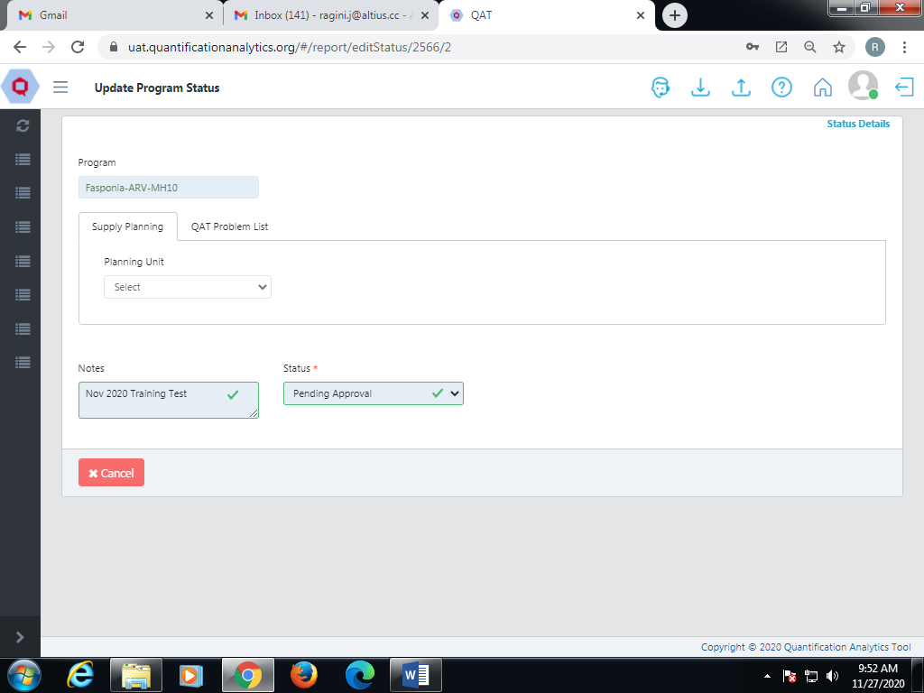

Figure 15.F- Supply Plan Version and Review

1. The user that submitted the supply plan for review will be notified when their submission is either Approved or Rejected. The user can also download the report in PDF and CSV.

# Handling Procurement Agents

A Procurement Agent selects the vendors, establishes payment terms, strategic vetting, selection, the negotiation of contracts and actual purchasing of goods that are shipped to a program. Procurement Agents are generally hired by the agency funding a particular shipment (a “Funding Source” in QAT) and identified by the Program-level user when planning a shipment. Procurement Agents are managed by **Application Level Admin** and **Realm Level Administrator**.

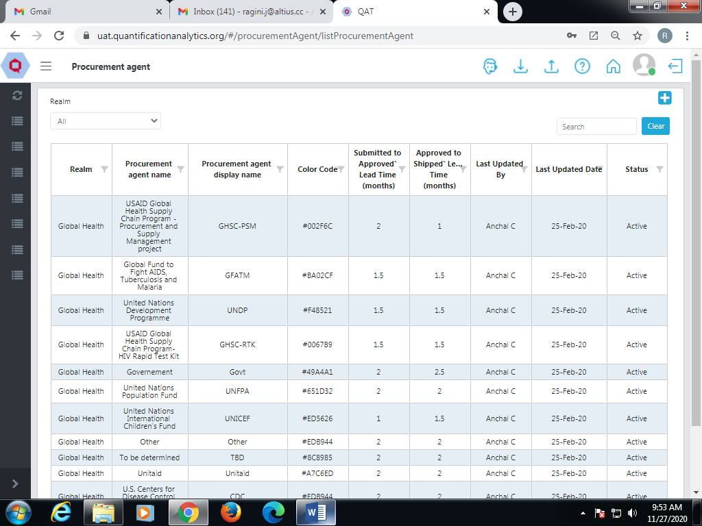

Figure 16- Procurement Agent

1. The above screen shows Procurement Agent Names and codes.
2. Go to “Realm Level Masters” from the sidebar menu.
3. Click on the function “Procurement Agent”.
4. Select the Realm and click on the “Go” button.

**Note: applicable only when multiple realms are assigned to the user.**

1. **Add Procurement Agent**

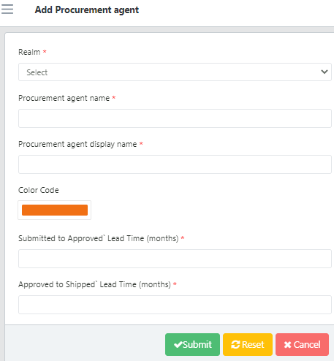

Figure 16.a- Add Procurement Agent

1. On the Procurement Agent List, go to the top right corner of the screen.
2. Click on the blue “add” button.
3. A screen showing “Add Procurement Agent” will be seen.
4. Enter the required details.
5. Click on the “Submit” button to save the changes.
6. **Details to know before mapping the planning/procurement unit**

|  |  |
| --- | --- |
| Procurement Agent | A Procurement Agent is responsible for buying high quality items for clients at the lowest possible price and in the correct amount. |
| SKU Code | Stock Keeping Unit Code is a feature used to identify specific products and often printed on the product and case labels. barcodes may be printed on product labels. |
| MOQ | Minimum Order Quantity refers to the minimum amount that can be ordered from a supplier. |
| Units per Container | A container unit models the logistical handling of the transportation of one or several containers (For eg. Number of planning units that can be transported in a 40’ container, per dimensions) |
| Weight | The weight per planning unit. |
| Planning Unit | The planning unit is the product to be planned in QAT. It is a product with full description up to the primary packaging (e.g. bottle of 30 tablets, 10x10 blister pack, etc.) |
| Catalog Price | Price included in a catalog. |
| Units per Pallet | Units per pallet defines the number of planning units that can be packed onto a standard pallet, per pallet dimension. Units per pallet describes the individual items on a pallet into single "units" that can be moved easily with a pallet jack or forklift truck. |
| Volume | The volume of the planning unit |

Table 16.b- Details of Procurement Agent

**NOTE:**

1. The use of a unit load enables goods and packages to be grouped together. Then they get handled and moved more effectively using mechanical equipment.
2. Unit Load in a Container is the maximum 'load' that a specific container can carry.
3. Unit per container is the number of 'units' of a particular product that can be loaded into a 'container'. It is the same as the unit load in most cases.
4. **Map Procurement Agent Planning Unit**

**NOTE:** Blocks with ‘*’ are mandatory fields.

The user can create a Planning Unit on a different screen. Later he/she can add a procurement unit for that same planning unit and map both of them to a particular procurement agent under this particular function.

For example, USAID is a procurement agent that deals with paracetamol strips. QAT has paracetamol as a planning unit. In this case, one strip of paracetamol tablets will be mapped as a procurement unit.

**Map Planning Unit**

When clicking on the Map Planning unit, QAT shows the screen “Add procurement agent planning unit”. Primarily it shows the procurement agents for the respective planning units along with the catalog price. The existing data for the planning unit can be modified manually in the table.

**Map Procurement Unit**

When clicking on the Map Planning unit, QAT shows the screen “Add procurement agent procurement unit”. The screen shows the procurement agents for the respective procurement units along with the catalog price. The existing data for the planning unit can be modified manually in the table. Only **Application** **Admins** and **Realm Admins** can map procurement unit**.**

In case the user wants to add a new procurement unit or planning unit for that particular procurement agent, he/she can select the planning unit from the dropdown list. The other details including price, volume, etc. can be added manually.

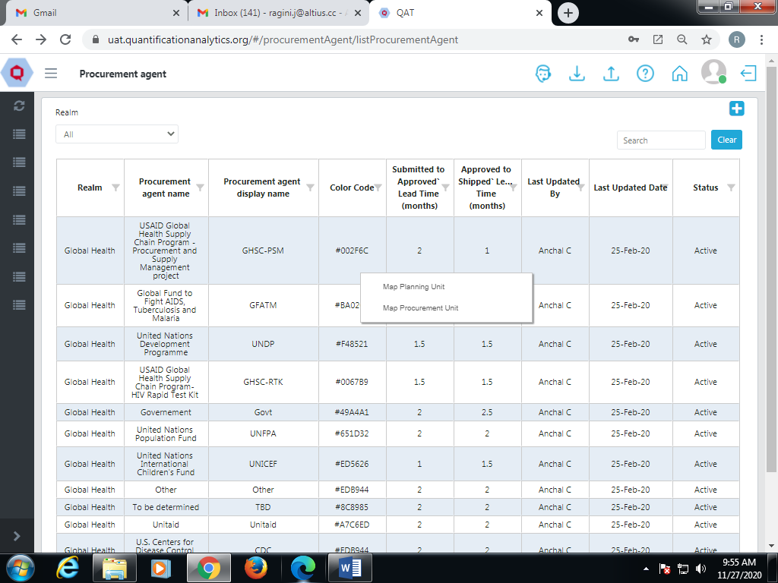

Figure 16.c- Details of Procurement Agent

1. **Add Procurement Agent Planning Unit**

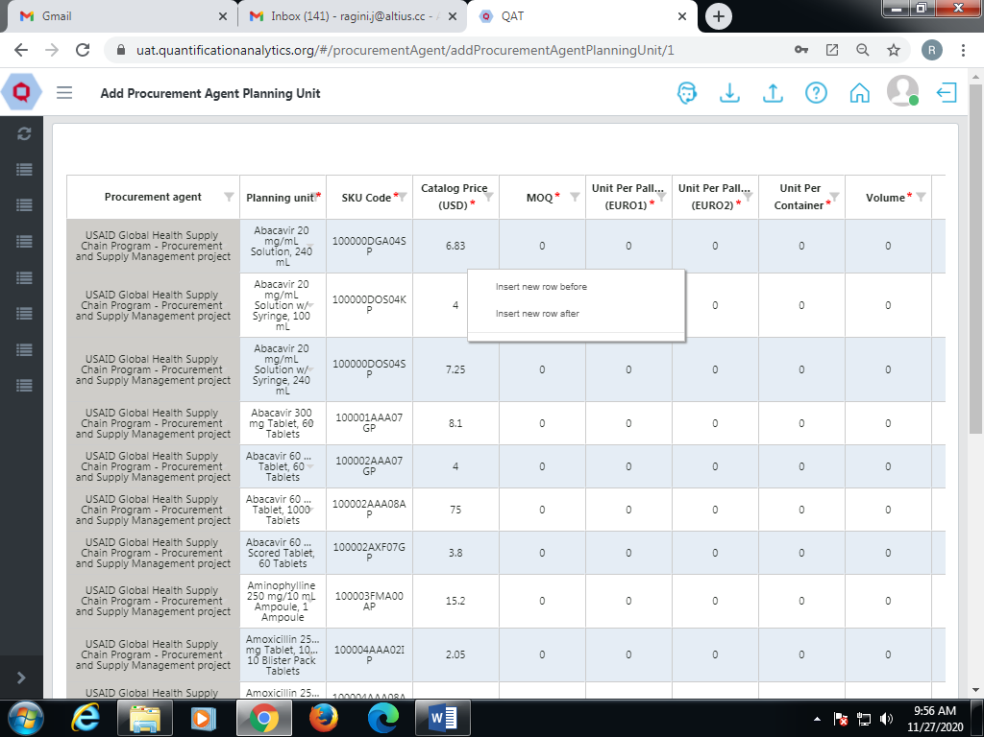

Figure 16.d- Add Procurement Agent Planning Unit

1. Right click on the cell Procurement Agent List for a specific agent.
2. It shows two functions as “Map Planning Unit” and “Map Procurement Unit”.
3. Click on the “Map Planning Unit” function.
4. A new screen “Add Procurement Agent Planning Unit” will be displayed.
5. The user can change the existing data by double clicking in a cell.
6. Click on the “Add Row” function to add data or right click on the table to insert new rows.
7. Enter the required information and click on “Submit”.
8. **Add Procurement Agent Procurement Unit**

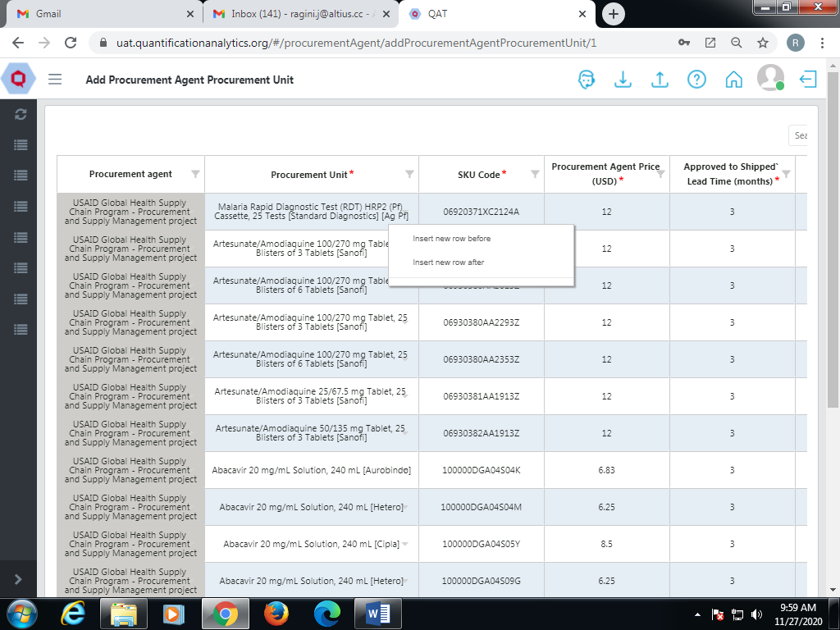

Figure 16.e- Add Procurement Agent Procurement Unit

1. Select the procurement agent.
2. Right click on the cell of that specific agent.
3. It shows two functions as “Map Planning Unit” and “Map Procurement Unit”.
4. Click on “Map Procurement Unit”.
5. Click on the “Add Row” function to add the data or right click on the table to insert new rows.
6. Enter the required information and click on “Submit”.
7. **Update Procurement Agent**

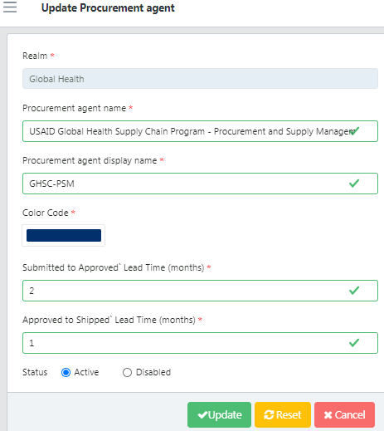

Figure 16.f- Update Procurement Agent

1. Go to the Procurement Agent list.
2. Click on the required Procurement Agent that needs to be updated.
3. The update section will be displayed.
4. Edit the required details.
5. Select the status as “Active” and click on the “Update” button.

# Background Data

**Introduction**

The Background Data functions enable the user to modify program, supplier lead times, and product costs; and to establish product minimum/maximum stock levels.

# Products

Products are different forms of medicinal products including liquid formulations, tablets, capsules, topical medicines, suppositories, drops, injection, medical implants etc.

# Selecting Products

Selecting a number of products can lead to better supply, appropriate prescribing, and lower costs. Products are those that satisfy the health care needs of the majority of the population. Selecting products begins with defining a list of common diseases for each level of health care. Hence, the product should be selected according to the required category

# Tickets for Product Creation

1. To report a bug, the user needs to submit tickets.
2. In case there is an update or change in the master data, there is a need to submit a ticket.
3. Also the ticket is submitted when a bug is found or reported.

# Consumption

1. In QAT, the consumption of the required product is shown for a given time period.
2. It compares the amount of stock available, amount of stock required, and stock shipped to customers.
3. QAT shows the consumption data in tabular form as well as in graphical format.
4. The system shows the actual and forecasted data to the user.
5. It also provides a comparison between the actual and forecasted consumption to make sure that the user has an adequate amount of stock for a defined time period.
6. **Actual Consumption:** Reported or estimated quantities of product that left the program’s logistics system through normal dispensing to client activities.
7. **Forecast Consumption:** Quantities expected to be dispensed in the future.

# Inventory

Inventory refers to all the products/medical devices that are ready to be consumed or sold.

# Region

# Regions are the areas where distribution centers are housed. Some countries may not have multiple Regions or distribution centers. Instead they will have a single distribution center which is referred to as “National” in the QAT system. Many countries have regions designated as “South”, “North” “East”, or “West”.

# Reorder Frequency

Order quantities are often the focus of supply chain planning as they directly affect the frequency with which things are done. Users can anticipate how many orders should be assigned to a specific time period.

# Freight Cost

The Default Freight Cost field shows the approximate freight cost for a shipment as a percentage of the shipment's product value. It incorporates all expenses related to product delivery (i.e., charges, clearance fees, etc.). QAT utilizes the default freight cost when calculating freight cost if you don't fill in freight cost estimates for individual providers.

# AMC (Average Monthly Consumption):

Average Monthly Consumption (AMC)



* Consider only non zero values. Also future months include the current month

Example :

Months in past = 3(Based on program planning unit)

Months in future = 3(Based on program planning unit)

Current month = May 2020

Consumption in Feb 2020 = 5,000

Consumption in Mar 2020 = 6,890

Consumption in Apr 2020 = 6,907

Consumption in May 2020 = 7,087

Consumption in Jun 2020 = 5,678

Consumption in Jul 2020 = 6,789

AMC = Consumption in No. of MONTHS_IN_PAST + Consumption in No. of MONTHS_IN_FUTURE/ number of months

AMC = (Consumption for Feb,Mar,Apr,May 2020 + June & Jul 2020) / 6

AMC = (5,000+6,890+6,907+7,087+5,678+6,789) / 6

AMC = 6,392

# MoS (Month of Stocks): Amount of Ending Balance at hand divided by average monthly consumption.

Months Of Stock

Example :

Ending Balance = 22,642

AMC = 6,392

Months Of Stock = Ending Balance / AMC

Months Of Stock = 22,642 / 6,392

Months Of Stock = 3.54

# Supply Plan Data

Specific fields related to consumption, inventory, and shipments come into play while performing specific transactions in the QAT application.

1. **Consumption**: Stock dispensed by the program to clients.
2. **Inventory**: Materials used to make the products.
3. **Actual Flag**: Indicates whether a particular consumption record is the actual consumption or forecasted consumption.
4. **Shipments**: Stock received by the program from suppliers
5. **Stock**: All the products that are ready to be consumed or sold
6. **Stock** **count**: A check of how much stock an organization has at a particular time
7. **Stock adjustments**: Events or transactions that change the stock on hand within

the program (i.e., loss of expired stock, transfers to or from another

program, etc.).

**Application** **Admins, Realm Admins, Program Admins**, **Supply Plan Reviewers** and **Program Users** can add/editconsumption data, shipment data and inventory.

## Consumption Data

Consumption details: Provide details of Consumption Date, Region, Quantity, no. of Days Stocked Out, Actual/Forecasted flag, Active/Inactive status.

1. **Add Consumption Data**
2. The screen below shows adding the consumption data into the system.
3. Go to “Supply Plan Data” and select Consumption data.
4. The screen displays the “Consumption Data” section.
5. Enter the Program and QAT planning unit.
6. The consumption screen displayed here is similar to the Supply Plan Report. (Refer to “Consumption” from “A. Supply Plan Reports” for more details.)
7. The screen shows data for all the dates and regions that were selected.

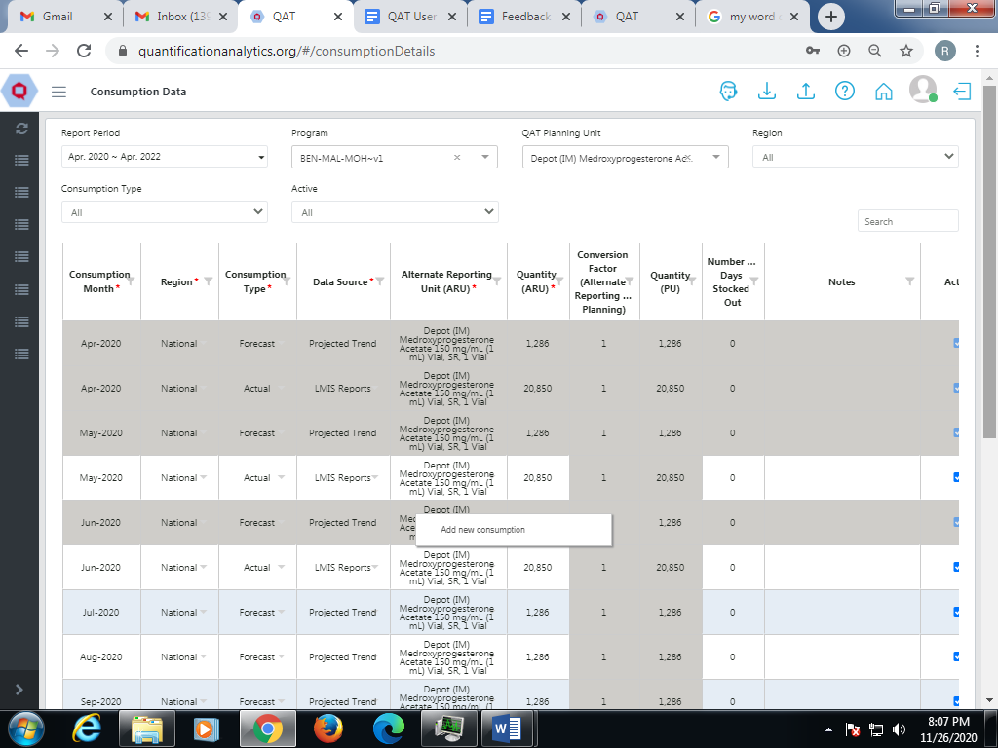

Figure 18.A- Consumption Data

1. To add the new consumption, right click on the cell and select ‘Add new consumption’ or select the blue ‘+ Add row’ at the bottom.

Enter the required information (consumption month, quantity, etc.) and click ‘Submit’.

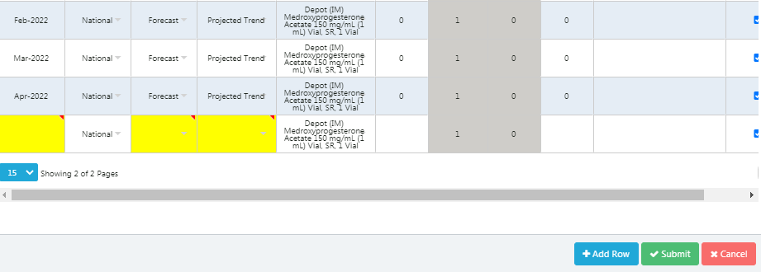

Figure 18. A .a- Add Consumption Data

1. **Show Batch Information**

**This can only be applied to actual consumption.**

1. Right click on the “Actual Consumption” row to add list/batch.
2. Two functions will be shown: Show Batch Information & Add new consumption.
3. Click on Show Batch Information and a pop up of Batch Details will be displayed.
4. The user can add the Batch Number, Expiry Date and Quantity.
5. The batch number can be added manually or the system will automatically add a 23-digit batch number.

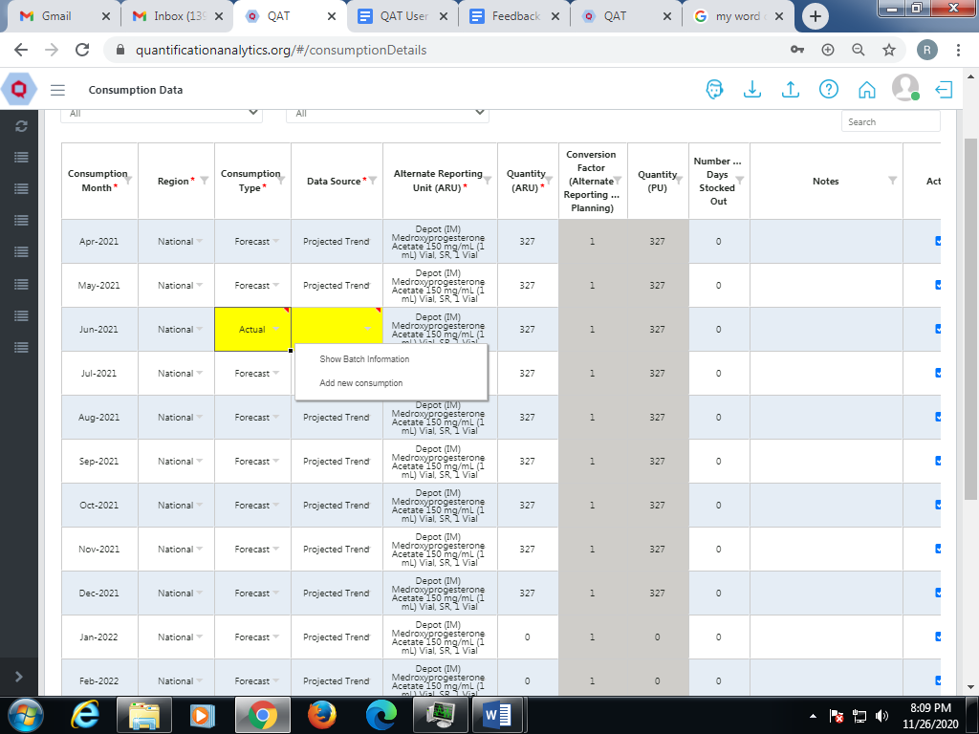

Figure 18. A.b- Show Batch Information

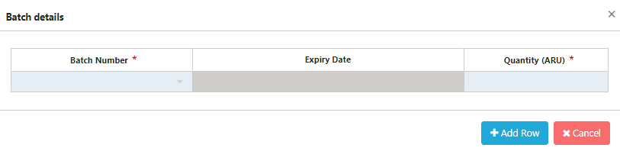

Figure 18. A.b.1- Batch Details

1. **Update Consumption Data**
2. To update the Consumption data, the user can double click on the cells.
3. It will show the respective functions available for that particular function.

**NOTE**: In case of Actual Consumption the user can modify the data only up to the past 6 months while forecasted consumption allows data modification up to the last 4 months.

1. For example, this screen shows that if the user wants to change the Consumption Date, he/she can double click on that specific date and the calendar will be displayed.

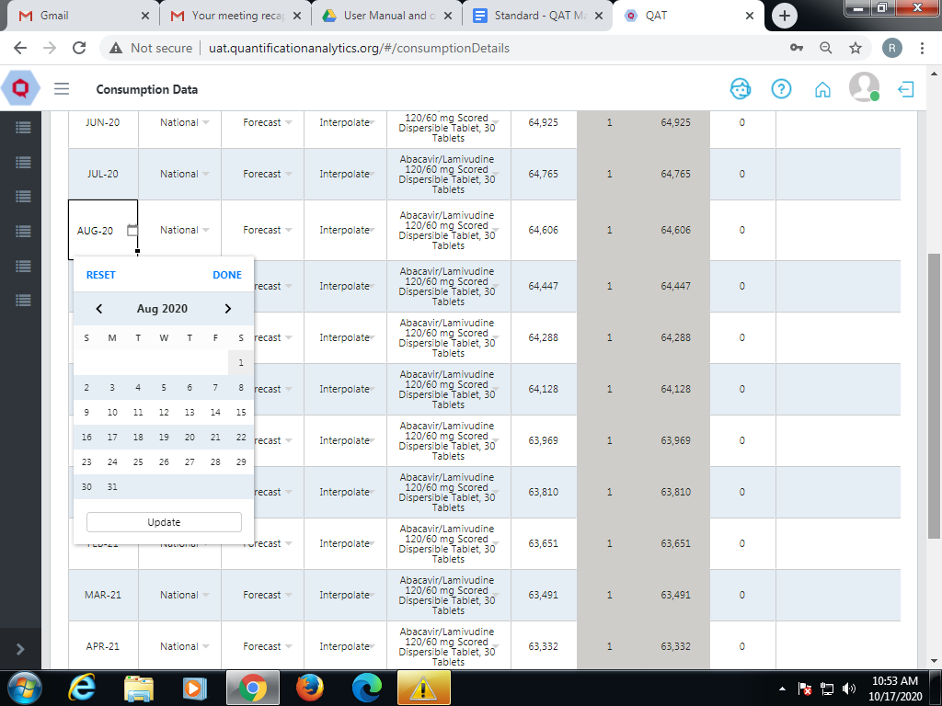

Figure 18. A.c- Update Consumption Data

1. **Delete Consumption Data**

**NOTE:** Once the user submits the data, he/she cannot delete the row.

1. To delete the consumption data before submitting, the user can right click on the newly created row.
2. It will show Add new consumption and Delete selected rows.
3. Click on “Delete selected rows” and the entire row will be deleted.

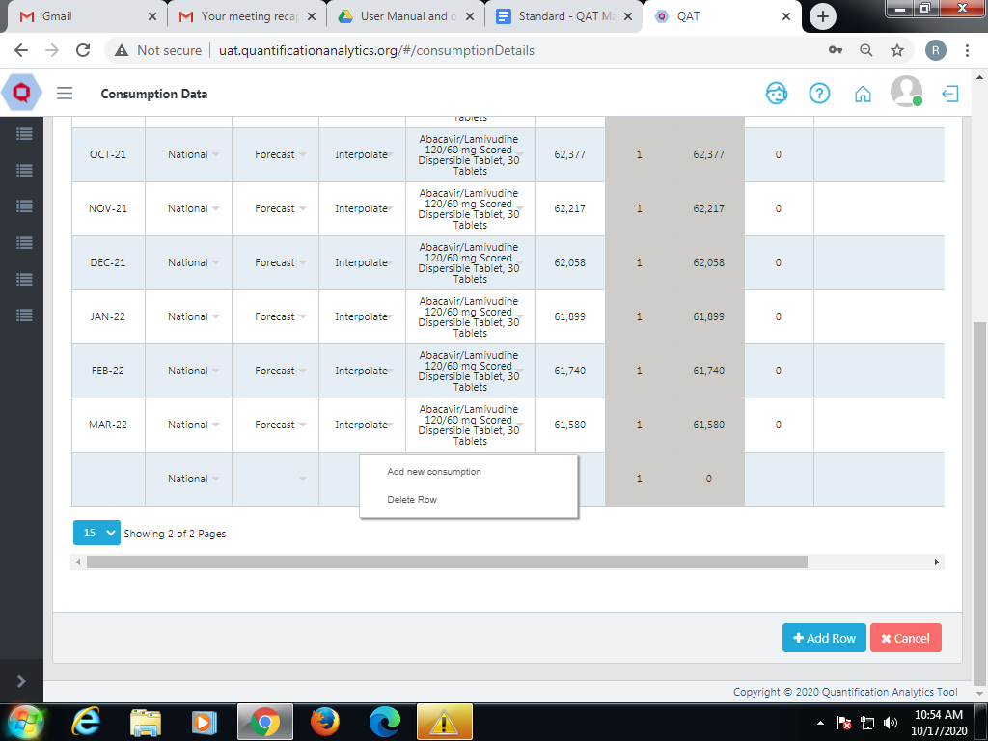

Figure 18. A. d- Delete Consumption Data

## Shipment Data

Shipment data is specifically to add and modify the data.

1. **Add Shipment Data**
2. The screen below shows adding the shipment data into the system
3. Go to “Supply Plan Data” and select Shipment Data.
4. Enter the program and QAT planning unit.
5. Right click on the cell and select “Add new shipment” or select the ‘+Add Row’ button at the bottom of the screen.
6. The row(s) will be added to the table.
7. Enter the required shipment details (e.g. date, status, procurement agent, etc.)
8. Certain details cannot be entered before others. For example, you must enter a funding source before entering the budget.

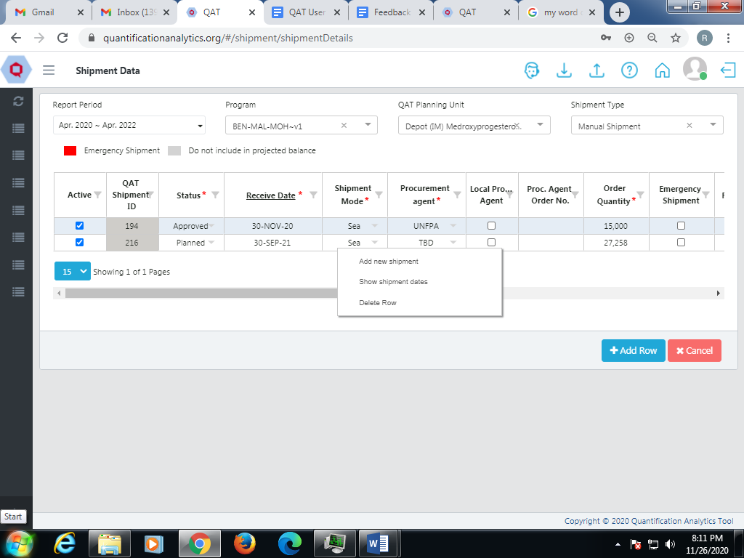

Figure 18.B- Shipment Data

1. To view the Quantity Calculator for strategic product, double click on the cell and “Quantity Calculator” will be displayed on screen.
2. If the product is a non-strategic product, the user can directly modify the order quantity.

But if the product is strategic, the user needs to use the quantity calculator.

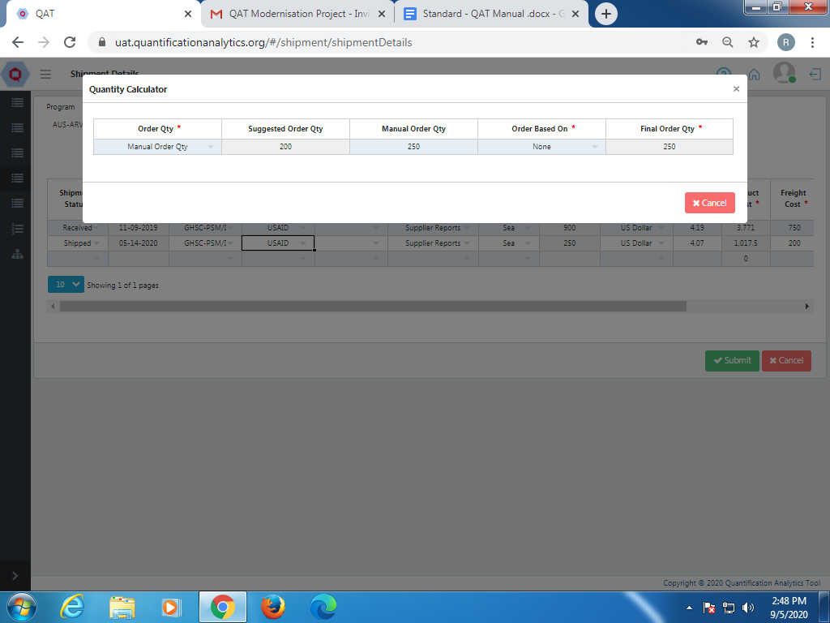

Figure - Quantity Calculator

1. To view the shipment dates, click on the other function i.e. “show shipment dates” and the following screen will be displayed.

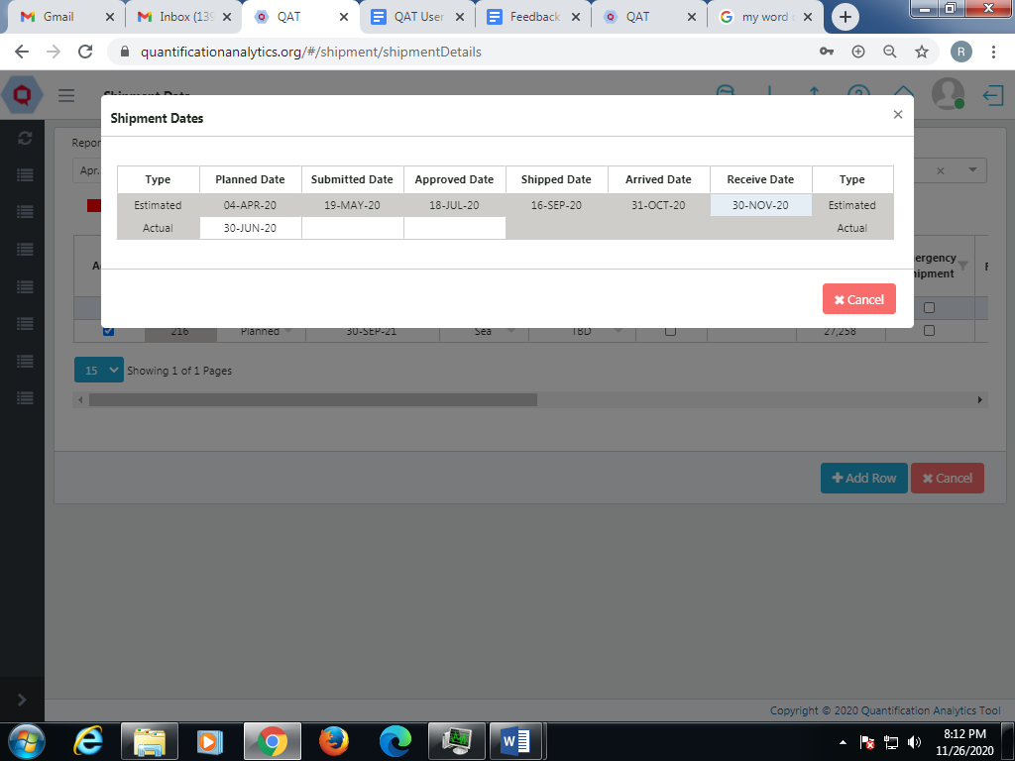

Figure 18. B.a.1Shipment Dates

1. Click on the function “Emergency order” and the data will be displayed in red.

**NOTE**: “Emergency orders” are highlighted in red whereas “Do not include in projected balance” is shown in grey.

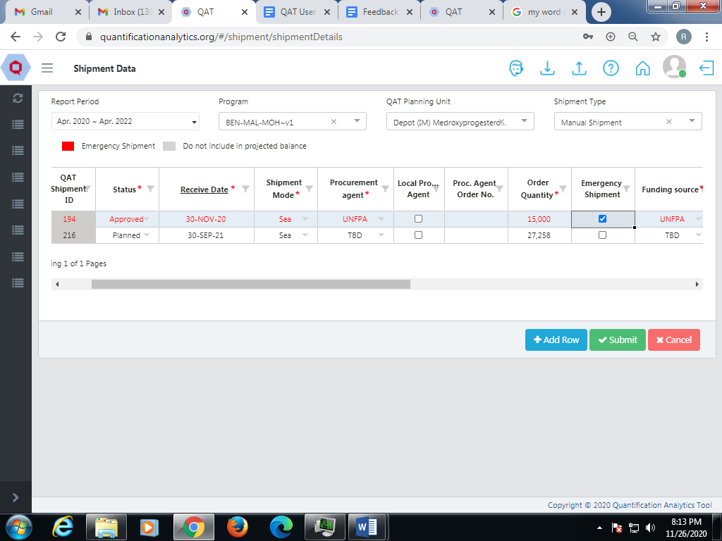

Figure - Emergency Order

1. **Show Batch Information**

**This can only be done for shipments in the ‘Shipped, Arrived and Received’ status.**

To see Batch Information, click on the other function i.e. “Show Batch Information”.

A pop up of Batch Details will be displayed.

The user can right click on that table to “Add new batch”.

The batch number can be added manually or the system will automatically add a 23 digit batch number.

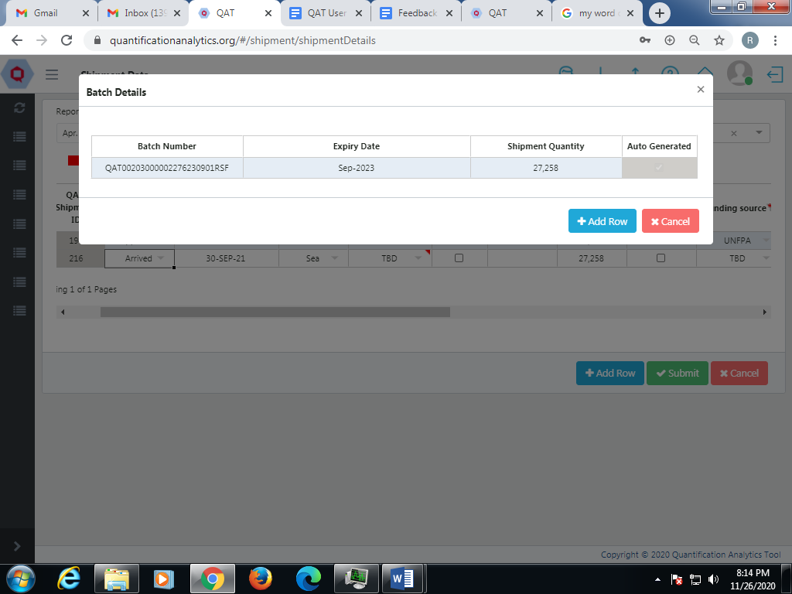

Figure 18.B.b - Show Batch Information

1. **Delete Shipment Data**
2. To delete the Shipment Data, right click on the newly created row.
3. It will show the function to “Delete selected rows”.
4. Click on that function and the entire row will be deleted.

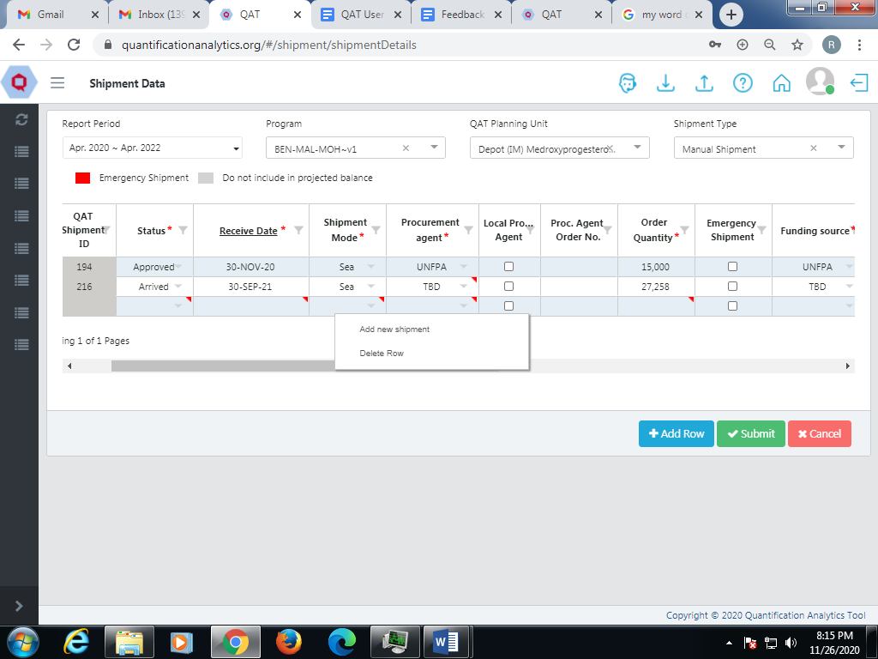

Figure 18.B.c - Deleting Shipment Data

1. **Update Shipment Data**

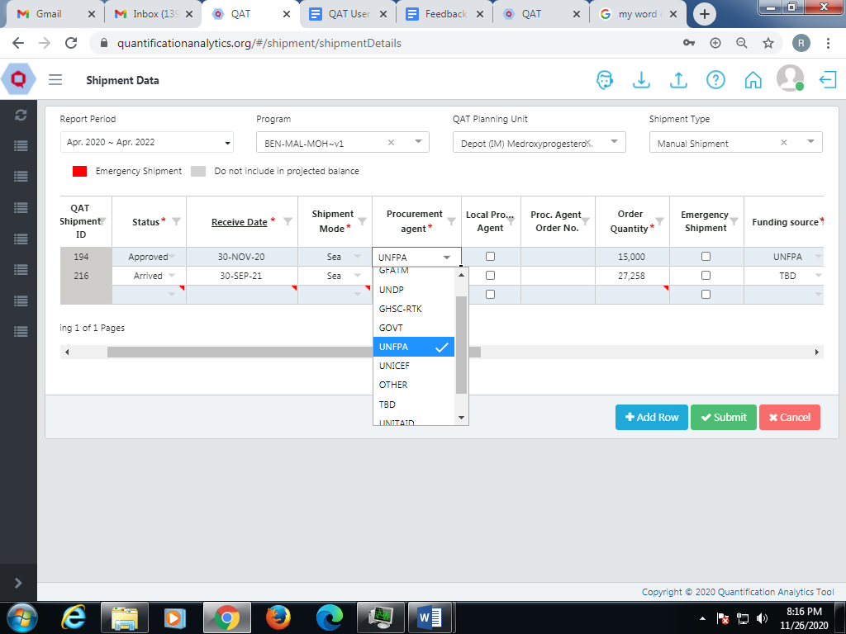

Figure 18.B.d- Update Shipment Data

1. The user can double click on any of the cells to update the Shipment Data.
2. It will show the various functions available for that function.
3. Select the required function and the data will be updated.

## Inventory Data

Inventory Details- Provide details of Region, Inventory date, Expected stock, Manual adjustment, Actual stock and, Active /Inactive status

1. **Adding Inventory Data**
2. Go to “Supply Plan Data” and select Inventory Data.
3. The screen displays the “Add inventory” section. Enter the program, QAT planning unit and Data Type “Inventory”.
4. While adding Inventory Adjustments, select the Data Type as “Adjustments”.
5. Right click on the cell and select “Add new adjustments” or “Add New Inventory Count”. You can also click on the ‘+Add Row’ button at the bottom of the screen.
6. The rows will be added to the table.
7. The following screen shows adding new inventory in Inventory Data Type.

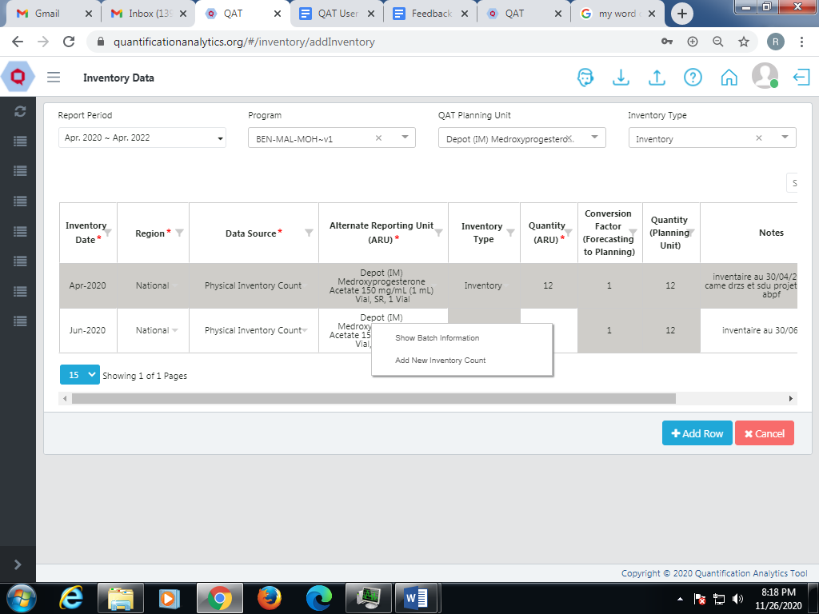

Figure 18.C- Add Inventory Data

1. **Show Batch Information**
2. To see the Batch Information, click on the other function: “Show Batch Information”.
3. A pop up of Batch Details will be displayed.
4. Right click on that table to “Add new batch”.
5. The batch number can be added manually or the system will automatically add a 23-digit batch number.

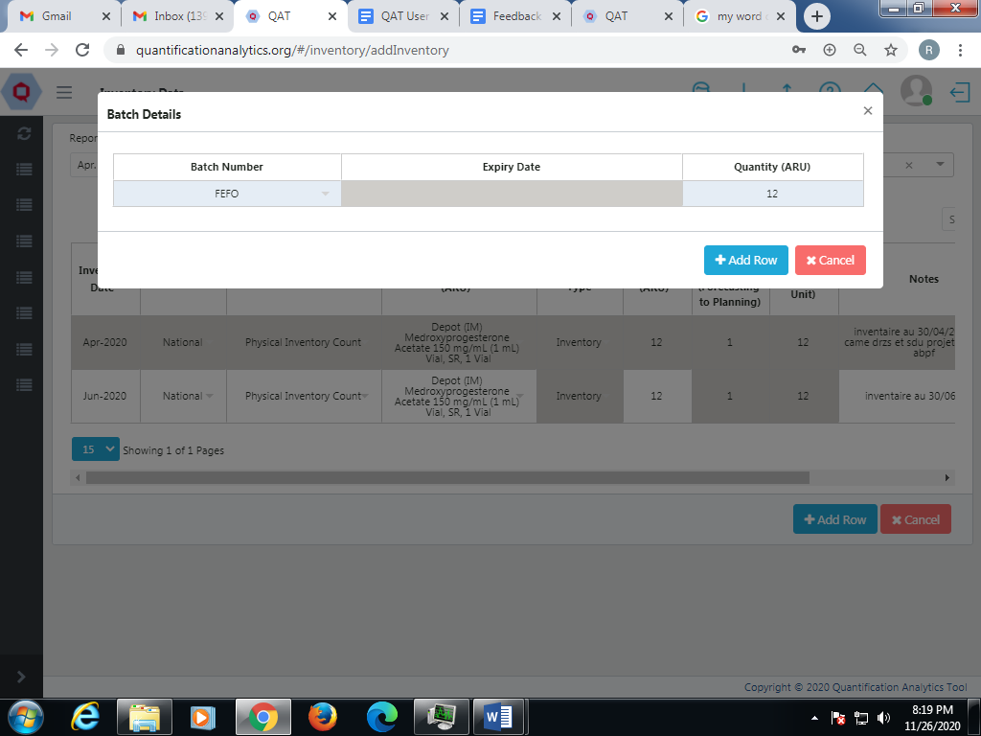

Figure 18.C.a- Batch Details

1. **Update Inventory Data**
2. The user can double click on any of the cells to update the Inventory Data.
3. It will show the respective functions available for that function.
4. Select the required function and the data gets updated.

**Note**: The user can modify the data only up to the past 6 months.

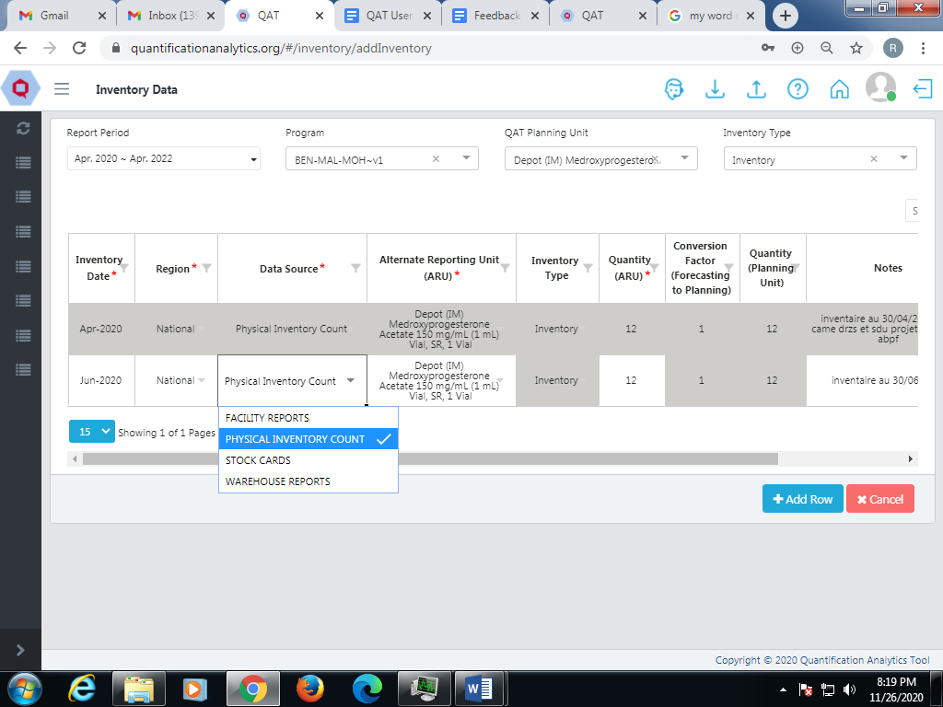

Figure 18.C.b- Update Inventory Data

## ERP Shipment Linking

The QAT system gets order data automatically from the ARTMIS ERP system. Users will normally link QAT orders and ARTMIS orders in ARTMIS using the QAT shipment ID. This function is available for **Application** **Admins, Realm Admins, Program Admins** and **Program Users.**

If an order is not linked through ARTMIS, users have the ability to manually link in QAT. To do this:

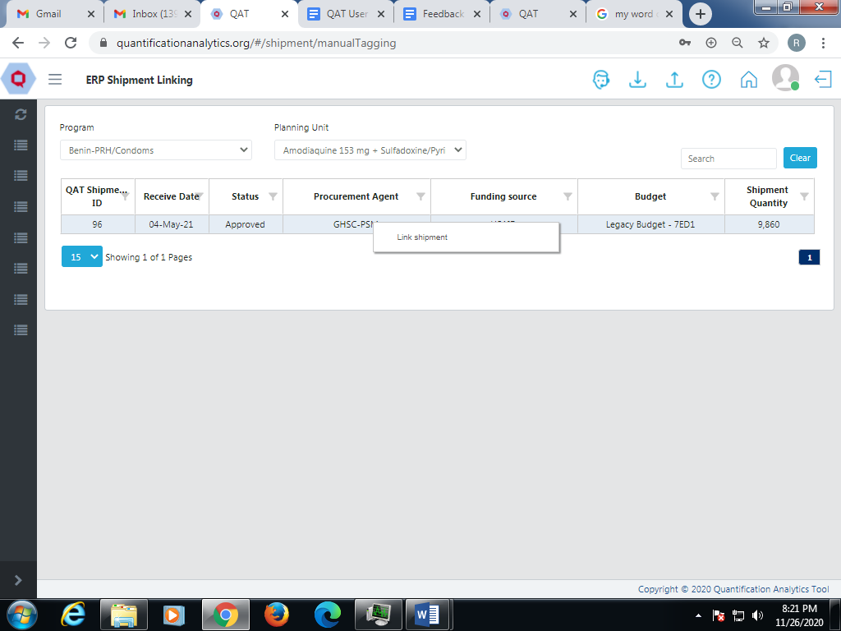

Figure 18.D- ERP Shipment Linking

1. Go to “Supply Plan Data” and select “ERP Shipment Linking”.
2. Select the “Program” and “Planning Unit”.
3. The above data will be displayed on the screen.
4. Double click on the cell in that table.
5. The “Search ERP Orders” table will be shown.
6. Enter the “Order Number” and “Prime Line Number”
7. Click on the “Go” button and the relevant data will be displayed.
8. Click on the “Link” button to link the order number to the prime line number.

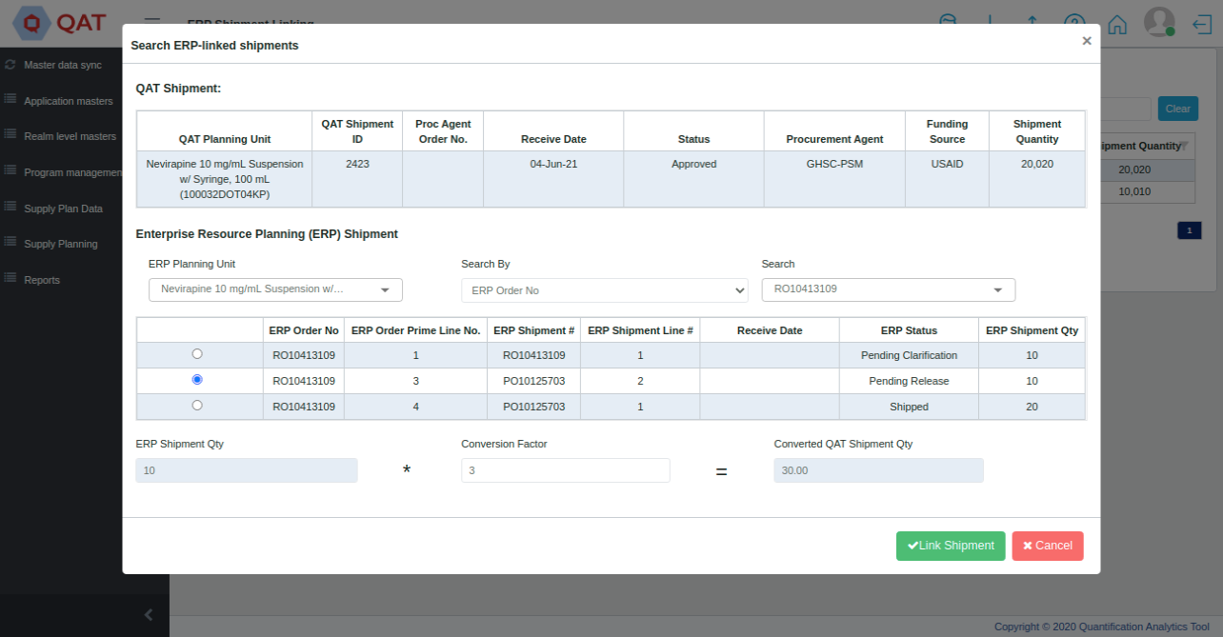

Figure 18.D- Search ERP Linked Shipments

## ERP Shipment Delinking

This function allows the user to delink the QAT shipment ID from the ERP order. This function is available for **Application** **Admins, Realm Admins, Program Admins** and **Program Users.**

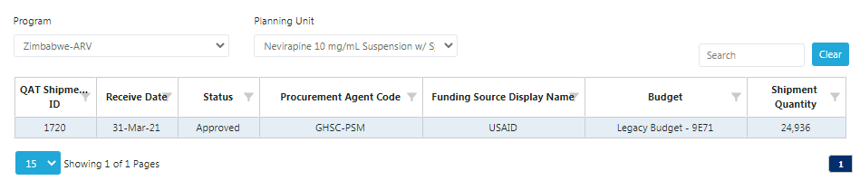

Figure 18.E- ERP Shipment Delinking

1. Go to “Supply Plan Data” and select ERP Shipment Delinking.
2. Select the “Program” and “Planning Unit”.
3. The data will be displayed on the screen.
4. Click on the row and a popup will be displayed.
5. Select “Yes” and click on “Submit”.

## Quantimed Import

Quantimed is an interface system that provides forecasted consumption data needed by QAT users. QAT will allow users to 'import' Quantimed data into QAT and include that in the database. The Quantimed software program is a tool designed to facilitate the process of determining the quantities of medicines and medical supplies required for a health program and to assist in order planning and budgeting. This function is available for **Application** **Admins, Realm Admins, Program Admins** and **Program Users.**

**To Import a Quantimed Data File**

1. Go to “Supply Plan Data”.
2. Select “Quantimed Import”
3. The below screen will be displayed.

**NOTE**: This report is accessible to Program users, Program Admin, and Realm Admin users.

**Step 1: Import Quantimed Data File**

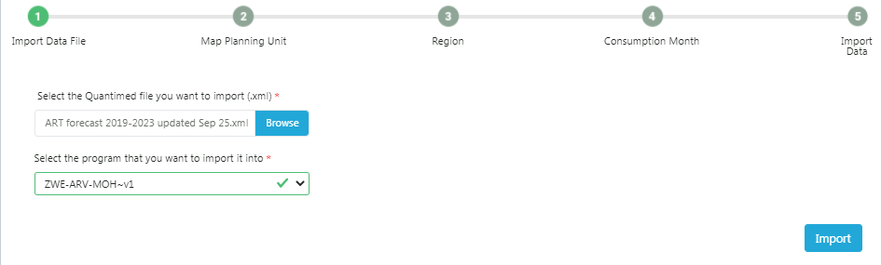

Figure 18.F.1- Import Quantimed Data File

1. Choose the xml file from the local system.
2. Select the program that you want the Quantimed file to import to.
3. Click on the “Import” button as shown above.

**Step 2: Map Planning Unit**

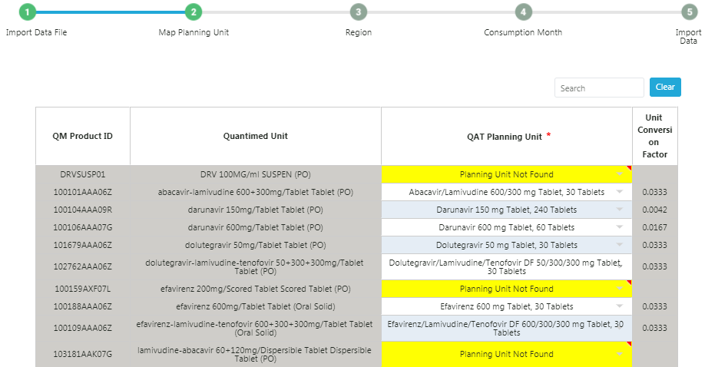

Figure 18.F.2- Map Planning Unit

1. Select the Planning Unit using the drop-down menu.
2. If you do not want to import that planning unit, click on the “DO NOT IMPORT” function.
3. If you do not see the planning unit you are looking for, select “Planning Unit Not Found”
4. Click on “Next” once the planning units are selected.

**Step 3: Region**

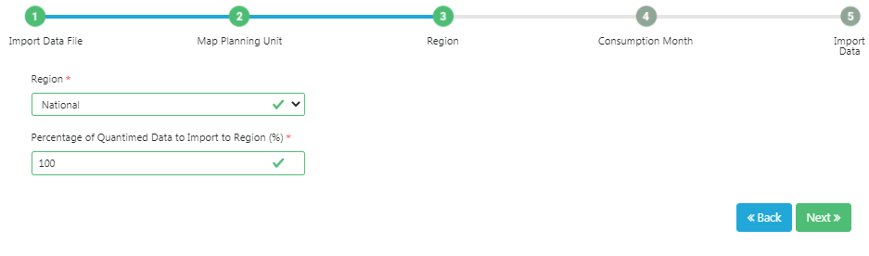

Figure 18.F.3- Region

1. In this step select the Region as required.
2. Click on “Next”.

**Step 4: Consumption Month**

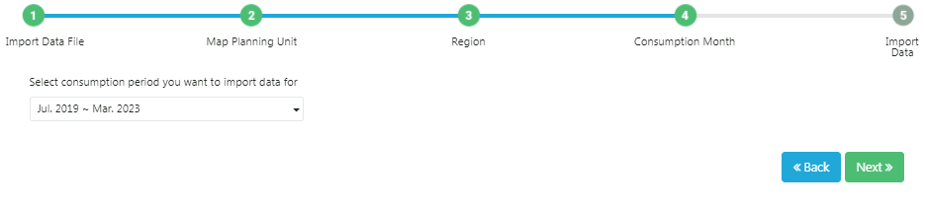

Figure 18.F.4- Consumption Month

1. Select the consumption period as required.
2. The period you select is the period of data that you will be able to import.
3. Click on “Next”.

**Step 5: Import Data** 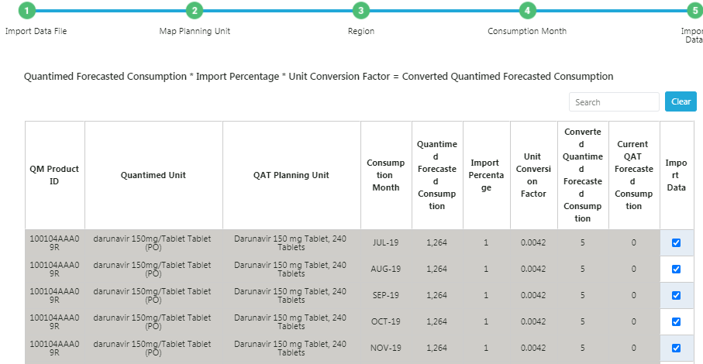

Figure 18.F.5- Import Data

1. The data will be displayed on the screen.
2. If you do not want to import certain records, click on the checkbox in the ‘Import?’ column on the far right. This will prevent QAT from importing that specific data.
3. Click on the “Submit” button to import the data.

# Supply Planning

Supply Planning is the component of supply chain management involved with determining how to best fulfill the requirements created from the demand plan. The objective is to balance supply and demand in a manner that achieves the service delivery and financial objectives of the health program.

## Supply Planning

All major data points (consumption, shipments, inventory) come together on the supply planning module, and this is where many supply planners will spend the majority of their time. Users are able to click on many of the cells in the table to directly edit their data. **Application** **Admins, Realm Admins, Program Admins**, **Supply Plan Reviewers** and **Program Users** can add/edit the supply plan. The Guest User can only view the supply plan.

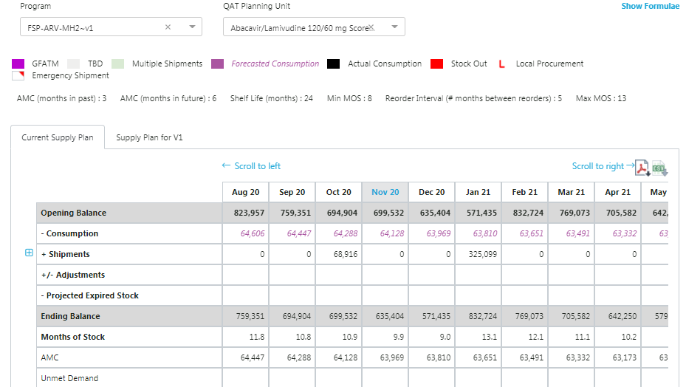

Figure 19.A- Supply planning

1. Supply Planning > “Supply Planning”

To begin:

* 1. Select the required **Program**. The dropdown function in the supply plan will show all the programs that have been downloaded by the user in his local machine. Refer to “Working with Program Data” for details.
  2. Select the required **QAT Product**.

1. The screen displays Supply Plan divided into two parts: **Current Supply Plan** and **Supply Plan for Version1.**
2. By default, the past 5 months and 12 future months from the current date are shown. Use **Scroll to Left/Right** to shows data for 6 months in the past/future

### Opening & Ending Balance

* **Opening Balance** is equal to the ending balance of the previous month, except the very first month of the program, where the opening balance is zero.
* As the user begins the data entry for consumption, shipments and adjustments, the **ending balance** changes. The ending balance is calculated as shown below:

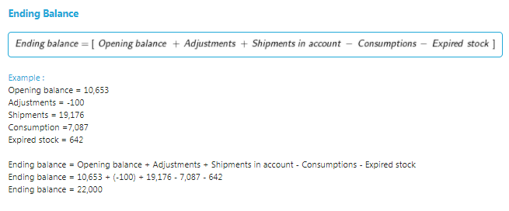

### Consumption

Users can enter two types of consumption: **forecast consumption** and **actual consumption.** Users may not enter actual consumption in months in the future or forecast consumption more than six months in the past from the current month.

Multi-region programs would have multiple rows for entering/editing the consumption records for each region. The total shows the aggregated consumption for all regions.

1. To **add** consumption records, click any cell on the Consumption row of the supply plan. A new window called **Consumption Details** will pop up.
2. Click on the consumption record of any month to display further details.
3. Right click on the details row and select “Add new consumption” to create a new record.

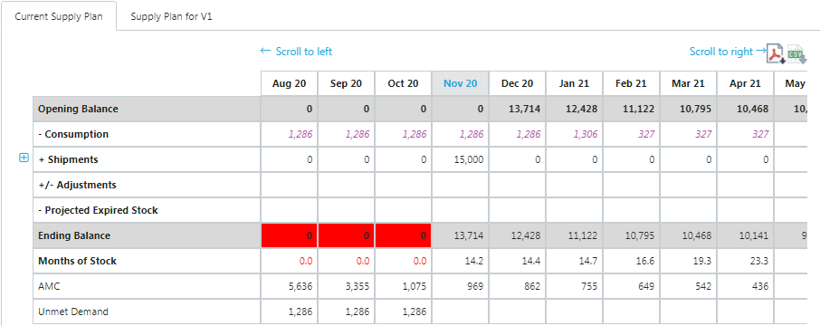

Figure 19.A.b- Supply Plan

1. Add all the required consumption details including consumption type, data source, quantity, etc.
2. Click submit.

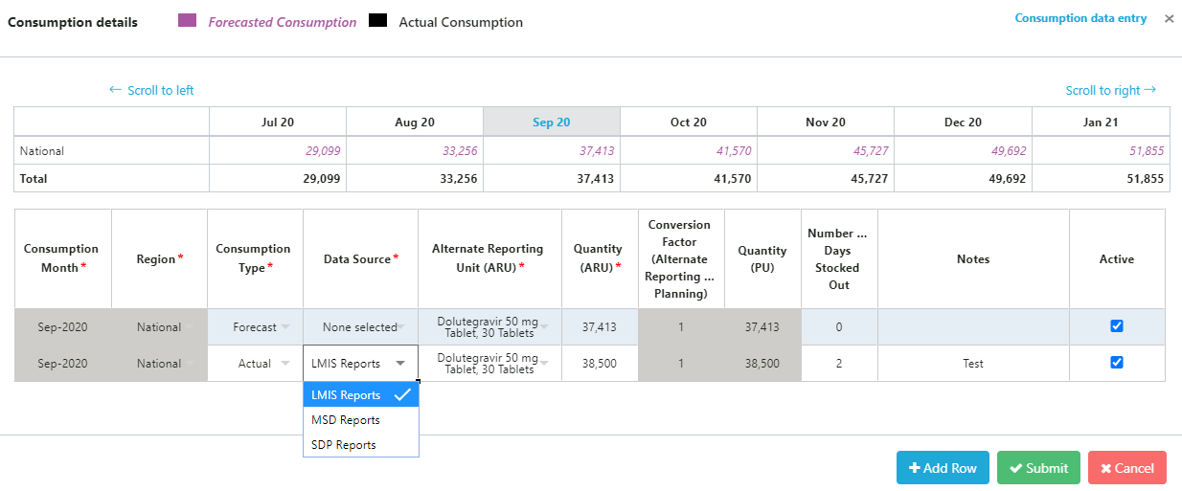

Figure 19.A.b- Supply Plan - Consumption

1. To **edit** a consumption record or any of its details, users can access the Consumption Details screen following step #1-2 above.
2. Edit any of the consumption details and click on “Submit” to save the changes.

Additionally, through the Consumption Details screen, users can access the Consumption data entry by clicking the link on the top right corner “Consumption Data Entry”. This link will redirect the user to the main consumption data entry screen shown on the Supply Plan Data chapter of this manual. A direct click will open a separate tab on the browser. To open it on a separate QAT PWA, right click on the link and select “Open link in new Quantification Analytics Tool window”.

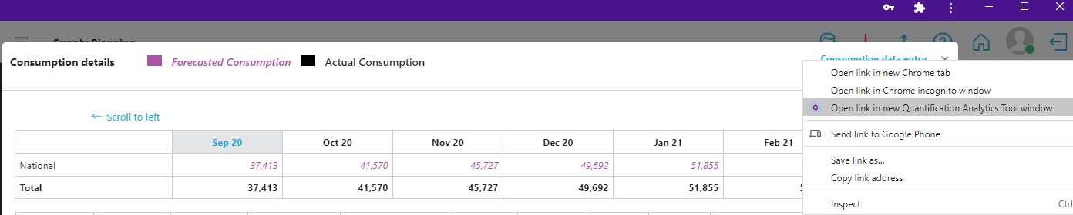

Figure 19.A.b - Quantification Analytics Tool Window

### Shipment

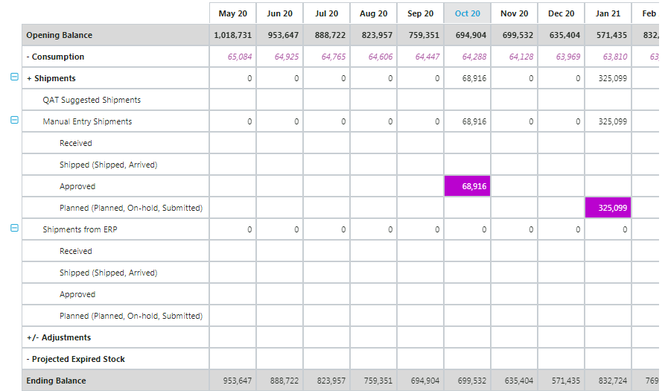

Figure 19.A.c- Shipments

1. The third function in the current supply plan is “Shipment”.
2. Select “Program” and the “QAT product”.
3. Total counts of all the shipments are shown in the shipment row.
4. The next row is for QAT suggested shipments which are shipments “suggested” by QAT to reach maximum stock levels
5. QAT suggests a shipment when inventory of that month is less than the min stock.

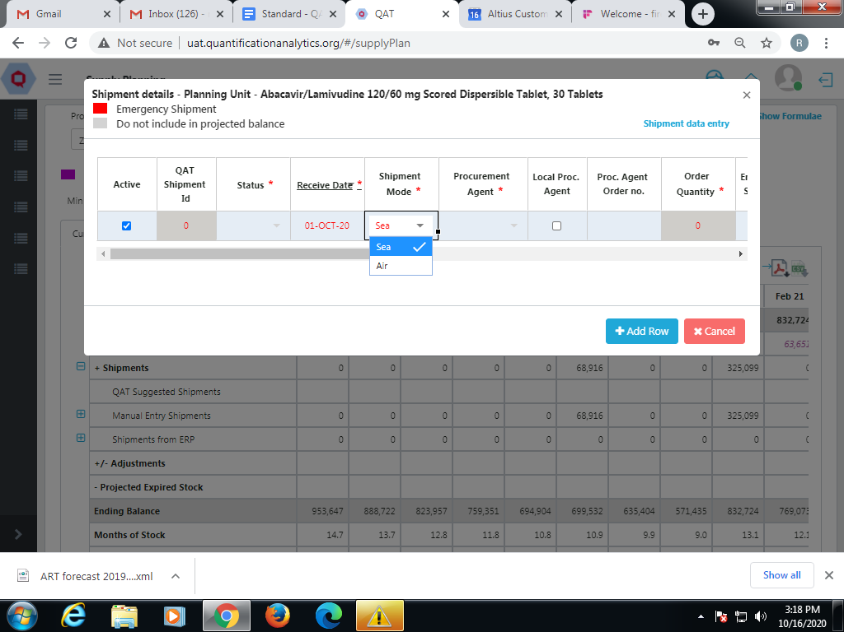

Figure 19.A.c- Supply plan - Shipment

1. Click on the “Shipment Data Entry” function on the top right corner to view the Data Entry page as shown above.
2. Click on the specific cell to view the shipment details.
3. The colors given to the shipment statuses are based on the procurement agent.
4. A red icon indicates the given shipment is an “Emergency Shipment”.
5. The formula to calculate “Suggest Order” is shown below:

|  |
| --- |
|  |

### Manual Entry Shipments

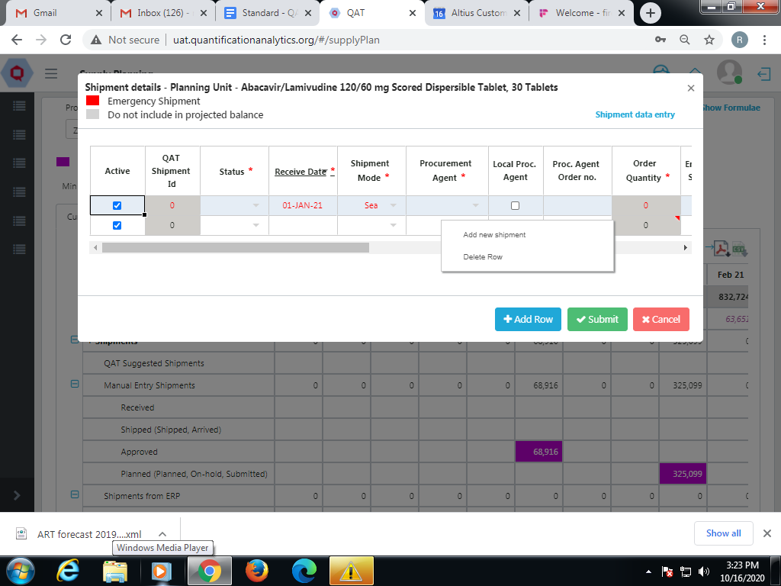

Figure 19.A.d- Supply Plan - Manual Entry Shipment

1. Click on the side button on Manual Entry Shipment and the above screen will be shown.
2. If a user wants to create a shipment for a particular month, click on the cell in the manual entry shipment row.

**NOTE: If a user clicks on the manual entry shipment cell, it will allow the user to create a new manual entry shipment for that particular month. It will not show the existing shipments for that month.**

**Order quantity for manual entry shipments will always be zero. The user can change the quantity later.**

1. Right click on the cells to add new shipments.
2. In case of Emergency shipment, the frozen lead time is shown in red.
3. By using the pull down button the cells, the user can enter the details.
4. If the user wants to convert the suggested shipment status to planned shipment, estimated date will be calculated automatically.

**NOTE**: The user cannot choose the TBD (To be decided) function until the shipment status is designated as planned.

1. If the user selects the shipment status as planned, then he/she doesn’t need to enter the budget in suggested shipments.
2. This list is filtered by data source type.
3. **Shipment mode** – there are two shipment modes i.e. air and sea.
4. There is a function to select currency. Based on the currency selected, the user will get the catalog price.
5. But that price can be changed during negotiation.
6. Freight cost is based on shipment mode.
7. Shipment Mode can be sea or air. Freight cost is affected by whether the Shipment Mode is sea or air.
8. Right click on row, see quantity calculator:
9. Manual order quantity and suggested order quantity can be made by selecting based on quantity.

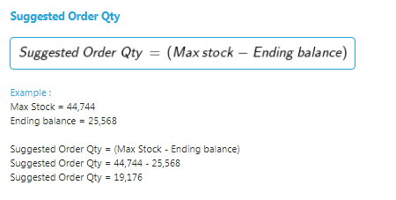

### Adjustments

Users can add/edit stock adjustments by clicking on any cell of the Adjustments row in the supply plan module.

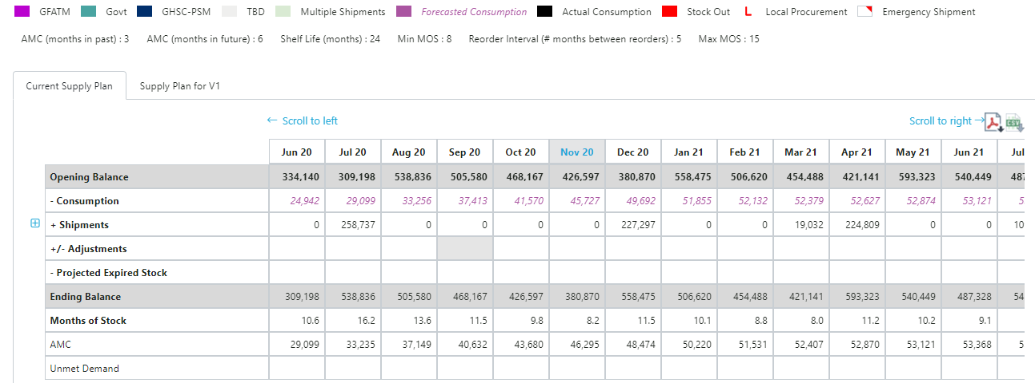

Figure 19.A.e- Adjustments

1. Click on the month and cell on the adjustment row for which you want to display the Adjustments and Inventory Details screen.
2. Click the Adjustment cell under the month you want to add/enter data.
3. Enter the required adjustment details, including data source, quantity, and notes.
4. To add multiple adjustments for the same month, click on add row, or right-click on the adjustment details table and select “Add new adjustment”.

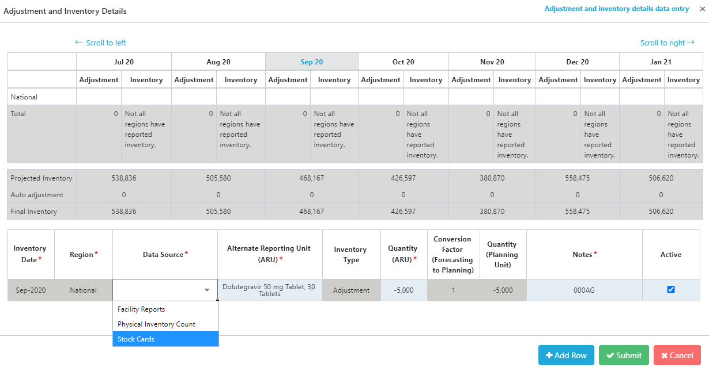

Figure 19.A.e- Supply plan - Adjustment

Users can enter both positive and negative adjustments, in the past and in the future. For multi-region programs, users can enter adjustments for each region, where available.

## Scenario Planning

QAT provides users with predefined scenarios for supply planning. This is a new functionality that previous supply planning software did not include. There are currently six predefined planning scenarios available to users; more can be added depending on the need and use cases. This function is available for **Application** **Admins, Realm Admins, Program Admins, Supply Plan Reviewers** and **Program Users.**

Available scenarios:

* **Increase forecasted consumption**: by a user-defined percentage and timeframe.
* **Decrease forecasted consumption**: by a user-defined percentage and timeframe.
* **Remove unfunded shipments**: all shipments without an assigned funding source (TBD) will be removed from stock projections
* **Remove all Planned shipments not within the lead time**: all shipments with status “planned” that do not comply with the established lead times will be removed from stock projections
* **Remove all Approved shipments not within the lead time**: all shipments with status “approved” that do not comply with the established lead times will be removed from stock projections
* **Remove all Shipped shipments not within the lead time**: all shipments with status “shipped” that do not comply with the established lead times will be removed from stock projections.

To access these scenarios:

1. Go to Supply Planning.
2. Click on “Scenario Planning”.
3. Select a predefined scenario from the dropdown menu and edit the required fields
4. Click Add.

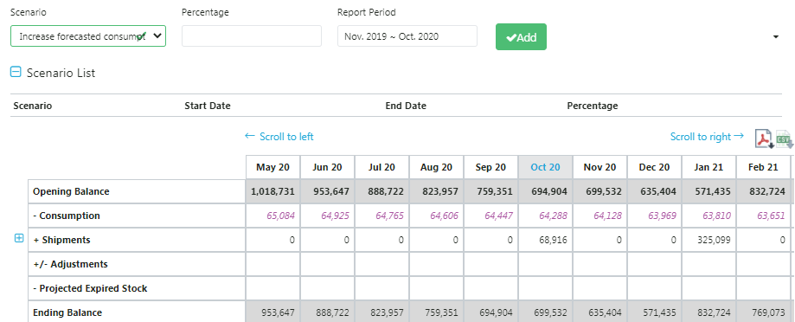

Figure 19.B- Scenario Planning

1. The scenario will be shown in the “Scenario List”.

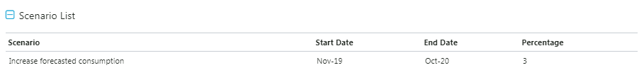

Figure 19.B- Scenario Planning

1. Click on the “Submit” button.
2. The “new” supply plan will get stored in the local machine of that user, and the user can commit this to the server via the Commit functionality.

## Supply Plan Report

**Realm Admins, Program Admins, Guest Users** and **Program Users** can view the supply plan report**.**

***Purpose:*** *To allow the user to quickly assess the stock status of a selected product by graphically comparing the availability of the product to dynamic minimum and maximum inventory levels and to be able to see all consumption, inventory and shipping details in one place.*

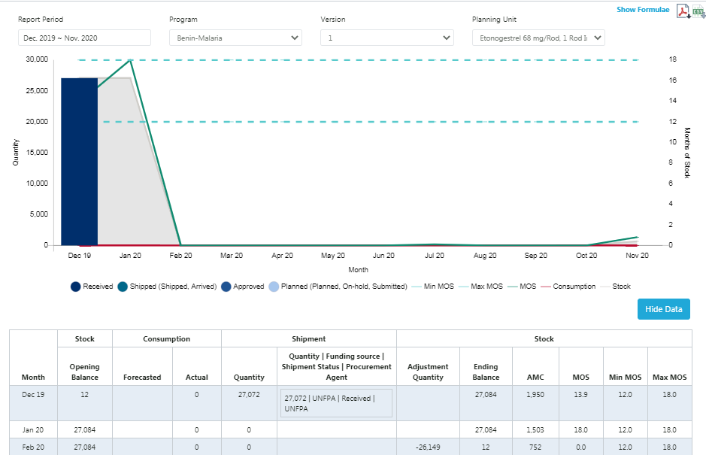

Figure 19.C - Supply Plan Report

1. Go to Supply Planning.
2. Click on the “Supply Plan Report.”
3. Select the Report Period, Program, Version, and required Planning unit.
4. The report is a graphical representation of the supply plan. You can also see a tabular view, by clicking on “Show Data.”
   1. The Shipment Quantity column is the sum of all shipments that have a receive date in that month
   2. The Shipment Quantity | Funding Source | Shipment Status column allows the user to see multiple shipments on the same line that occur in the same month.
5. The stock, consumption, and shipments for a single planning unit can be viewed through this report.

# Reports

QAT Reports allow the user to extract and view their supply planning data in graphs, tables, and other visual formats. They also allow the user to easily navigate, sort, filter, and view the data for specific needs. QAT Reports produce visualizations and display data in a way that can improve decision making.

The QAT Reports are divided into **Global Reports** and **Program Specific Reports**. Program-specific Reports are shown offline, as well as online. However, the Global Reports are shown only in online mode and are only available to Global Users, such as the Realm Administrator and the Application Administrator.

**NOTE:**

All QAT Reports have the ability to be exported into a Comma Separated Values (CSV) file as well as PDF format.

## Importing Data Through an QAT Excel Template -

**Purpose**: If the user changes the language while downloading the report in CSV format, the file may not reflect the language change. Therefore, it is suggested that the user should follow the given procedure in order to get the CSV table in his/her preferred language.

1. Click on the CSV icon on the top right of the screen as shown below:
2. The CSV file will get stored in the Download folder of the user’s PC
3. Open a MS Excel session.
4. Click on the “Data” function.
5. Then Select “From Text” function.
6. Users will need to access the file that is in the Download folder.

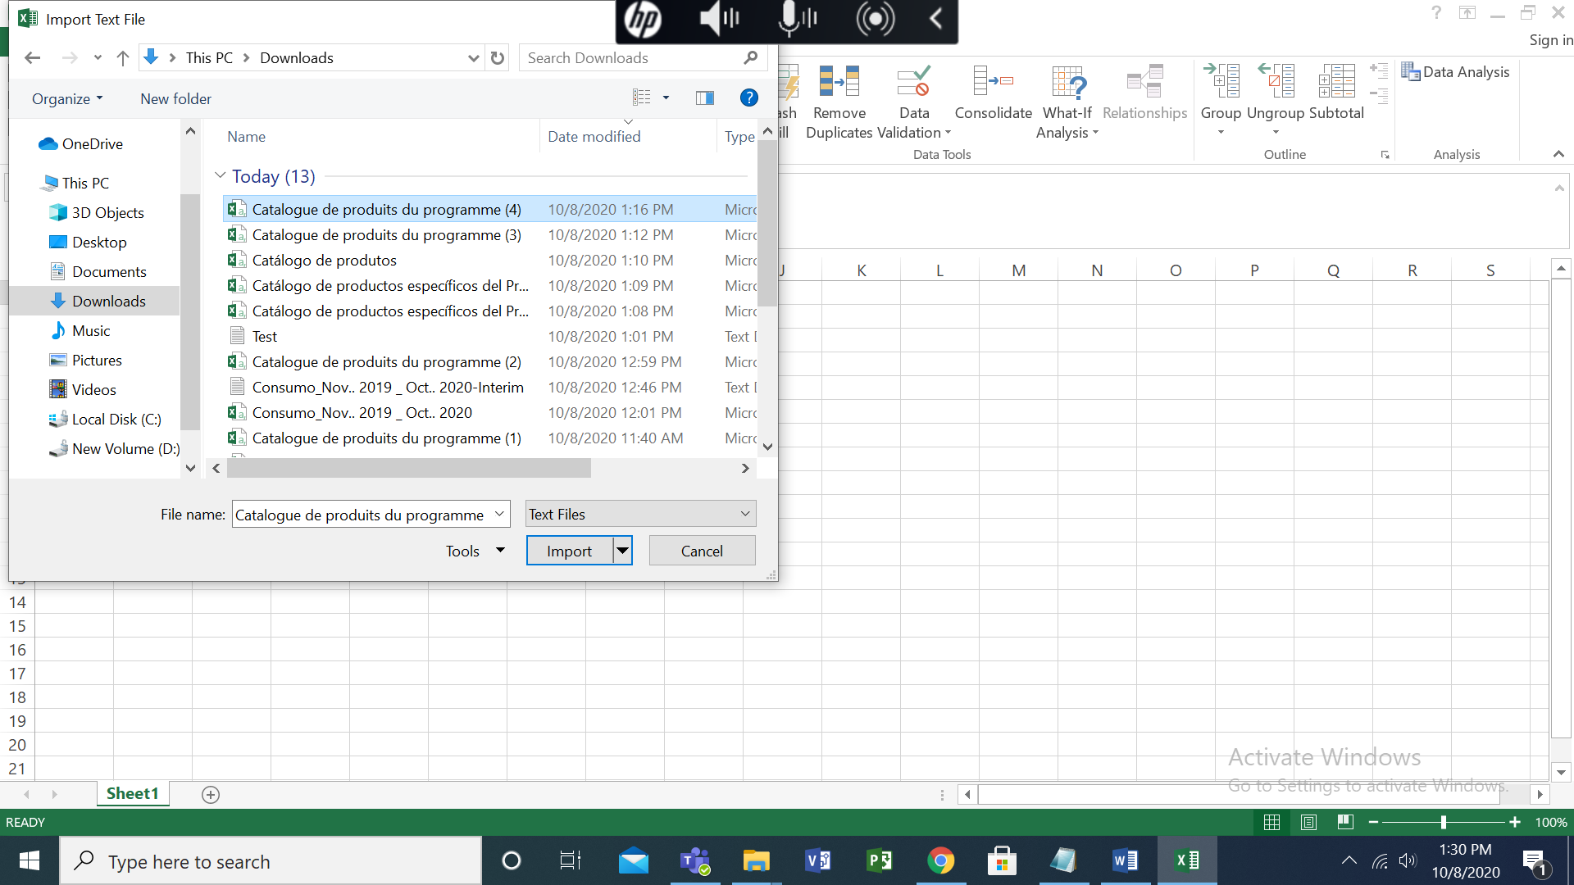

Figure 20.A.1- Import Document

1. Click on the Import button.
2. The below screen will be seen:

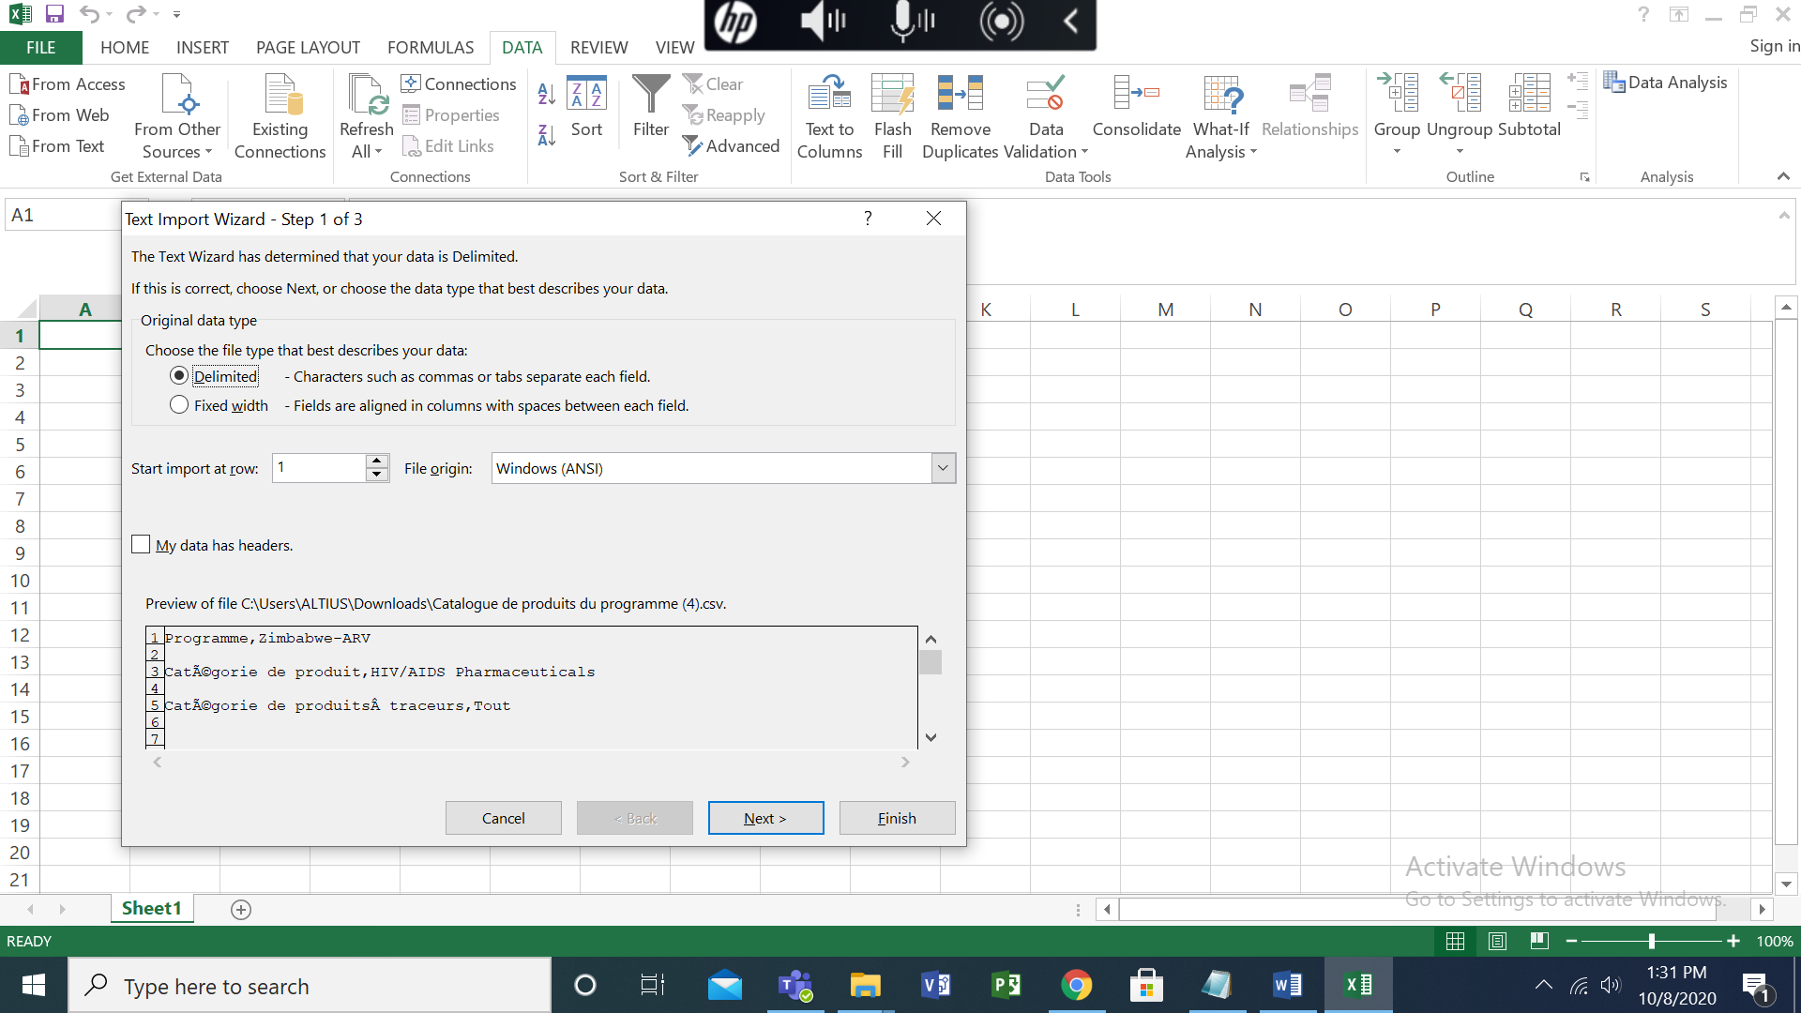

Figure 20.A.2- Import Process

1. In File origin, the dropdown values are sorted alphabetically. Select the **65001: Unicode (UTF-8)** function.

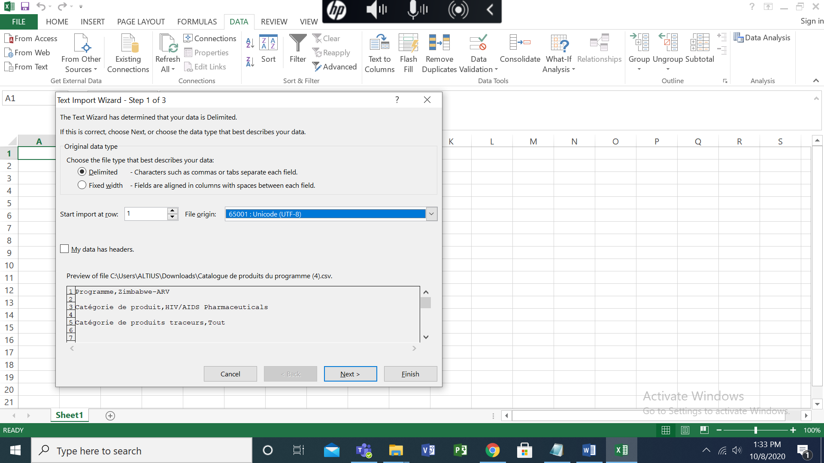

Figure 20.A.3- Saving Procedure

1. Click Next button
2. Select/Check the “Tab” and “Comma” functions as below:

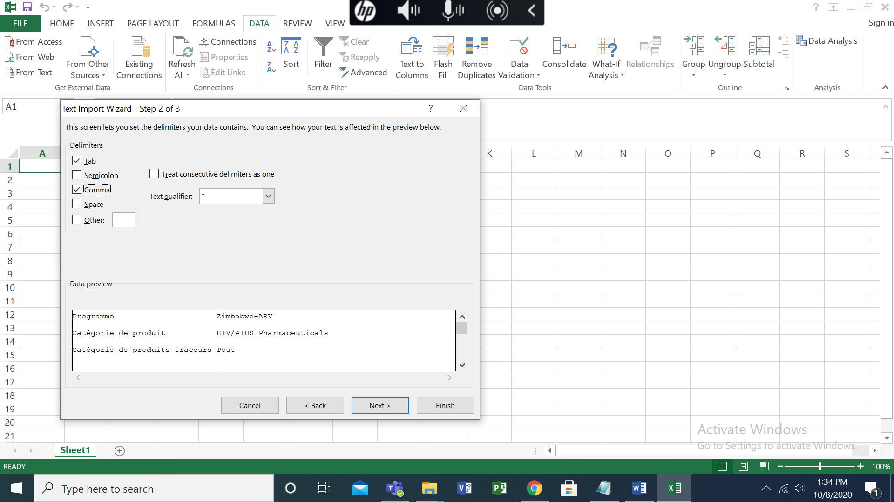

Figure 20.A.4- Finishing the Process

1. Click on Next.
2. Then Click on Finish.
3. The data will render perfectly.

## Important Formulae

For each QAT Report, there are important backend calculations that contribute to the overall data seen in the visualization. These calculations and underlying assumptions can be found by clicking “Show Formulae” in the upper right-hand screen of each QAT Report.

|  |
| --- |
|  |

|  |
| --- |
|  |

|  |
| --- |
|  |

|  |
| --- |
|  |

|  |
| --- |
|  |

## QAT Problem List

**Purpose:** A supply plan review integrated within QAT that allows for a quality check to easily identify problematic data/issues and correct these before committing a supply plan to the server as a “Draft” or “Final” Version.

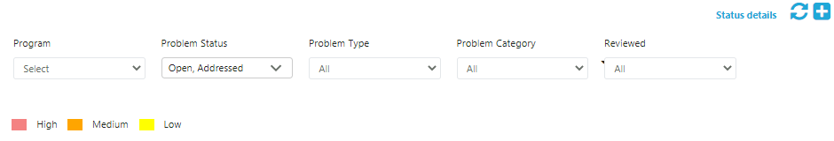

Figure 20.C- QAT Problem List

**Note:** Only the Problem associated with those programs which have been loaded by the user in their local machine will appear in the QAT Problem List. For details on how to load specific programs and versions, refer to the load program section of the User Manual.

**Realm Admins, Program Admins, Guest Users** and **Program Users** can view the QAT Problem Action Report**.**

QAT Problems can be subdivided into three main categories: Data Quality, Procurement Schedule, and Supply Planning. They are also assigned to different levels of criticality: Low (yellow), Medium (orange), and High (red). The criticality informs users the extent to which a problem affects the quality of the supply plan. However, regardless of criticality, all problems must be “In-compliance” or “Addressed” in the QAT Problem List to be committed as a Final Version. There are five main statuses associated with the individual problems in the QAT Problem List:

1. **In-Compliance** – Issue has been closed through data entry by the user. Status will be automatically changed, and notes are not required.

*Example – A planning unit is missing actual consumption in the last 3 months. A user enters actual consumption data for the last 3 months. QAT automatically marks this as ‘in-compliance’.*

1. **Resolved** – Issue has been manually marked by reviewer as ‘resolved’. The reviewer uses this status if this issue will unlikely be corrected via data entry and also does not require further notes in the future. Only a reviewer can mark an issue as ‘resolved’.

*Example – A planning unit gets flagged for not following dynamic forecasting. The user enters a note that this planning unit does not follow dynamic forecasting as it is not a seasonal product. The reviewer marks this as resolved because the explanation will most likely not change in the future.*

1. **Addressed** – Issue has been manually marked by either reviewer or user as ‘addressed’. The user applies this status when they cannot resolve the issue through data entry. This status must be accompanied by a note. The reviewer uses this status if this issue cannot be resolved in this review period, but will be resolved in the future, most likely in a few periods, rather than before the next review.

*Example – A phasing out planning unit only has 8 months of forecasted consumption in the future instead of 18. This is acceptable as it is a phasing out planning unit, but the user will still need to de-activate the planning unit once it is fully phased out, which is why the issue is marked as ‘addressed’ instead of ‘resolved’.*

1. **Open** – This issue has been automatically flagged by QAT, or the issue has been manually marked by the reviewer as ‘open’. The reviewer uses this status when rejecting a supply plan to indicate that the notes are not accepted. The reviewer uses this status when accepting a supply plan to indicate this issue cannot be resolved this review period but should be corrected via data entry or addressed next review period.

*Example – A shipment with a receive date in the next 6 months is missing a funding source. The user notes that they will have a funder assigned to this shipment next month. The reviewer wants to ensure the funder is added for the next submission and thus marks it as ‘open,’ instead of ‘addressed.’*

1. **Reviewed -** The issue has been reviewed by the supply plan reviewer. This field is only editable by the supply plan reviewer.

**Problem 1: Missing recent actual consumption inputs (within the last 3 months)**

Consider that the actual consumption for a Planning unit has been missing for the last **3 months or more.** In this case the Planning Unit is Abacavir/Lamivudine 120/60 mg Scored Dispersible Tablet, 30 Tablets is missing recent actual consumption (within the last 3 months)

**NOTE:** The problem arises only when the actual consumption inputs for the last three months or more are not filled in. If the inputs are filled in for any of those three months, the problem will not be identified by the system.

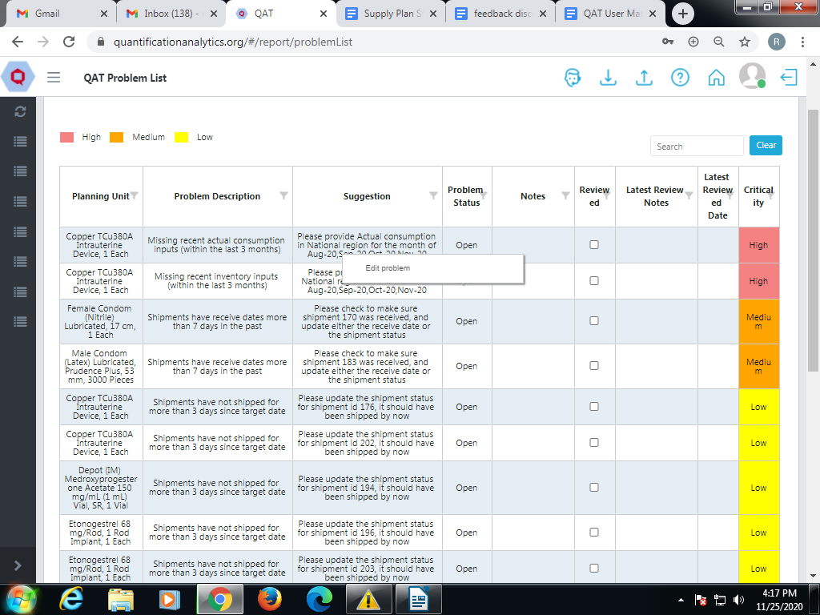

Figure 20.C.1- Missing recent actual consumption inputs

1. The screen will show the problem description and suggest how to resolve the problem.
2. In this particular case, check recent actual consumption inputs for Abacavir/Lamivudine 120/60 mg Scored Dispersible Tablet, 30 Tablets and provide data for June, July, and August.
3. To **close** this problem, click on it and you will be redirected to the “Consumption Details” screen where the required data can be entered.

OR

1. To **address** this problem, right click on it and then click “Edit Problem.” You will be redirected to the “Update Problem” screen.
2. Scroll down to the bottom, and from the Problem Status dropdown, choose “Addressed,” add a note as to why this problem cannot be closed through data entry, and click “Update.”

**Problem 2: Any gaps in the last 3 months (actual consumption)**

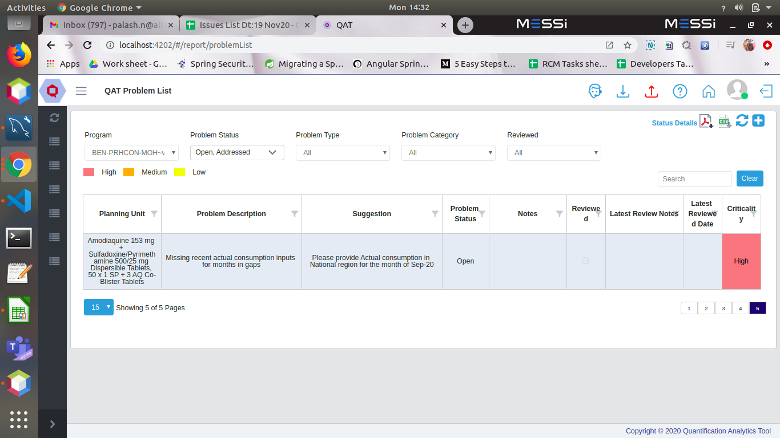

Figure 20.C.2- Any gaps in the last 3 months

Consider that the actual consumption of the middle month has been missing in the last **3 months.** In this case the Planning Unit is Abacavir/Lamivudine 120/60 mg Scored Dispersible Tablet, 30 Tablets.

1. The screen will show the problem description and suggest how to resolve the problem.
2. In this particular case, check recent actual consumption inputs for Abacavir/Lamivudine 120/60 mg Scored Dispersible Tablet, 30 Tablets and provide data for July.
3. To **close** this problem, click on it and you will be redirected to the “Consumption Details” screen where the required data can be entered.

OR

1. To **address** this problem, right click on it and then click “Edit Problem.” You will be redirected to the “Update Problem” screen.
2. Scroll down to the bottom, and from the Problem Status dropdown, chose “Addressed,” add a note as to why this problem cannot be closed through data entry, and click “Update.”

**Problem 3: Missing recent inventory inputs (within the last 3 months)**

Consider that the inventory for a Planning unit has been missing for the last **3 months or more.** In this case the Planning Unit is Abacavir/Lamivudine 120/60 mg Scored Dispersible Tablet, 30 Tablets.

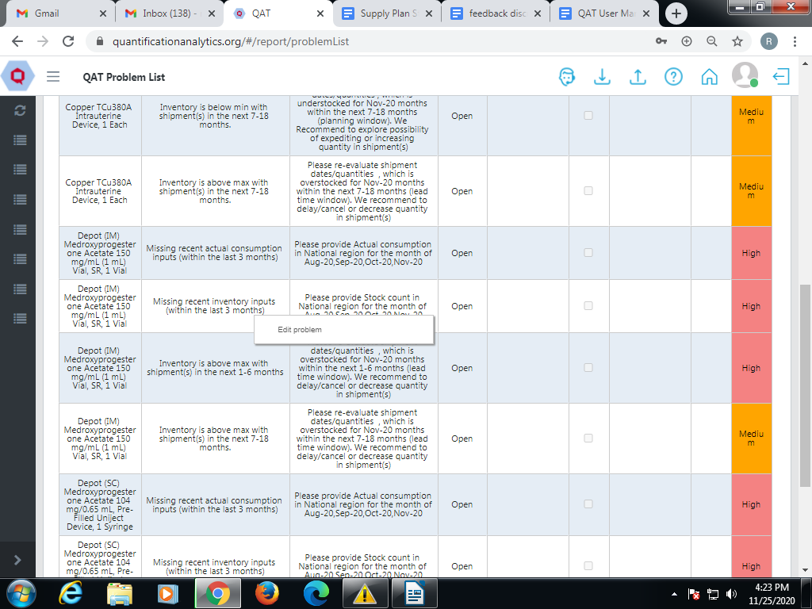

Figure 20.C.3- Missing recent inventory inputs

1. The screen will show the problem description and suggest how to resolve the problem.
2. In this particular case, check recent inventory inputs for Abacavir/Lamivudine 120/60 mg Scored Dispersible Tablet, 30 Tablets and provide data for June, July, and August.

To **close** this problem, click on it and you will be redirected to the “Inventory Details” screen where the required data can be entered.

OR

To **address** this problem, right click on it and then click “Edit Problem.” You will be redirected to the “Update Problem” screen.

Scroll down to the bottom, and from the Problem Status dropdown, chose “Addressed,” add a note as to why this problem cannot be closed through data entry, and click “Update.”

**Problem 4: Shipments with received dates in the past**

Assume the expected delivery date for a shipment is September 1, but the shipment does not arrive on September 1. QAT will not report a problem until September 8.

7 days is the buffer time for the problem to be flagged.

1. The status of the order was not changed to “Received/Delivered” by users. The system is programmed to wait 7 days before updating the status. There can be multiple reasons for delay.

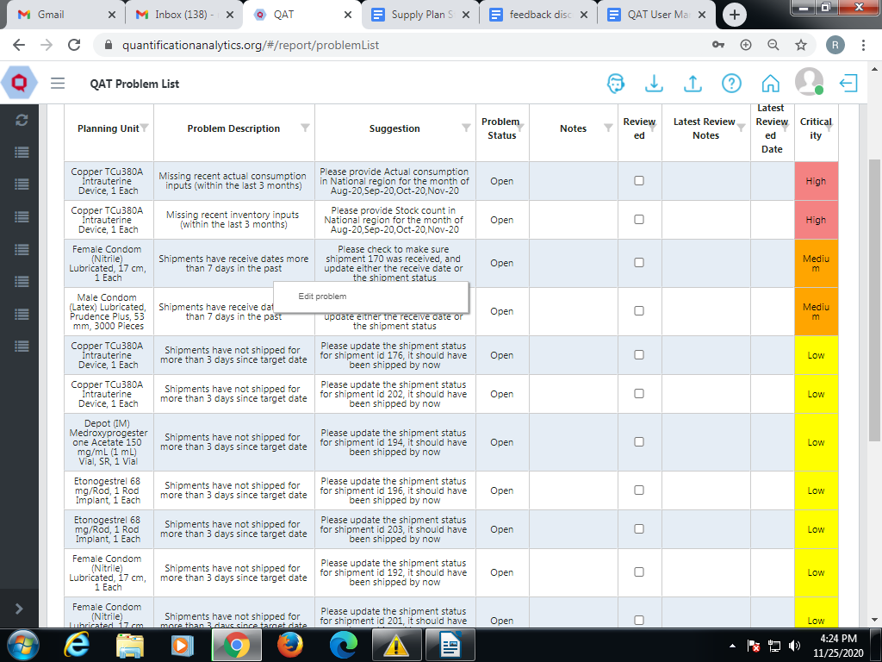

Figure 20.C.4- Shipments with received dates in the past

1. The screen will show the problem description and suggest how to resolve the problem.
2. In this particular case, check shipment receive dates or shipment statuses for Shipment ID 73

To **close** this problem, click on it and you will be redirected to the “Shipment Details” screen where the required data can be entered.

OR

To **address** this problem, right click on it and then click “Edit Problem.” You will be redirected to the “Update Problem” screen.

Scroll down to the bottom, and from the Problem Status dropdown, choose “Addressed,” add a note as to why this problem cannot be closed through data entry, and click “Update.”

**Problem 5: Shipments that should have been Submitted before the current date, but are still in the Planned Stage**

Consider for a particular shipment the status has not changed to “Submit” on the given targeted date.

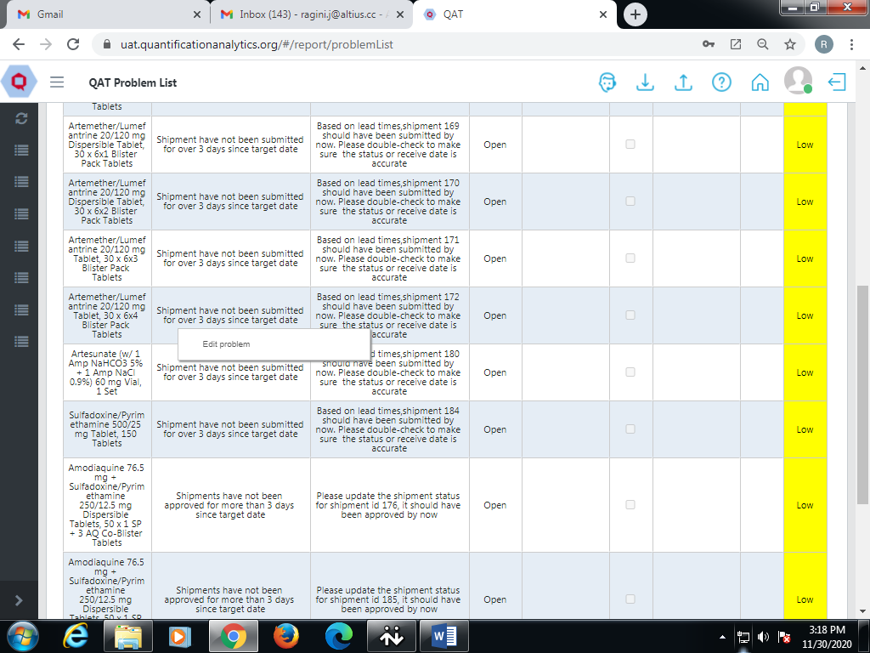

Figure 20.C.5- Shipments that should have been Submitted

1. The screen will show the problem description and suggest how to resolve the problem.
2. In this particular case, check shipment submitted dates or shipment statuses for Shipment ID 172

To **close** this problem, click on it and you will be redirected to the “Shipment Details” screen where the required data can be entered.

OR

To **address** this problem, right click on it and then click “Edit Problem.” You will be redirected to the “Update Problem” screen.

Scroll down to the bottom, and from the Problem Status dropdown, choose “Addressed,” add a note as to why this problem cannot be closed through data entry, and click “Update.”

**Problem 6: Shipments that should have been Approved by now but are still in Submitted or earlier stage**

Assume that for a particular shipment the status has not changed to “Approved” on the given target date.

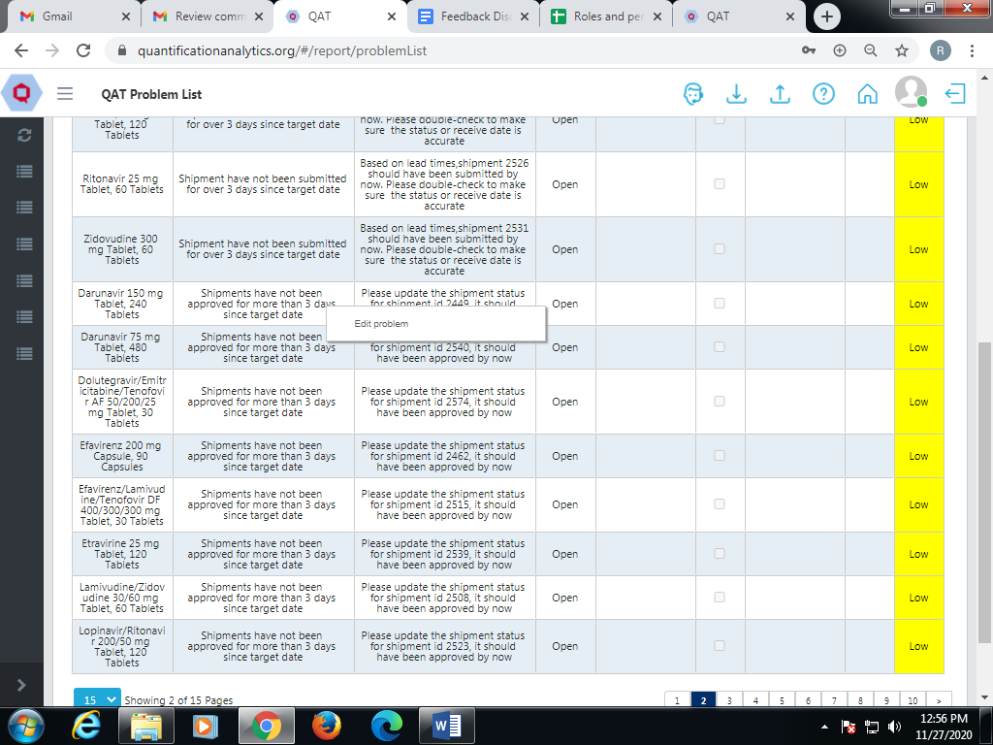

Figure 20.C.6- Shipments that should have been Approved

1. The screen will show the problem description and suggest how to resolve the problem.

In this particular case, check shipment approved dates or shipment statuses for Shipment ID 2540

To **close** this problem, click on it and you will be redirected to the “Shipment Details” screen where the required data can be entered.

OR

To **address** this problem, right click on it and then click “Edit Problem.” You will be redirected to the “Update Problem” screen.

Scroll down to the bottom, and from the Problem Status dropdown, chose “Addressed,” add a note as to why this problem cannot be closed through data entry, and click “Update.”

**Problem 7: Shipments that should have been Shipped but are still in Approved or earlier stage**

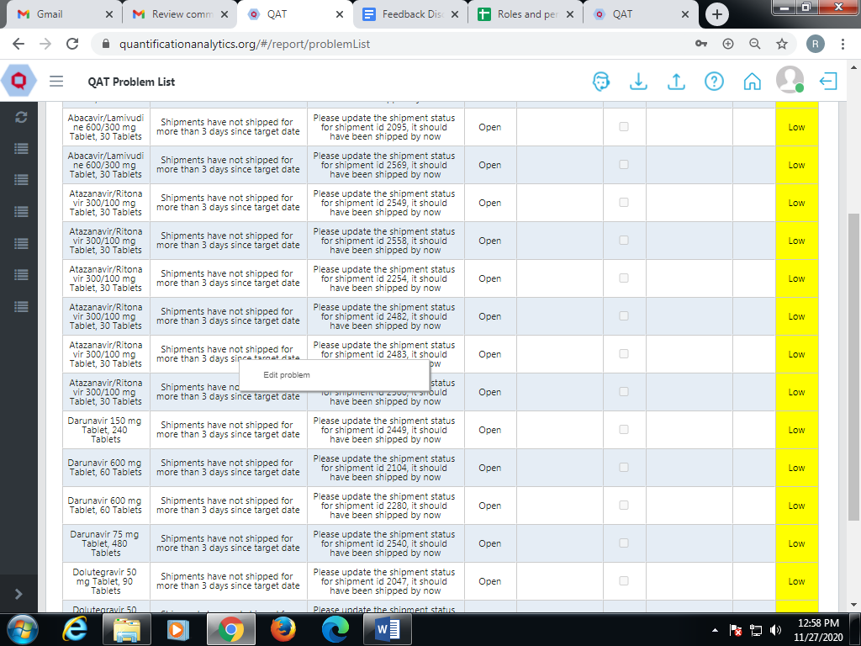

Figure 20.C.7- Shipments that should have been Shipped

Assume that for a particular shipment the status has not changed to “Shipped” on the given target date.

1. The screen will show the problem description and suggest how to resolve the problem.
2. In this particular case, check shipment shipped dates or shipment statuses for Shipment ID 2483
3. To **close** this problem, click on it and you will be redirected to the “Shipment Details” screen where the required data can be entered.

OR

1. To **address** this problem, right click on it and then click “Edit Problem.” You will be redirected to the “Update Problem” screen.
2. Scroll down to the bottom, and from the Problem Status dropdown, choose “Addressed,” add a note as to why this problem cannot be closed through data entry, and click “Update.”

**Problem 8: Shipments that should have Arrived but are still in Shipped or earlier stage**

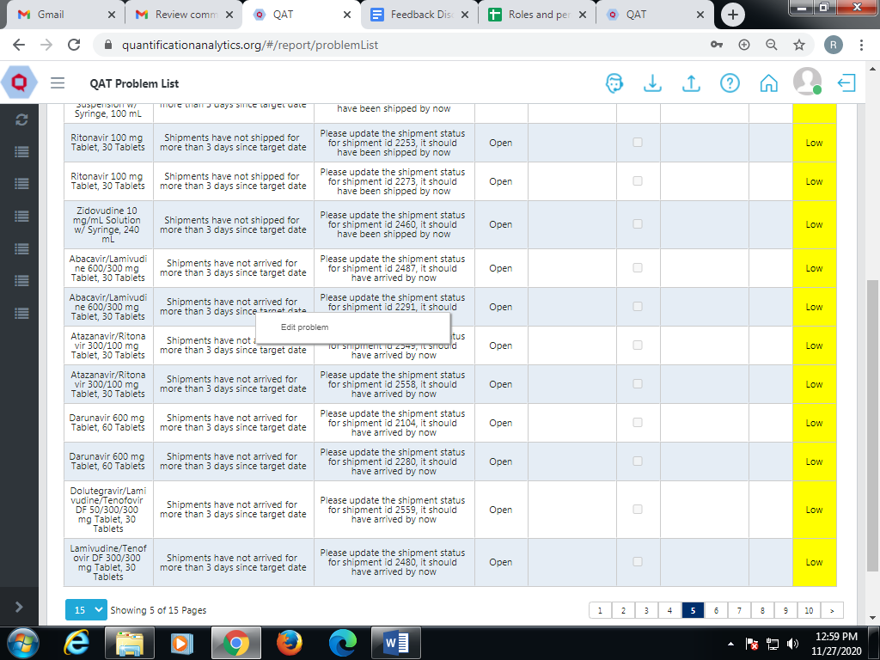

Figure 20.C.8- Shipments that should have Arrived

Assume for a particular shipment the status has not changed to “Arrived” on the given target date.

1. The screen will show the problem description and suggest how to resolve the problem.
2. In this particular case, check shipment arrived dates or shipment statuses for Shipment ID 2291.
3. To **close** this problem, click on it and you will be redirected to the “Shipment Details” screen where the required data can be entered.

OR

1. To **address** this problem, right click on it and then click “Edit Problem.” You will be redirected to the “Update Problem” screen.
2. Scroll down to the bottom, and from the Problem Status dropdown, chose “Addressed,” add a note as to why this problem cannot be closed through data entry, and click “Update.”

**Problem 9: Supply Plan lacks forecasted consumption within the next 18 months**

Assume that the forecasted consumption for a Planning unit for the next **18 months** has been missing**.** In this case the Planning Unit is Nevirapine/Lamivudine/Zidovudine 50/30/60 mg Dispersible Tablet, 60 mg.

For a period of 18 months, if the forecasted consumption for one or more months is not available, the system will flag a problem. To resolve this problem, the forecasted consumption data should be filled in for every month in the next 18 months.

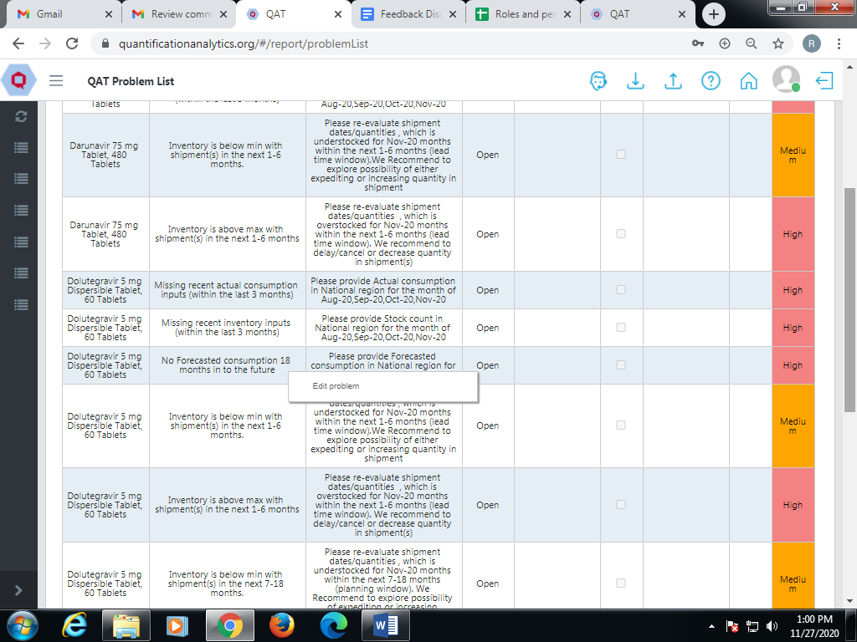

Figure 20.C.9- Supply Plan lacks forecasted consumption

1. The screen will show the problem description and suggest how to resolve the problem.
2. In this particular case, check forecasted consumption inputs for Nevirapine/Lamivudine/Zidovudine 50/30/60 mg Dispersible Tablet, 60 mg and provide data for 18 months into the future.

To **close** this problem, click on it and you will be redirected to the “Consumption Details” screen where the required data can be entered.

OR

To **address** this problem, right click on it and then click “Edit Problem.” You will be redirected to the “Update Problem” screen.

Scroll down to the bottom, and from the Problem Status dropdown, choose “Addressed,” add a note as to why this problem cannot be closed through data entry, and click “Update.”

**Problem 10: Dynamic forecasting is not used for commodity groups (Malaria, ARV, VMMC)**

Any products that belong to tracer categories: Malaria, ARV, or VMMC will be screened for dynamic forecasting. Dynamic forecasting has been utilized as long as forecasted consumption for these three commodity groups do not have four consecutive months with static consumption.

Let us consider the example of Malaria. For all malaria tracer categories and their planning units, the consumption should not be static for four consecutive months.

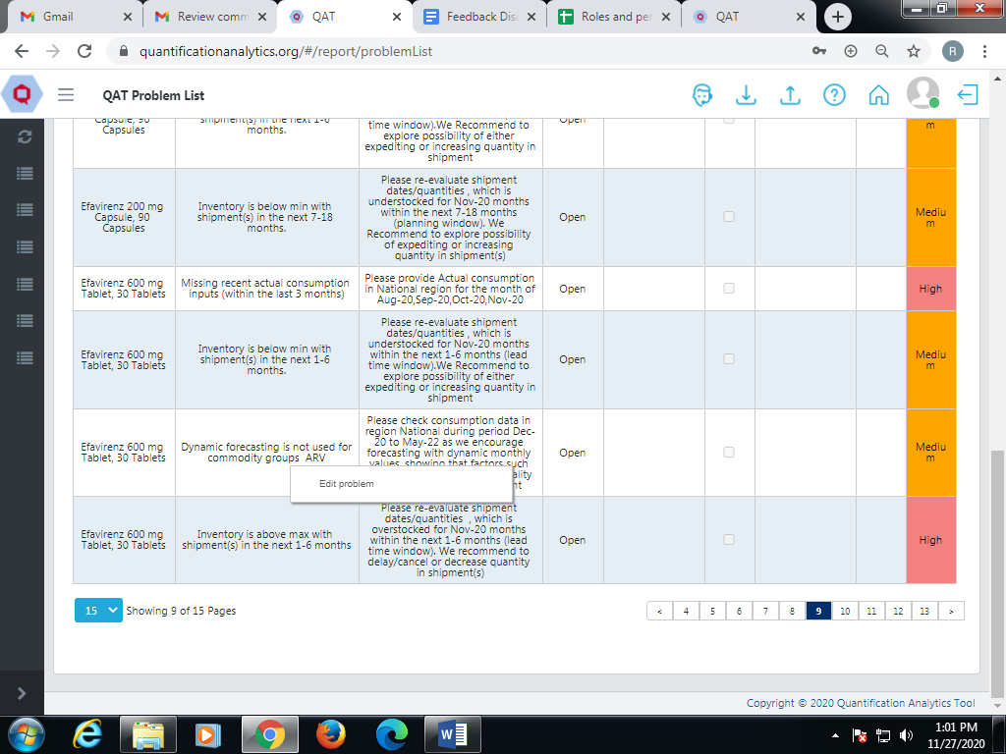

Figure 20.C.10- Dynamic forecasting is not used for commodity groups

1. The screen will show the problem description and suggest how to resolve the problem.
2. In this particular case, check forecasted consumption inputs for XX and provide dynamic forecasted consumption for Malaria.
3. To **close** this problem, click on it and you will be redirected to the “Consumption Details” screen where the required data can be entered.

OR

1. To **address** this problem, right click on it and then click “Edit Problem.” You will be redirected to the “Update Problem” screen.
2. Scroll down to the bottom, and from the Problem Status dropdown, chose “Addressed,” add a note as to why this problem cannot be closed through data entry, and click “Update.”

**Problem 11: Inventory is above max with shipment (s) in the next 1-6 months.**

Assume that the inventory for a planning unit is currently above the maximum stock level and within the next six months there is a shipment to be received. In such cases the user has to delay the shipment or order less in order to avoid continual overstock. To avoid the overstock, QAT raises this as a problem.

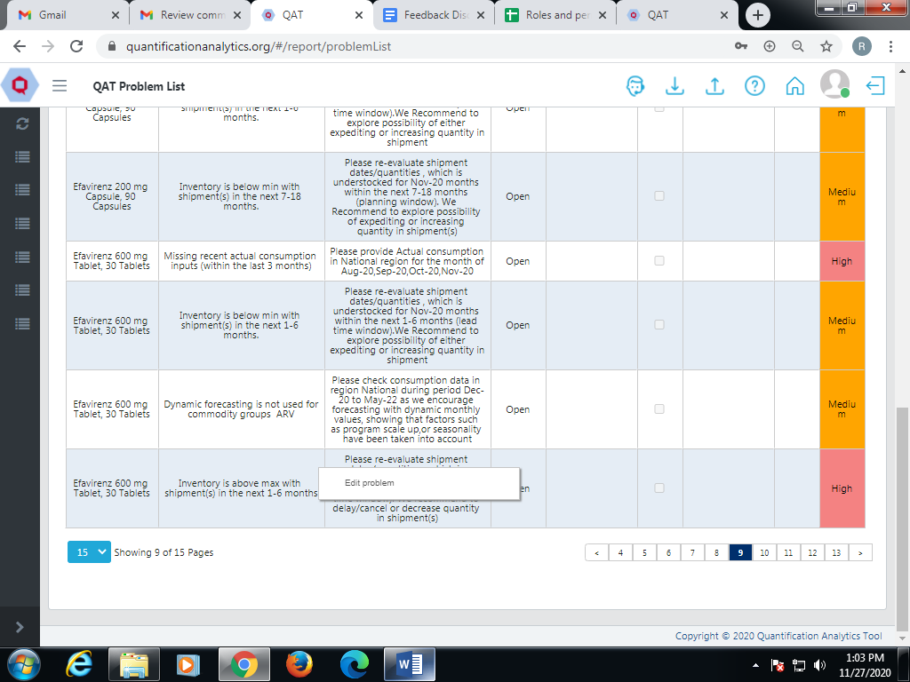

Figure 20.C.11- Inventory is above max with shipment (s) in the next 1-6 months

1. The screen will show the problem description and suggest how to resolve the problem.
2. In this particular case, the aim is to change shipment dates and/or quantities for Abacavir/Lamivudine 120/60 mg Scored Dispersible Tablet, 30 Tablets by either delaying the shipment or reducing the quantity to avoid overstock and wastage in the future.
3. To **close** this problem, click on it and you will be redirected to the “Supply Planning” screen where you can choose to either delay the shipment or reduce the quantity.

OR

1. To **address** this problem, right click on it and then click “Edit Problem.” You will be redirected to the “Update Problem” screen.
2. Scroll down to the bottom, and from the Problem Status dropdown, chose “Addressed,” add a note as to why this problem cannot be closed through data entry, and click “Update.”

**Problem 12: Inventory is below min with shipment(s) in the next 1-6 months.**

Assume that the inventory for a planning unit is currently below the minimum stock level and within the next six months there is a shipment to be received that still does not bring the planning unit above the minimum stock level. In such cases the user should expedite the shipment or increase the order quantity to stay above the minimum stock level. To maintain adequate stock levels, QAT raises a problem.

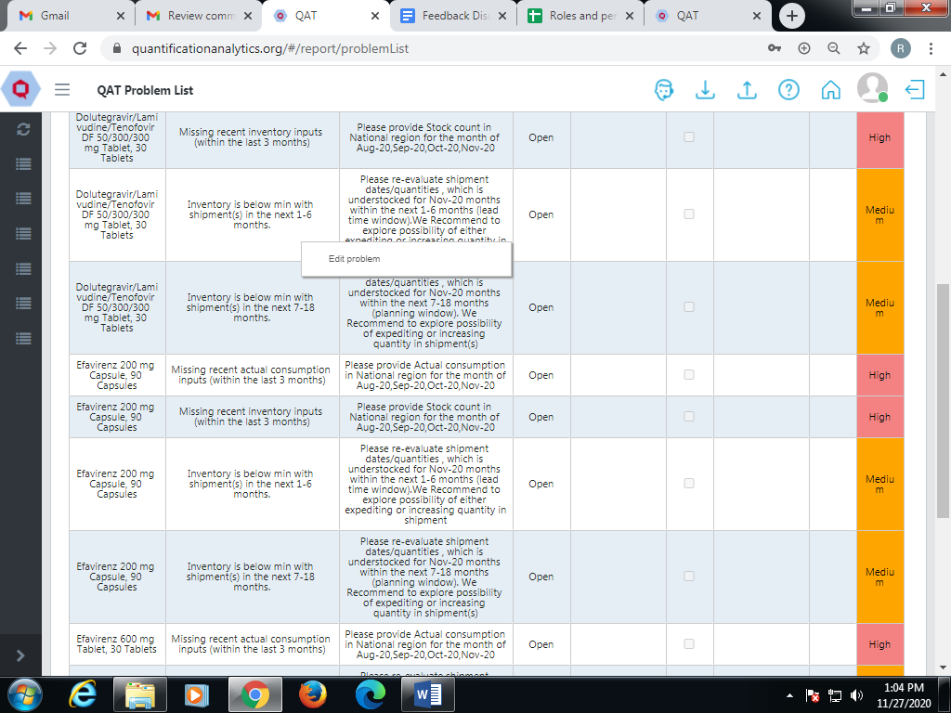

Figure 20.C.12- - Inventory is below min with shipment(s) in the next 1-6 months

1. The screen will show the problem description and suggest how to resolve the problem.
2. In this particular case, the aim is to change shipment dates and/or quantities for Darunavir 150mg Tablet, 240 Tablets by either expediting the shipment or increasing the quantity to bring the stock level above minimum.
3. To **close** this problem, click on it and you will be redirected to the “Supply Planning” screen where you can choose to either expedite the shipment or increase the quantity.

OR

1. To **address** this problem, right click on it and then click “Edit Problem.” You will be redirected to the “Update Problem” screen.
2. Scroll down to the bottom, and from the Problem Status dropdown, chose “Addressed,” add a note as to why this problem cannot be closed through data entry, and click “Update.”

**Problem 13: Inventory is above max with shipment(s) in the next 7-18 months.**

Assume that the inventory for a planning unit is currently above the maximum stock level and within the next 7-18 months there is a shipment to be received. In such cases the planning unit will be overstocked. QAT raises a problem because the user should either delay/cancel the shipment or decrease the order quantity to avoid overstock and potential wastage.

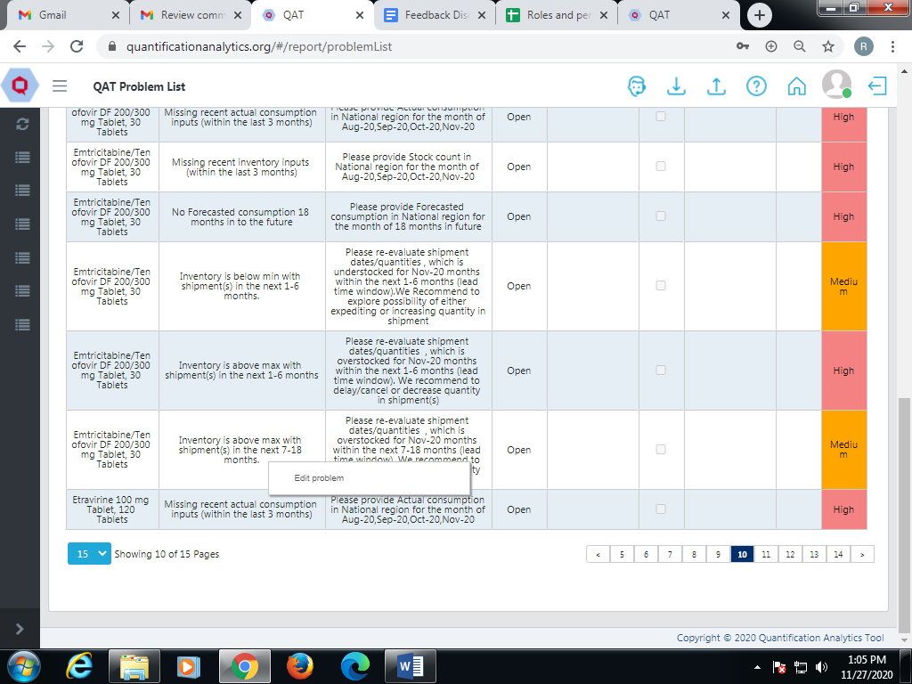

Figure 20.C.13- - Inventory is above max with shipment(s) in the next 7-18 months

1. The screen will show the problem description and suggest how to resolve the problem.
2. In this particular case, the aim is to change shipment dates and/or quantities for Abacavir/Lamivudine 120/60 mg Scored Dispersible Tablet, 30 Tablets by either delaying/cancelling the shipment or decreasing the quantity.
3. To **close** this problem, click on it and you will be redirected to the “Supply Planning” screen where you can choose to either delay/cancel the shipment or decrease the quantity.

OR

1. To **address** this problem, right click on it and then click “Edit Problem.” You will be redirected to the “Update Problem” screen.
2. Scroll down to the bottom, and from the Problem Status dropdown, chose “Addressed,” add a note as to why this problem cannot be closed through data entry, and click “Update.”

**Problem 14: Inventory is below min with shipment(s) in the next 7-18 months.**

Assume that the inventory for a planning unit is currently below the minimum stock level and within the next 7-18 months there is a shipment to be received that still does not bring the planning unit above the minimum stock level. In such cases the user should expedite the shipment or increase the order quantity to stay above the minimum stock level. To maintain the stock levels, QAT raises a problem.

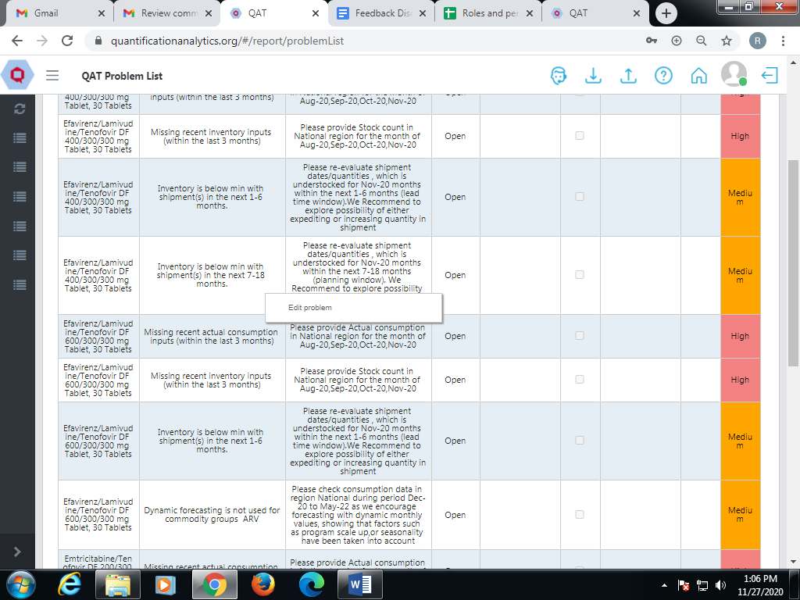

Figure 20.C.14- Inventory is below min with shipment(s) in the next 7-18 months

1. The screen will show the problem description and suggest how to resolve the problem.
2. In this particular case, the aim is to change shipment dates and/or quantities for Dolutegravir 5mg, Dispersible Tablet, 60 Tablets by either expediting the shipment or increasing the quantity to bring the stock level above minimum.
3. To **close** this problem, click on it and you will be redirected to the “Supply Planning” screen where you can choose to either expedite the shipment or increase the quantity.

OR

1. To **address** this problem, right click on it and then click “Edit Problem.” You will be redirected to the “Update Problem” screen.
2. Scroll down to the bottom, and from the Problem Status dropdown, chose “Addressed,” add a note as to why this problem cannot be closed through data entry, and click “Update.”

**Problem 15: Inventory is below min without shipment(s) in the next 1-6 months.**

Assume that the inventory for a planning unit is currently below the minimum stock level and there are no shipments to be received within the next six months. In such cases the user should order an emergency shipment or expedite a current shipment that has a receive date beyond 6 months to stay above the minimum stock level. Thus, to avoid understock or a stock out, QAT raises a problem.

Screenshot To be Updated

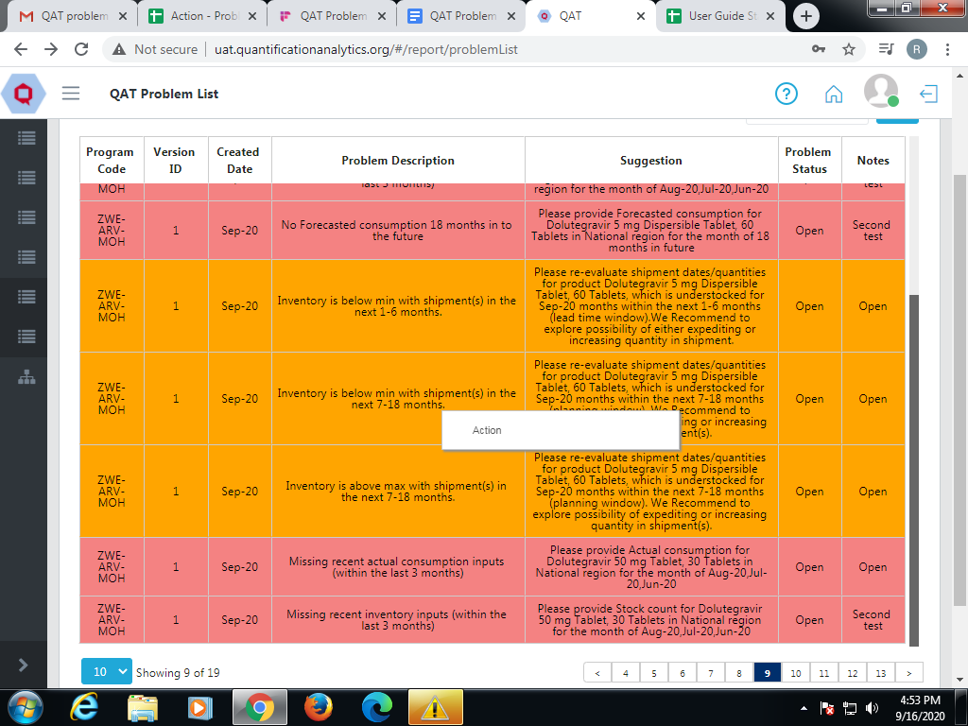

Figure 20.C.15- Inventory is below min without shipment(s) in the next 1-6 months

1. The screen will show the problem description and suggest how to resolve the problem.
2. In this particular case, the aim is to order an emergency shipment or expedite a current shipment for XX to bring the stock level above minimum.
3. To **close** this problem, click on it and you will be redirected to the “Supply Planning” screen where you can choose to order an emergency shipment or expedite a current shipment.

OR

1. To **address** this problem, right click on it and then click “Edit Problem.” You will be redirected to the “Update Problem” screen.
2. Scroll down to the bottom, and from the Problem Status dropdown, choose “Addressed,” add a note as to why this problem cannot be closed through data entry, and click “Update.”

**Problem 16: Inventory is below min without shipment(s) in the next 7-18 months.**

Assume that the inventory for a planning unit is currently below the minimum stock level and there are no shipments to be received within the next 7-18 months. In such cases the user should plan to order a shipment in the 7-18 months time window to stay above the minimum stock level. Thus, to maintain adequate stock levels, QAT raises a problem.

Screenshot To be Updated



Figure 20.C.16- Inventory is below min without shipment(s) in the next 7-18 months

1. The screen will show the problem description and suggest how to resolve the problem.
2. In this particular case, the aim is to plan a shipment for XX to maintain adequate stock levels.
3. To **close** this problem, click on it and you will be redirected to the “Supply Planning” screen where you can choose to plan a new shipment.

OR

1. To **address** this problem, right click on it and then click “Edit Problem.” You will be redirected to the “Update Problem” screen.
2. Scroll down to the bottom, and from the Problem Status dropdown, chose “Addressed,” add a note as to why this problem cannot be closed through data entry, and click “Update.”

**Addressing a Problem**

1. In an instance where a user is unable to close a Problem through data entry and automatically remove it from the QAT Problem List as “In-Compliance,” they may “Address” the Problem.
2. Right click on the Problem and then click “Edit Problem.” You will be redirected to the “Update Problem” screen.
3. Scroll down to the bottom, and from the Problem Status dropdown, chose “Addressed,” add a note as to why this problem cannot be closed through data entry, and click “Update.”

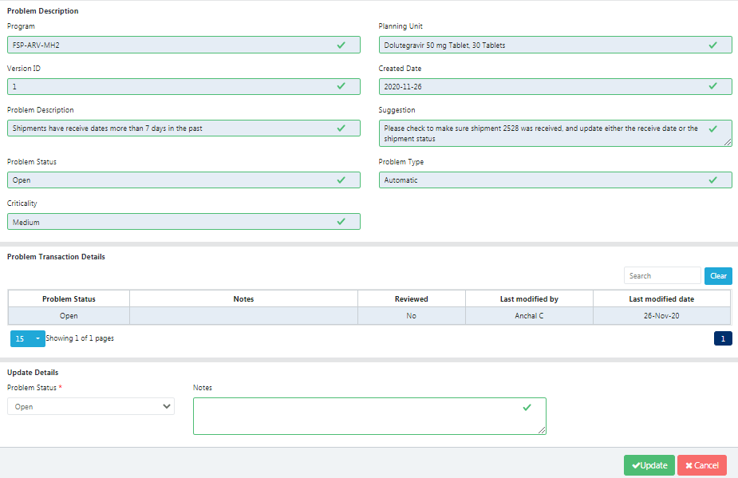

Figure 20.C.17- Change Problem Status

## Program Catalog

**Purpose**: to view a standardized list of all the planning units and forecasting units in your QAT program and their corresponding attributes.

**Realm Admins, Program Admins, Guest Users** and **Program Users** can view the Program Catalog report**.**

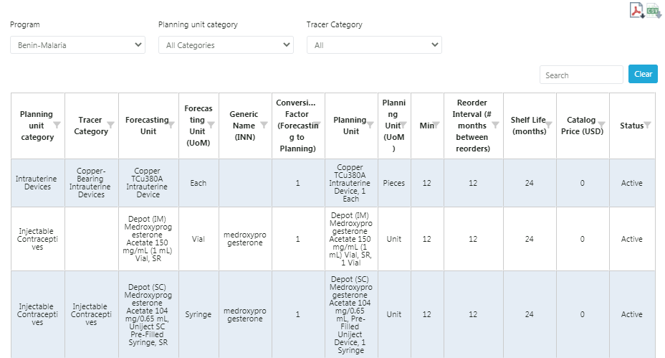

Figure 20.D- Program Catalog

1. Go to “Reports” in the sidebar menu.
2. Click on the “Program Catalog” and choose Program, Planning Unit Category, and Tracer Category.
3. It shows all of the Planning Units and Forecasting Units that are being used for a specific QAT program and their corresponding attributes
4. However, a user may select all Planning Unit Categories and Tracer Categories, or they may choose a specific category for viewing.
5. A tabular view of the data will be displayed below the selected Program.
6. Click on the top right corner buttons to download this report in PDF or CSV format.

## Stock Status

1. **Stock Status Over Time**

**Purpose:** to compare one or more products and their inventory-levels across a period time

**Realm Admins, Program Admins, Guest Users** and **Program Users** can view the Stock Status over Time report**.**

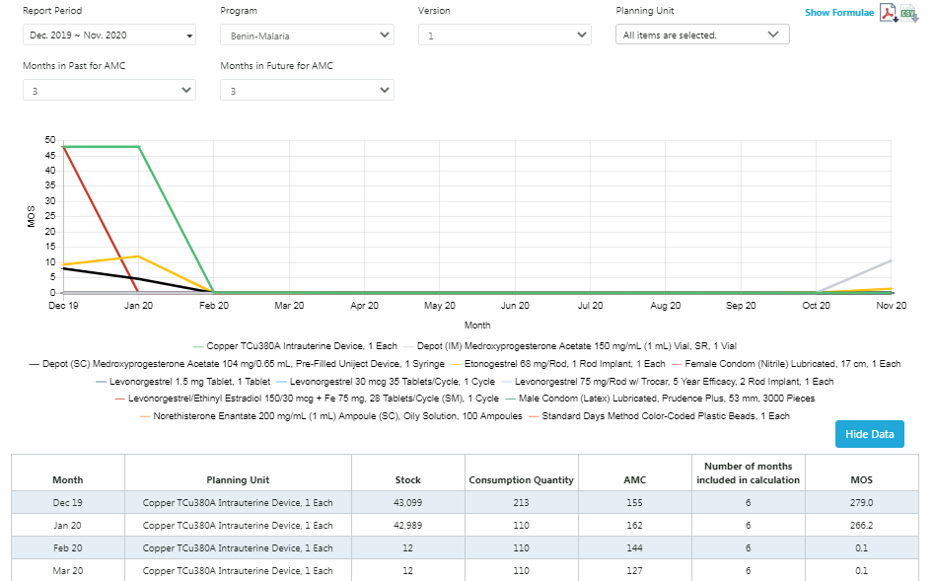

Figure 20.E.a- Stock Status Over Time

1. Go to “Reports” in the sidebar menu.
2. Click on “Stock Status.”
3. Click on the “Stock Status Over Time.”
4. Select the Report Period, Program, Version, Planning Unit, Months in Past for AMC, and Months in Future for AMC
   1. **Note:** The Planning Unit can be single, multi-select, or select all. The “Select All '' function may not be advantageous if the program has many planning units, as the graph will not be able to decern the individual lines on the graph. We suggest choosing less than ten products at once. Specifically, this report can be useful to compare categories (ex. TLDs vs. TLEs).
5. There is both a graph and tabular view for this report.
6. The graphs x-axis represents the MOS with each colored line representing different planning units over time.
7. The user may also choose to see the graph is tabular form, by clicking the “Show Data” button in the lower right corner.
8. Click on the top right corner buttons to download this report in PDF or CSV format.
9. **Stock Status Matrix**

**Purpose:** to provide a quick snapshot of the months of stock across time in an easy-to-read table format.

**Realm Admins, Program Admins, Guest Users** and **Program Users** can view the Stock Status Matrix report**.**

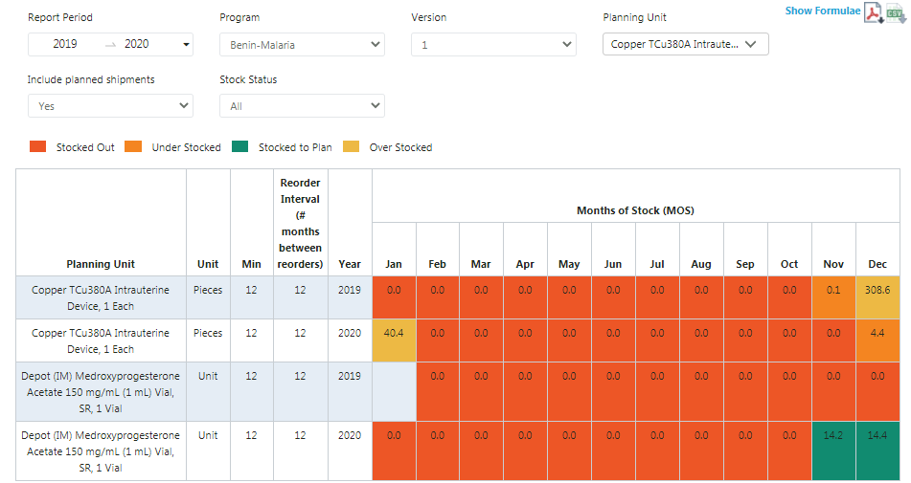

Figure 20.E.b - Stock Status Matrix

1. Go to “Reports” in the sidebar menu.
2. Click on “Stock Status.”
3. Click on “Stock Status Matrix” and select the Report Period, Program, Version, Planning Unit, “Include in Planned Shipments,” and Stock Status
4. The MOS for each planning unit selected will be shown monthly according to the number of years selected in the Report Period.
5. The various color corresponds to the stock levels during that particular month
   1. Red – Stocked Out
   2. Orange – Under Stocked
   3. Green – Stocked to Plan
   4. Yellow – Over Stocked
6. Click on the top right corner buttons to download this report in PDF or CSV format.
   1. **Note:** Although the PDF and CSV do not export the conditionally formatted colors, users may copy and paste the table to keep all the formatting.
7. **Stock Status Snapshot**

**Purpose:** to give a high-level view of a program’s stock status across planning units at a single point in time (one month).

**Realm Admins, Program Admins, Guest Users** and **Program Users** can view the Stock Status Snapshot report**.**

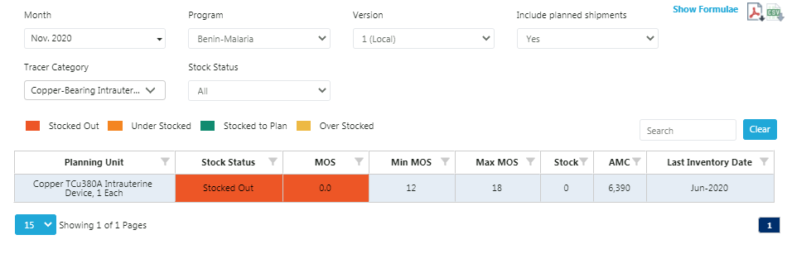

Figure 20.E.c- Stock Status Snapshot

1. Go to “Reports” in the sidebar menu.
2. Click on “Stock Status.”
3. Click on “Stock Status Snapshot” and select Month, Program, Version, “Include Planned Shipments?”, Tracer Category, and Stock Status.
4. This report will show all planning units in a singular program for a singular month.
5. The various color corresponds to the stock levels during that particular month
   1. Red – Stocked Out
   2. Orange – Under Stocked
   3. Green – Stocked to Plan
   4. Yellow – Over Stocked
6. Click on the top right corner buttons to download this report in PDF or CSV format.
   1. **Note:** Although the PDF and CSV do not export the conditionally formatted colors, users may copy and paste the table to keep all the formatting.
7. **Stock Status Snapshot - Global**

Purpose: to give a high-level view of a program’s stock status across planning units at a single point in time (one month) for multiple programs.

**Only Realm Admins** can view the Stock Status Snapshot - Global report**.**

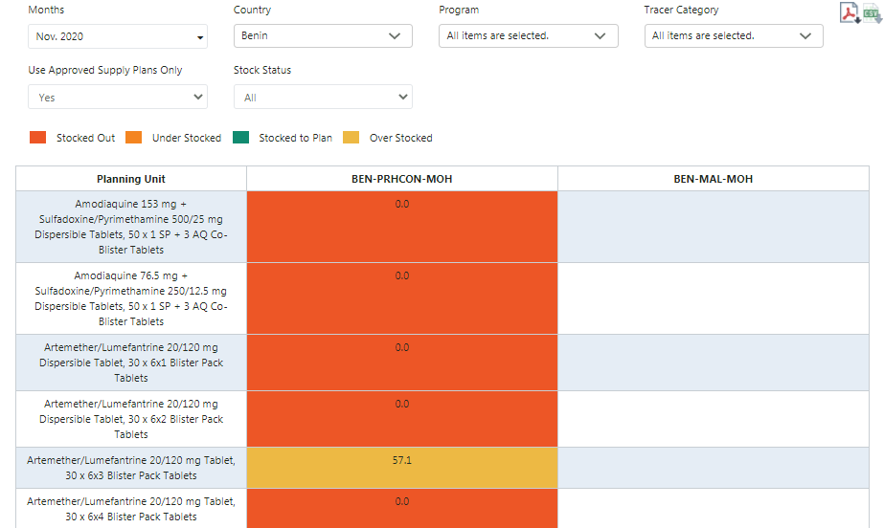

Figure 20.E.d- Stock Status Snapshot Global

1. This is a global report and only available to Realm-Level Administrators.
2. Go to “Reports” in the sidebar menu.
3. Click on “Stock Status.”
4. Click on “Stock Status Snapshot Global” and select Month, Country, Program, Tracer Category, “Use Approved Supply Plans Only?”, and Stock Status
5. This report calculates the MOS based on the individual QAT Program's set minimum and maximum stock levels across planning units for a particular month. The stock levels that are shown in this report will correspond to various colors:
   1. Red – Stocked Out
   2. Orange – Under Stocked
   3. Green – Stocked to Plan
   4. Yellow – Over Stocked
6. Based on the information provided in the report, procurement managers may be able to use it for making decision such as:
   1. If shortfalls are projected, a user can plan additional shipments, or advance the receipt date of expected shipments.
   2. If a surplus is projected, a user can postpone a shipment, or reduce the quantity you expect to receive.
   3. If there are excessive unexplained adjustments, a user could investigate the quality of their data.
7. Click on the top right corner buttons to download this report in PDF or CSV format.
   1. **Note:** Although the PDF and CSV do not export the conditionally formatted colors, users may copy and paste the table to keep all the formatting.

## Consumption Reports

1. **Consumption Forecast vs Actual**

Purpose: to visually compare the accuracy of forecasting consumption over time

**Realm Admins, Program Admins, Guest Users** and **Program Users** can view this report**.**

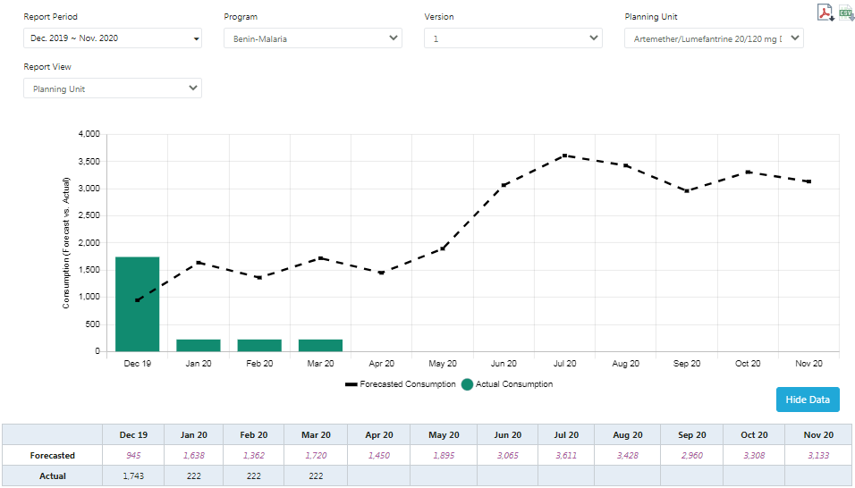

Figure 20.F.a- Consumption Forecast vs Actual

1. Go to “Reports” in the sidebar menu.
2. Click on “Consumption Reports”.
3. Click on the “Consumption Forecast vs. Actual” and select the Report Period, Program, Version, Planning Unit.
4. This report highlights the difference between forecasted and actual consumption for a given planning unit across time.
5. The legend denotes what is being shown on the graph:
   1. Green vertical bars represent the actual consumption
   2. Black dotted horizontal line represents the forecasted consumption
6. The user may also choose to see the graph is tabular form, by clicking the “Show Data” button in the lower right corner.
7. Click on the top right corner to download this report in PDF or CSV format.
8. **Consumption Global Report**

Purpose: to visually show the consumption of a planning unit or multiple planning units across countries. Only **Realm Admins** can view the report**.**

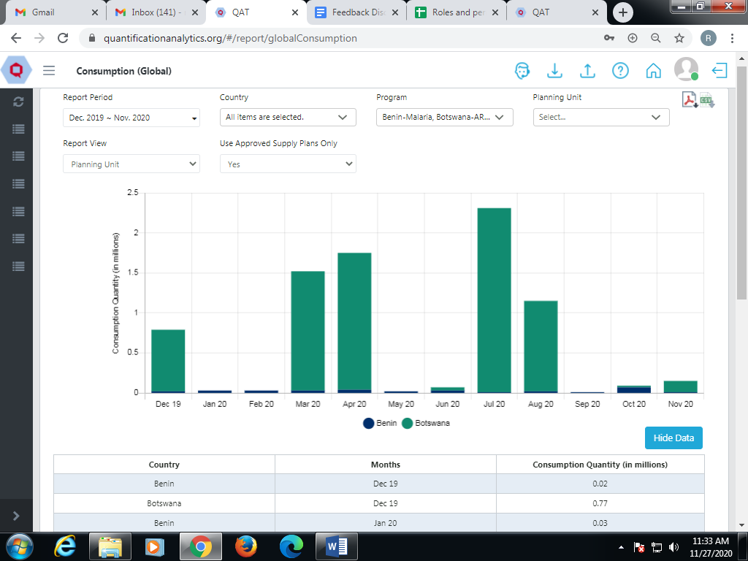

Figure 20.F.b- Consumption Global Report

1. This is a global report and only available to Realm-Level Administrators.
2. Go to “Reports” in the sidebar menu.
3. Click on “Consumption Reports.”
4. Click on “Consumption (Global)” and select Report Period, Realm, Country, Program, Planning Unit, Report View, and “Use Approved Supply Plan Only.”

The various colors stacked in the horizontal bars represent different countries. Users can determine which country by referencing the graph legend.

1. The x-axis corresponds to the consumption quantity (in millions) for each country.
2. The user may also choose to see the graph is tabular form, by clicking the “Show Data” button in the lower right corner.
3. Click on the top right corner to download this report in PDF or CSV format.
4. **Forecast Error- Monthly View**

Purpose: to visually show forecast accuracy using the weighted average percent error (WAPE) method, over time. **Realm Admins, Program Admins, Guest Users** and **Program Users** can view the report**.**

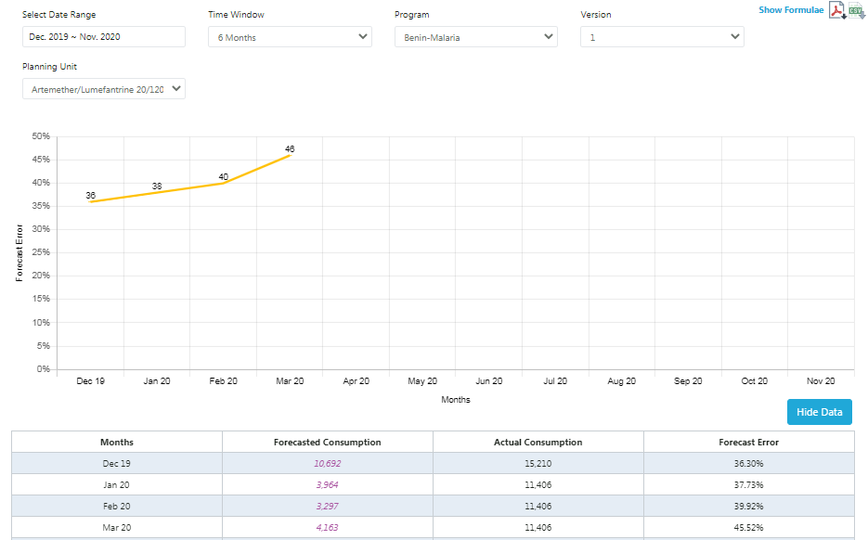

Figure 20.F.c- Forecast Error (Monthly)

1. Go to “Reports” in the sidebar menu.
2. Click on “Consumption Reports”.
3. Click on the “Forecast Error (Monthly)” and select the Date Range, Time Window, Program, Version, and Planning Unit.
   1. It is best to choose a Date Range in the past where both forecasted and actual consumption are available for use in the calculations.
4. The graph represents the weighted average percentage error (WAPE) for a specific planning unit across time.
   * + - 1. 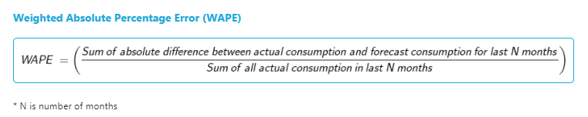The Forecast month is calculated based on the Time Window chosen. For this case, the last 6 months. However, the Time Window can also be calculated using 3, 6, 9, or 12 months.
5. The user may also choose to see the graph is tabular form, by clicking the “Show Data” button in the lower right corner.
6. Click on the top right corner to download this report in PDF or CSV format.
7. **Forecast Error- By Planning Unit**

**Purpose: to assess forecast accuracy for selected products during a specified period. Only Realm Admins** can view the report**.**

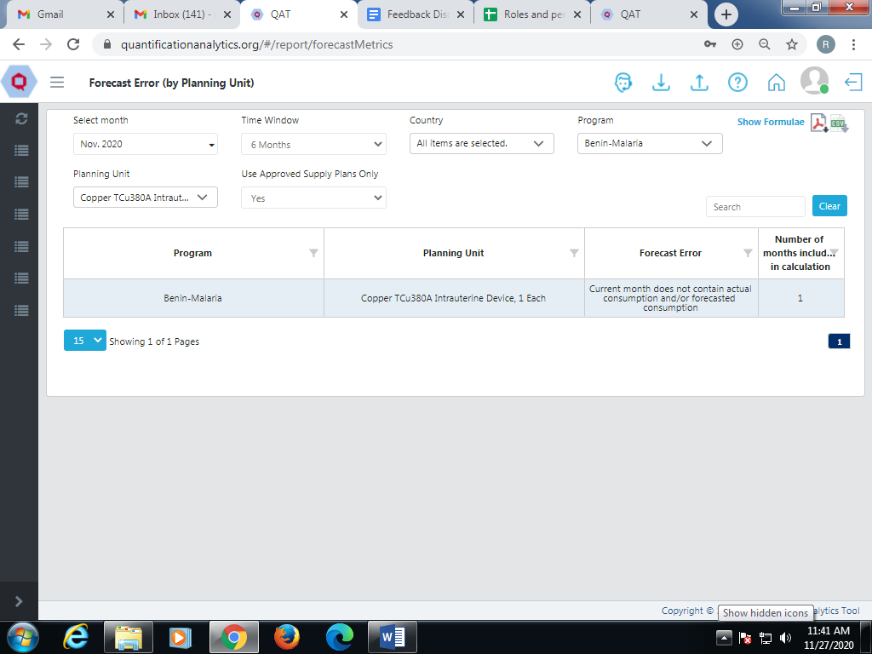

Figure 20.F.d - Forecast Error (by Planning Unit)

1. This is a global report and only available to Realm-Level Administrators.
2. Go to “Reports” in the sidebar menu.
3. Click on “Consumption Reports”.
4. Click on the “Forecast Error (by Planning Unit)” and select Month, Time Window, Country, Program , Planning Unit, and “Use Approved Supply Plans Only”.
   1. It is best to use a month in the past where both the forecasted and actual consumption are available for use in the calculations. Here is the formula to calculate it:

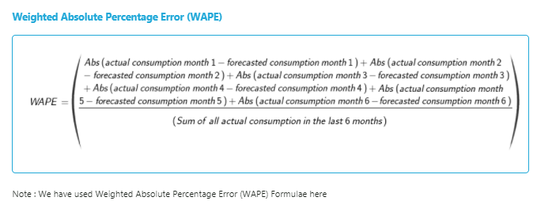

1. Click on the top right corner to download this report in PDF or CSV format.

## Shipment Reports

1. **Shipment Global Report**

**Purpose:** to aggregate procurement quantities by funding source across all countries (realm-level access required). Only **Realm Admins** can view the report**.**

1. Go to “Reports” in the sidebar menu.
2. Click on “Shipment Reports”
3. Click on the “Shipment (Global)”
4. Select the desired parameters to display and filter the report by.
5. The first graph shows the total demand across the realm for shipments in the Ordered and Planned status.
6. The second graph represents the total quantity on order by the different funding sources.
7. The user can download the report in PDF and CSV.

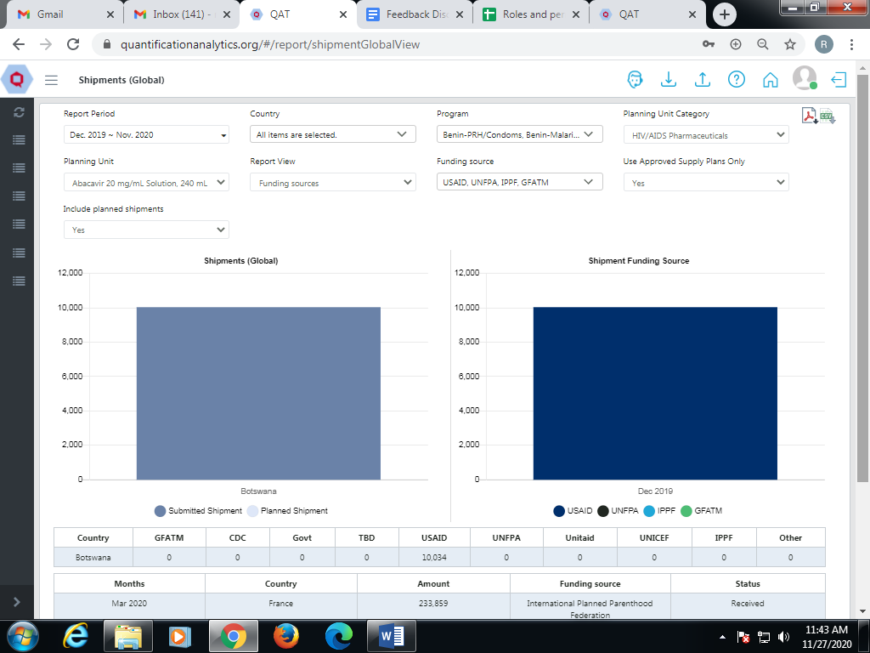

Figure 20.G.a- Shipment Global Report

1. **Shipment Overview**

Purpose: to aggregate procurement quantities by funding source across all countries. Only **Realm Admins** can view the report**.**

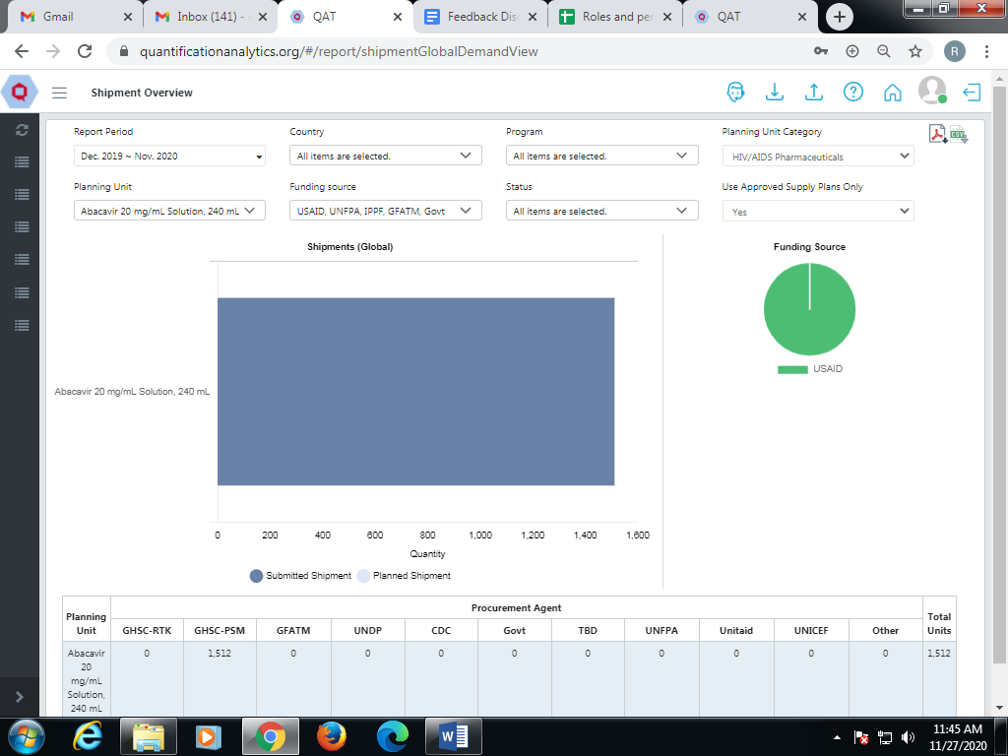

Figure 20.G.b- Shipment Overview

1. Go to “Reports” in the sidebar menu.
2. Click on “Shipment Reports”
3. Click on “Shipment Overview”
4. Select the required parameters to display the report.
5. The amount that has been shipped for a particular Planning Unit is shown.
6. A pie chart shows the Funding Sources the quantities procured by funding sources.
7. The user can download the report in PDF and CSV.
8. **Shipment Details**

**Purpose:** to provide a comprehensive view of all shipments for a program. This report is available at the program level. **Realm Admins, Program Admins, Guest Users** and **Program Users** can view the report**.**

1. Go to “Reports” in the sidebar menu.
2. Click on “Shipment Reports”.
3. Click on “Shipment Details”.
4. Select the parameters to display the report.
5. The user can view the report in the Forecasting Unit view as well as in the Planning Unit view.
6. The user can download the report in PDF and CSV.

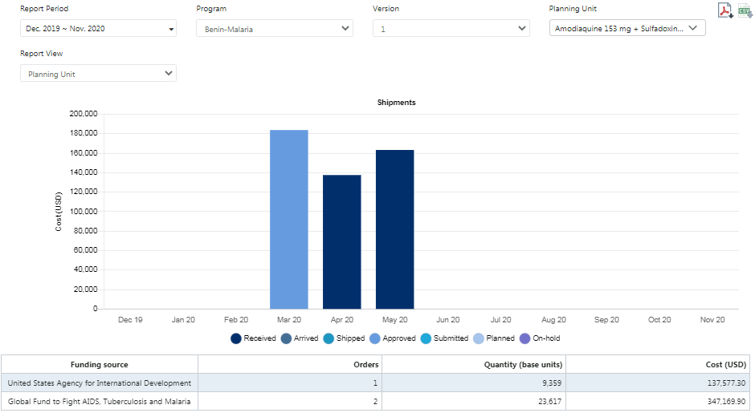

Figure 20.G.c - Shipment Details

1. **Shipment Cost Details**

Purpose: to provide a comprehensive view of all shipments for a program. It’s a simpler version of the shipment details (no charts) and similar to PipeLine’s Shipment Summary. Can be displayed by funding source, procurement agent, or planning unit.

**Realm Admins, Program Admins, Guest Users** and **Program Users** can view the report**.**

1. Go to “Reports” in the sidebar menu.
2. Click on “Shipment Reports”
3. Click on “Shipment Cost Details”.
4. This report displays a list of all the shipments for the selected planning unit(s).
5. The user can download the report in PDF and CSV.

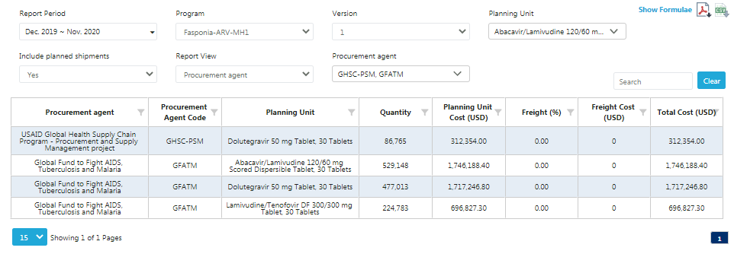

Figure 20.G.d- Shipment Cost Details

1. **Shipment Cost Overview**

**Purpose: to provide a general view of the total shipment costs per calendar year for a program and planning unit, by funding source. Similar to the Annual Shipment Costs report in PipeLine. Realm Admins, Program Admins, Guest Users** and **Program Users** can view the report**.**

1. Go to “Reports” in the sidebar menu.
2. Click on “Shipment Reports”.
3. Click on “Shipment Cost Overview”.
4. Enter the required details and click on the “Preview” button.
5. The report will be shown on screen.
6. Click on the “Download” button at the top right corner of the report.
7. The report will be downloaded to the local computer.
8. This report can be viewed based on order date or received date.
9. The user can download the report in PDF.
10. Only PDF format is available to download since CSV cannot show this format.

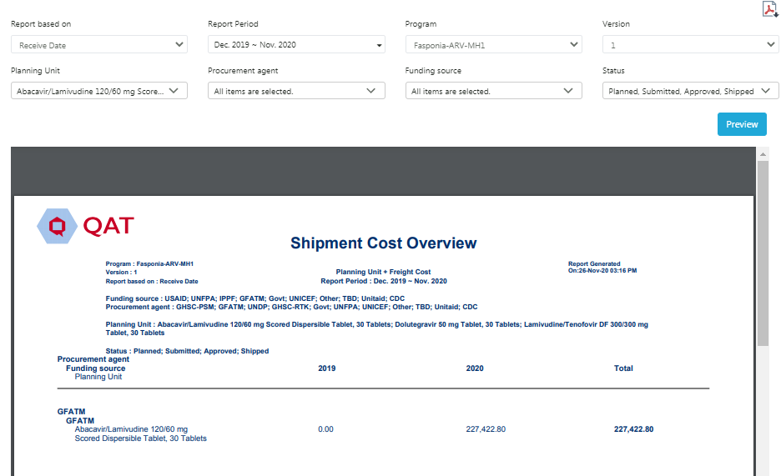

Figure 20.G.e- Shipment Cost Overview

1. **Budget**

Purpose: to show the different budgets assigned to a program, the estimated amounts allocated to existing shipments, and estimated amounts remaining. **Realm Admins, Program Admins, Guest Users** and **Program Users** can view the report**.**

1. Go to “Reports” in the sidebar menu.
2. Click on “Shipment Reports”.
3. Click on “Budgets”.
4. Select the required parameters to display the report.
5. The graph shows every predefined Budget in a program and whether it is allocated to shipments (planned or ordered); and the remaining amount.
6. Users can download the report in PDF and CSV format.

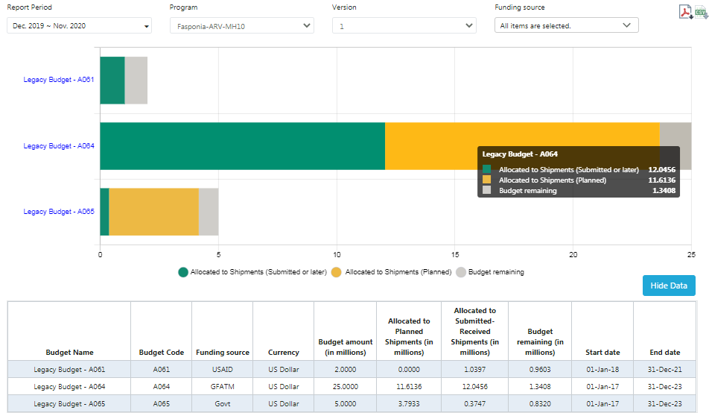

Figure 20.G.f- Budgets

1. **Procurement Agent Lead Time**

**Purpose:** to show the detailed lead times (in months) for all planning units, by procurement agent**. Realm Admins, Program Admins, Guest Users** and **Program Users** can view the report**.**

1. Go to “Reports” in the sidebar menu.
2. Click on “Shipment Reports”.
3. Click on “Procurement Agent Lead Time”.
4. Select the Program, Planning Units, and Procurement Agents.
5. The user can download the report in PDF and CSV.

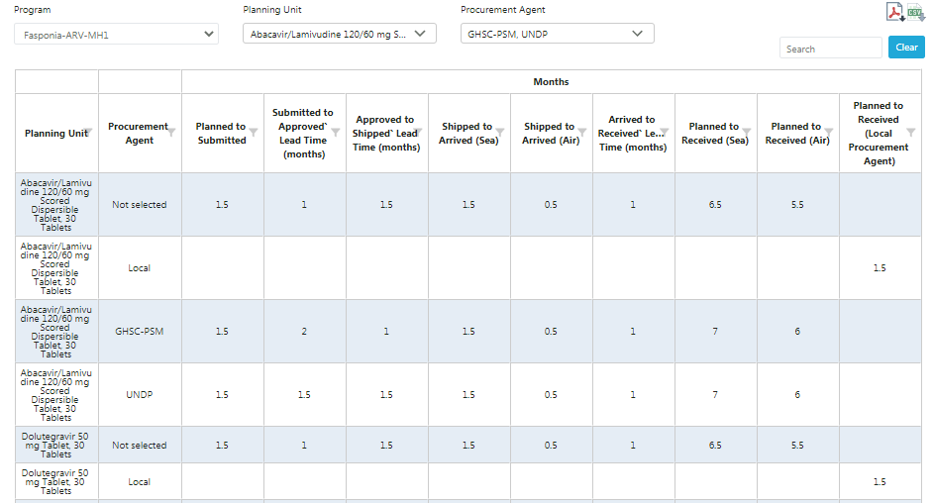

Figure 20.G.g- Procurement Agent Lead Times

1. **Inventory Reports**

All the Inventory reports can be viewed by **Realm Admins, Program Admins, Guest Users** and **Program Users.**

1. **Expiries**

**Purpose:** to provide planners with estimated quantities of planning units expiring in the future based on batch/shelf life

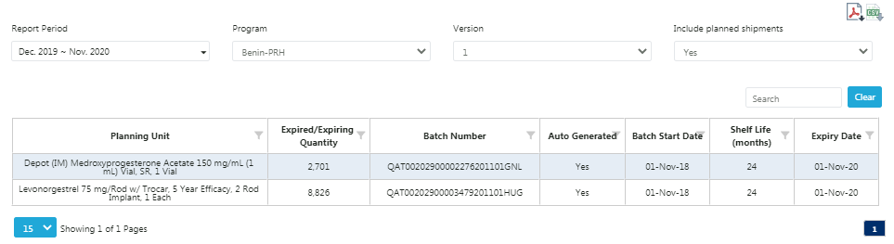

Figure 20.H.a- Expiries

1. Go to “Reports” in the sidebar menu.
2. Click on “Inventory Reports”.
3. Click on “Expiries” and the above screen will be displayed.
4. Select the Report Period, Program and Version.
5. The screen will display Planning Unit, Quantity, Batch number and Expiry Date according to the Program.
6. Expired Inventory refers to inventory that is at the end of its product life cycle.
7. This inventory has not been sold or used for a long period of time and is not expected to be sold in the future.
8. The user can download the report in PDF.
9. **Cost of Inventory**

**Purpose**: for a selected month, provides an estimated cost of inventory based on actual or projected stock on hand and the planning unit catalog price.

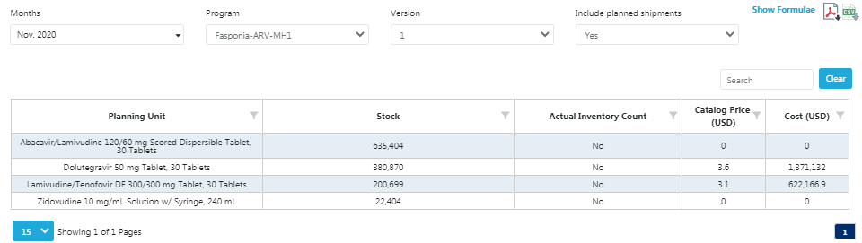

Figure 20.H.b- Cost of Inventory

1. Go to “Reports” in the sidebar menu.
2. Click on “Inventory Reports”.
3. Click on the “Cost of Inventory” and the above screen will be displayed.
4. The report shows available stock for particular months i.e. the closing balance.
5. It shows the cost and price of that planning unit as long as there is a catalog price for the planning unit.

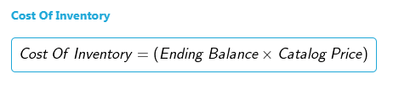

1. According to the above formula the cost is calculated.
2. Refer to the formulae section on the top right corner.
3. The user can download the report in PDF and CSV.
4. **Inventory Turns**

Purpose: to show the number of inventory turns per planning unit during a particular time period. Inventory turns are a way to measure the velocity of the supply plans. Inventory turnover is a key statistic often used to signal supply chain management effectiveness. Generally, higher turns mean a healthier supply chain – products are moving downstream and being replaced by fresh products more frequently.

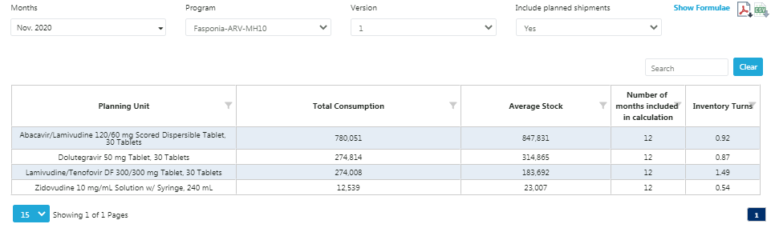

Figure 20.H.c- Inventory Turns

1. Go to “Reports” in the sidebar menu.
2. Click on “Inventory Reports”.
3. Click on the “Inventory Turn” and the above screen will be displayed.
4. Select the Program and Version.
5. The **Inventory Counts** for that particular month are shown.
6. This report shows the actual stock is available with the user and how much has been consumed.

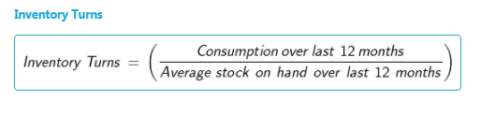

1. It is calculated by using the given formula.
2. The user can download the report in PDF and CSV.
3. **Stock Adjustment**

**Purpose:** to show a list of all the manually entered stock adjustments in a program. Note: automatically calculated adjustments will not display on this report.

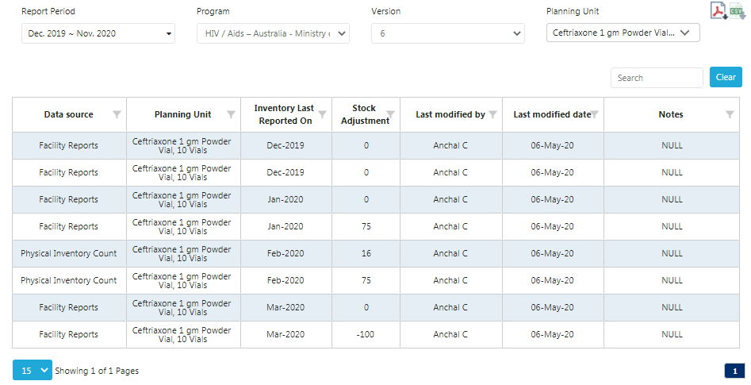

Figure 20.H.d- Stock Adjustment

1. Go to “Reports” in the sidebar menu.
2. Click on “Inventory Reports”.
3. Click on the “Stock Adjustments” and the above screen will be displayed.
4. Select the Program and Version to view the report.
5. For the selected planning unit, the amount of stock adjustment that has been done in that month will be shown.
6. It only shows stock adjustment for the particular planning unit.
7. The user can download the report in PDF and CSV.
8. **Warehouse Capacity - By Program**

Purpose: displays the volume (in cubic meters) of all regions within a country (if a user enters such information upon setting up a program.

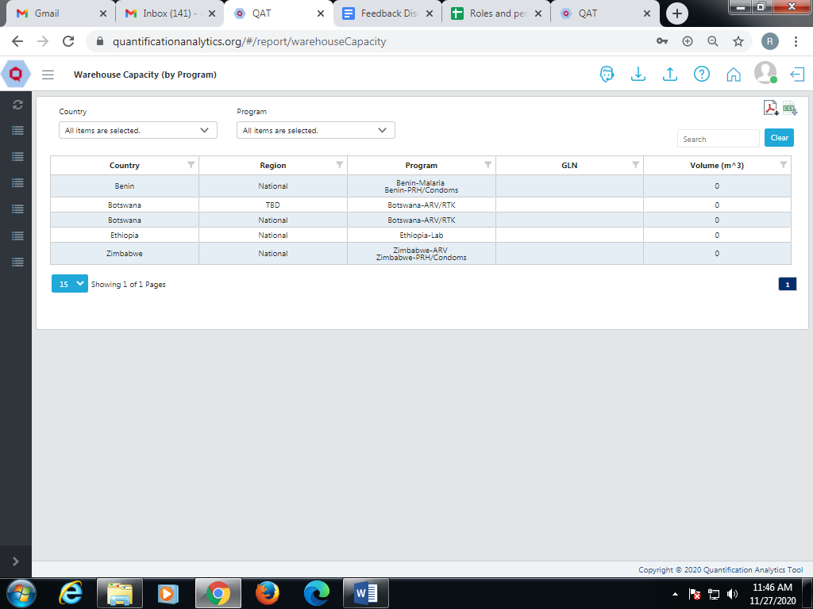

Figure 20.H.e- Warehouse Capacity

1. Go to “Reports” in the sidebar menu.
2. Click on “Inventory Reports”.
3. Click on “Warehouse Capacity” and the above screen will be displayed.
4. To check the Warehouse capacity, select the country and program. The associated data will be displayed.
5. All programs that are being executed for the relevant regions are shown in this report.
6. The report shows the Capacity CBM for the selected program in the region.
7. If the selected country has no region, it will show as National.
8. The user can download the report in PDF and CSV.
9. **Warehouse Capacity - By Country**

Purpose: displays the volume (in cubic meters) of all countries and regions within a country (realm-level access required).

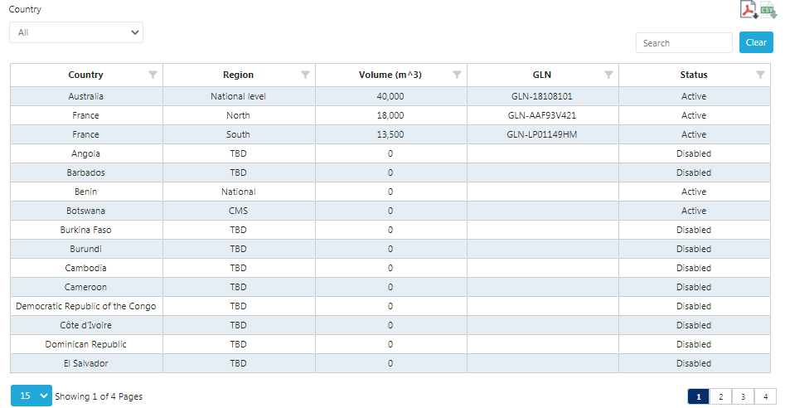

Figure 20.H.f- Warehouse Capacity - By Country

1. Go to “Reports” in the sidebar menu.
2. Click on “Inventory Reports”.
3. Click on “Warehouse Capacity - By Country” and the above screen is displayed.
4. The report shows the stock availability according to the Regions.
5. It shows the respective country, region, volume, GLN along with the current status.
6. Click on the top right corner to download this report in PDF or CSV format.

# Appendix

## Section 1 - Introduction

1. **Regions:** The QAT user can add sub-national levels of data in the form of Regions. The regions are defined at the Program Level. If a Program Administrator does not have subnational-level data or prefers to enter aggregated values, the user may keep the region “national” or “central.”

**Note**: To define sub-national levels, both consumption and inventory must be entered at each level, which the application would then aggregate to a National total.

1. **Programs:** Theseare synonymous to “supply plans”. Each program must choose only one Country, one Technical Area, one level (National, Central, etc.), and one organization (MOH, PEPFAR-only, PMI-only).
2. **Master data**: Many data points in QAT are standardized – for example, product lists, shipment statuses, data sources, etc. Master data references these standardized data. Users can request updates and additions to this master data though a ticketing mechanism.
3. **Syncing:** A majority of the functionalities of QAT can be used offline; however, some data must be synced when online in order to have a “live” copy of the data for all program users to access. QAT will sync when a user is online or if the user chooses to manually sync.

**Calculated Values**

1. **Average Monthly Consumption**

|  |
| --- |
|  |

1. **Projected Inventory**

|  |
| --- |
| The projected inventory is used by the planning system to monitor the reorder point and to determine the reorder quantity. |

1. **Months of Stock**

|  |
| --- |
|  |

1. **Minimum MoS**

|  |
| --- |
|  |

1. **Maximum MoS**

|  |
| --- |
|  |

1. **Reorder Quantity**

|  |
| --- |
| The reorder point is the level of inventory which triggers an action to replenish that particular inventory stock. |

## Section 2 – User & Program Management

**User roles:** These are dedicated assignments to users that allow for different levels of access and functional areas. Those that are relevant include:

|  |  |  |  |  |  |  |
| --- | --- | --- | --- | --- | --- | --- |
| **Business Function** | **Application Admin** | **Realm Admin** | **Program Admin** | **Supply Plan Reviewer** | **Program User** | **Guest User** |
| **Application Masters** | | | | | | |
| View Application Dashboard | Y | N | N | N | N | N |
| Label Translations | Y | N | N | N | N | N |
| Create Realm | Y | N | N | N | N | N |
| Manage Country | Y | N | N | N | N | N |
| Create Role | Y | N | N | N | N | N |
| Add Language | Y | N | N | N | N | N |
| Add Currency | Y | N | N | N | N | N |
| Add/manage Dimension | Y | N | N | N | N | N |
| Add/manage Unit | Y | N | N | N | N | N |
| Database Translation | Y | N | N | N | N | N |
| Create/manage User | Y | Y | N | N | N | N |
| Assign role to user | Y | Y | N | N | N | N |
| Edit Realm | Y | Y | N | N | N | N |
| **Realm level Masters** | | | | | | |
| View Realm Dashboard | Y | Y | N | N | N | N |
| Create/manage Realm Country | Y | Y | N | N | N | N |
| Create/manage Region | Y | Y | N | N | N | N |
| Create/manage Data Source | Y | Y | N | N | N | N |
| Create/manage Data Source Type | Y | Y | N | N | N | N |
| Create/manage Funding Source | Y | Y | N | N | N | N |
| Create/manage Organization | Y | Y | N | N | N | N |
| Create/manage Procurement Agent | Y | Y | N | N | N | N |
| Create/manage Supplier | Y | N | N | N | N | N |
| Create/manage Alternate Reporting Unit | Y | Y | Y | N | N | N |
| Create/manage Forecasting Unit | Y | Y | N | N | N | N |
| Create/manage Planning Unit | Y | Y | N | N | N | N |
| Create/manage Planning Unit Category | Y | Y | N | N | N | N |
| Create/manage Procurement Unit | Y | Y | N | N | N | N |
| Create/manage Tracer Category | Y | Y | N | N | N | N |
| Create/manage Technical Area | Y | Y | N | N | N | N |
| List/view Country | Y | Y | N | N | N | N |
| List/view Data Source | Y | Y | Y | N | Y | Y |
| List/view Data Source Type | Y | Y | Y | N | Y | Y |
| List/view Funding Source | Y | Y | Y | N | Y | Y |
| List/view Organization | Y | Y | Y | N | Y | Y |
| List/view Procurement Agent | Y | Y | Y | N | Y | Y |
| Create/manage/view Supplier | Y | N | N | N | N | Y |
| List/view Alternate Reporting Unit | Y | Y | Y | N | N | N |
| List/view Planning Unit Category | Y | Y | Y | N | Y | N |
| List/view Tracer Category | Y | Y | Y | N | Y | N |
| List/view Region | Y | Y | N | N | N | N |
| List/view Technical Area | Y | Y | Y | N | Y | Y |
| **Program Management** | | | | | | |
| View Program Dashboard | Y | Y | Y | Y | Y | Y |
| Setup/create a Program | Y | Y | N | N | N | N |
| Update program info | Y | Y | Y | N | N | N |
| Update/add planning unit to program | Y | Y | Y | N | N | N |
| Create/manage Budget | Y | Y | Y | N | N | N |
| List/view Budget | Y | Y | Y | N | Y | N |
| Import / Export Program | Y | Y | Y | N | Y | N |
| Load Program | Y | Y | Y | Y | Y | N |
| PipeLine Program Import | N | N | N | N | N | Y |
| Commit version | Y | Y | Y | N | Y | N |
| Review/Approve a Version | Y | Y | N | Y | N | N |
| **Supply plan data** | | | | | | |
| Add/edit supply plan data (consumption / inventory / shipments) | Y | Y | Y | Y | Y | N |
| ERP shipment linking and delinking | Y | Y | Y | N | Y | N |
| Import Quantimed data | Y | Y | Y | N | Y | N |
| **Supply planning** | | | | | | |
| Manage/edit Supply Plan | Y | Y | Y | Y | Y | N |
| View Supply Plan | Y | Y | Y | Y | Y | Y |
| Scenario Planning | Y | Y | Y | Y | Y | N |
| View Supply Plan Report | N | Y | Y | N | Y | Y |
| **Reports** | | | | | | |
| View QAT Problem List report | N | Y | Y | N | Y | Y |
| View Program Catalog Report | N | Y | Y | N | Y | Y |
| **Stock Status Reports** | | | | | | |
| View Stock Status Over Time report | N | Y | Y | N | Y | Y |
| View Stock Status Matrix report | N | Y | Y | N | Y | Y |
| View Stock Status Snapshot report | N | Y | Y | N | Y | Y |
| View Stock Status Snapshot (Global) report | N | Y | N | N | N | N |
| **Consumption Reports** | | | | | | |
| View Consumption (forecast vs actual) report | N | Y | Y | N | Y | Y |
| View Consumption (Global) report | N | Y | N | N | N | N |
| View Forecast Error (Monthly) report | N | Y | Y | N | Y | Y |
| View Forecast Error by (by planning unit) report | N | Y | N | N | N | N |
| **Shipment Reports** | | | | | | |
| View Shipment (Global) report | N | Y | N | N | N | N |
| View Shipment Overview report | N | Y | N | N | N | N |
| View Shipment Details report | N | Y | Y | N | Y | Y |
| View Shipment Cost Details report | N | Y | Y | N | Y | Y |
| View Shipment Cost Overview report | N | Y | Y | N | Y | Y |
| View Budget report | N | Y | Y | N | Y | Y |
| View Procurement Agent Lead Time report | N | Y | Y | N | Y | Y |
| **Inventory Reports** | | | | | | |
| View Expiries report | N | Y | Y | N | Y | Y |
| View Cost of Inventory report | N | Y | Y | N | Y | Y |
| View Inventory Turns report | N | Y | Y | N | Y | Y |
| View Stock Adjustment report | N | Y | Y | N | Y | Y |
| View Warehouse Capacity (by program) report | N | Y | Y | N | Y | Y |
| View Warehouse Capacity (by country) report | N | Y | Y | N | Y | Y |

## Section 3 - Background Data for Realm

1. **Procurement Systems Interfacing:** The software is designed to interface with different procurement order management systems from the various procurement agents. At Go-Live, QAT will have an interface with ARTMIS that will enable import of USAID product information along with shipment data directly into QAT, reducing the workload on planners to update shipment delivery dates, quantities, and statuses. In the future, PSM will work to engage other donors such as the Global Fund and/or UNFPA to interface with their systems, thus enabling importation of shipment data from them.
2. **Average Monthly Consumption (AMC):** A dynamic value (*could be different month to month*) that determines the average quantity of product that is used over a given period of time. For QAT, the default AMC will be an average of the past three months of consumption, the current month, and two months into the future. Items to note:
   1. With newly added products, any past months that do not contain consumption will be treated as “null”, not as zero.
   2. If there is missing monthly consumption data within the calculated time period, it will be treated as “null,” not as zero.
   3. QAT Program Administrators will have the ability to change the AMC time period to a maximum of 12 months into the past and 12 months into the future.
3. **Months of Stock (MOS):** This measure is conceptually the same as in PipeLine. However, due to the new AMC calculation methodology, results may vary from those seen in PipeLine.
4. **Minimum and Maximum Stock Levels**
   1. The **minimum stock level** (in months) is determined per planning unit and is set at the Program Level.
   2. **Maximum stock levels** (in months) are dynamically calculated based on the minimum stock level plus the reorder interval. QAT does not allow for the manual entry of maximum stock levels.
5. **Reorder Interval**: Frequency is a user-chosen value from a list of functions – monthly, quarterly, bi-annual, annual, etc. QAT Program Administrators will be able to adjust the minimum stock requirements and the frequency (default = monthly), as desired.
6. **Minimum Order Quantity (MOQ)**: Minimum number of units a product must be ordered in.
7. **Volumetrics**: In QAT, programs users will be able to define volumes, and thus be able to estimate the volumetrics of orders.
8. **ARTMIS Product Catalog**

ARTMIS stores the data while part of the data is consumed by QAT.

1. **Tickets**: When a program user notices an issue with QAT (i.e. bug, system error) or would like to update or add a planning unit, user role, program, technical area, or user access, they may submit a “ticket.” This ticket will be resolved by a Super Administrator and changes made accordingly.
2. **Planning Unit, Forecasting Unit, Procurement Unit, and Alternative Reporting Unit**
   1. **Planning Unit:** is the product to be planned for in QAT. It is a product with full description up to the primary packaging (e.g. bottle, 10x10 blister pack, etc.)
   2. **Forecasting Unit:** is the base unit that will be used for a specified forecasting period. Note: this will be introduced in QAT Module 2 - Forecasting.
   3. **Procurement Unit:** Item level. A higher-level description of the “Planning Unit” including supplier-specific attributes. This information will not be visible/selectable by QAT users, but will be sent automatically from procurement management systems.
   4. **Alternative Reporting Unit:** The product and the unit that the country's data (consumption or stock) is reported in. This could be the same as the planning unit or may be different if required.
3. **Lead times** for QAT shipments have been mapped to the supply planning statuses and are inputted per product by the QAT Program Administrator. If the data is not available for lead times per product, default lead times will be provided. There are six different lead time calculations:
   1. Planned to Submitted: time from when a shipment is planned (need identified) until it is entered into the procurement agent’s system.
   2. Submitted to Approved: time from when the shipment is entered into the procurement agent’s system until it is approved for procurement.
   3. Approved to Shipped: time from when the shipment is officially approved for procurement until it is shipped by the supplier.
   4. Shipped to Arrived: time from when the shipment has left the supplier’s location until it arrives at the port of entry.
   5. Arrived to Received: time from when the shipment arrives at port of entry and is in the customs clearance process until it arrives at the final destination and is ready to be distributed.
4. **Unmet demand**: This is a new concept created in QAT to avoid negative stock balance and will only allow a program’s stock on hand (SOH) to be greater than zero. However, in order to capture the difference between the forecast and what has been actually consumed up to the stock out, QAT will place that quantity in a separate row as unmet demand. This will be useful to inform what the theoretical real consumption would have been, had there not been a stock out (negative SOH).
5. **the link to the 'source code' for QAT is** [**https://github.com/AltiusIndia/fasp-core-ui**](https://github.com/AltiusIndia/fasp-core-ui)
6. **PipeLine Terms vs. QAT Terms:**

|  |  |
| --- | --- |
| PipeLine Terms | QAT Terms |
| - | Reorder Frequency |
| - | Minimum Order Quantity |
| AMC | AMC |
| Desired Stock | - |
| Minimum/Maximum Stock | Minimum/Maximum Stock |
| Negative Stock | Unmet Demand |
| Product | Planning Unit |
| Supply Plan Database | Program |
| Technical Area | Commodity Group |
| - | Status: Suggested |
| Status: Planned | Status: Planned |
| Status: Ordered | Status: Submitted |
| - | Status: Approved |
| Status: Shipped | Status: Shipped |
| Status: Arrived | Status: Arrived |
| Status: Received | Status: Received |
| - | Status: Cancelled |
| - | Status: On-hold |

1. **Database Design**
   * **Entity–Relationship Diagram - Server specifications**

The below diagram explains the suggested setup for the QAT

application.

Figure - Entity–Relationship Diagram - Server specifications

This is the suggested setup. The user can choose to downgrade this as per requirements. At a minimum, the following components are required

* 1. Load balancer or Web Server
  2. Application Server
  3. Database Server

1. **QAT Server Scripts**

|  |  |  |  |  |  |  |  |
| --- | --- | --- | --- | --- | --- | --- | --- |
| **Script name** | **Description** | **Script Path** | **Source folder** | **Source folder after completing script** | **Destination folder** | **Log Path** | **Schedule Time (EST)** |
| [task1.sh](http://task1.sh) | To pull Catalog files from ARTMIS to QAT | /home/ubuntu/QAT/script/task1.sh | Remote server -> /FASP/ARTMIS | Remote server -> /FASP/processed | Local server -> /home/ubuntu/QAT/ARTMIS | /home/ubuntu/QAT/logs/ARTMIS/artmis-dd-mm-yyyy.txt | 22:00 |
| [task2.sh](http://task2.sh) | To push Shipment and Program files from QAT to ARTMIS | /home/ubuntu/QAT/script/task2.sh | Local server -> /home/ubuntu/QAT/supplyPlan | Local server -> /home/ubuntu/QAT/supplyPlan/processed | Remote server -> /FASP/supplyPlan | /home/ubuntu/QAT/logs/ARTMIS/supplyPlan-dd-mm-yyyy.txt | 22:00 |
| [task3.sh](http://task3.sh) | To push Supply Plan files from QAT to ARTMIS | /home/ubuntu/QAT/script/task3.sh | Local server -> /home/ubuntu/QAT/supplyPlan | Local server -> /home/ubuntu/QAT/supplyPlan/processed | Remote server -> /FASP/supplyPlan | /home/ubuntu/QAT/logs/ARTMIS/supplyPlan-dd-mm-yyyy.txt | Every 15 min |

**Task1.sh**

1. We have a Local Directory of QAT Server /home/ubuntu/QAT/ARTMIS in which we will download the data from SFTP server from the /FASP/ARTMIS.
2. After Downloaded we will move data in a processed folder on SFTP Server /FASP/processed.
3. Log will be generated in QAT Server /home/ubuntu/QAT/logs/ARTMIS/artmis-dd-mm-yyyy.txt

Script Location /home/ubuntu/QAT/script/task1.sh (QAT Server)

**Task2.sh**

1. We have a Local path in QAT server /home/ubuntu/QAT/supplyPlan in which we need to transfer the csv file on SFTP server in /FASP/supplyPlan directory.
2. After transferring all the files on SFTP Server all the files will move in the local folder /home/ubuntu/QAT/supplyPlan/processed.
3. Log will be generated in QAT Server /home/ubuntu/QAT/logs/ARTMIS/supplyPlan-dd-mm-yyyy.txt

**Task3.sh**

1. We have a Local path in the QAT server /home/ubuntu/QAT/supplyPlan in which we need to transfer the json file on the SFTP server to the /FASP/supplyPlan directory.
2. After transferring all the files on SFTP Server all the files will move to the local folder /home/ubuntu/QAT/supplyPlan/processed.
3. Logs will be generated in QAT Server /home/ubuntu/QAT/logs/ARTMIS/supplyPlan-dd-mm-yyyy.txt

Script Location: /home/ubuntu/QAT/script/ (QAT Server)

**To connect SFTP server:**

sh QAT/script/sftp.sh